




www.thewestminsterschool.co.uk

2026/2027
Supporting Pupils with Medical Conditions Policy
Building foundations and providing opportunities to create confident, aspirational, and independent members of our community.
Approved by Governing Body on: | 13/10/2026
Signed by Chair of Governors: | 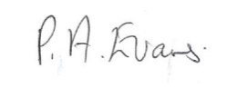
Executive Head Teacher: | O M Flowers
Lead Personnel: | J Flowers/M Harewood
Date of Review: | 13/10/2027

Statement of intent

The Westminster School wishes to ensure that pupils with medical conditions receive appropriate care and support at school. This policy has been developed in accordance with:
- The Children’s Wellbeing and Schools Act 2026 (Benedict's Law);
- The Department for Education's statutory guidance Supporting Children and Young People with Medical Conditions and Allegry (2026);
- Supporting Pupils at School with Medical Conditions;
- The Equality Act 2010;
- The Children and Families Act 2014;
- Keeping Children Safe in Education;
- The Special Educational Needs and Disability Code of Practice.
The school recognises that medical conditions, including severe allergies and anaphylaxis, must never prevent pupils from fully accessing education. The Westminster School is committed to providing a safe, inclusive environment where pupils with medical conditions can participate confidently in all aspects of school life through robust planning, staff training, partnership working and effective risk management.

Key roles and responsibilities
Supporting a child with a medical condition during school hours is not the sole responsibility of one person. A school’s ability to provide effective support will depend to an appreciable extent on working co-operatively with other agencies. Partnership working between school staff, healthcare professionals (and, where appropriate, social care professionals), local authorities, and parents and pupils is critical.
1.1 The Local Authority (LA) is responsible for:
1.1.1 Promoting cooperation between relevant partners and stakeholders regarding supporting pupils with medical conditions as outlined under Section 10 of the Children Act 2004, with a view to improving wellbeing of children with regard to their physical and mental health and their education, training and recreation.
1.1.2 The procedures relating to pupils with medical conditions or responding to emergencies whilst the pupil is on home-to-school transport.
1.1.3 Local authorities and ICS must make joint commissioning arrangements for education, health and care provision for children and young people with SEN or disabilities (Section 26 of the Children and Families Act 2014).
1.1.4 Local authorities should provide support, advice and guidance, including suitable training for school staff, to ensure that the support specified within individual healthcare plans can be delivered effectively.
1.1.5 Local authorities should work with schools to support with medical conditions to attend full-time. Where pupils would not receive a suitable education in a mainstream school because of their health needs, the local authority has a duty to make other arrangements. Statutory guidance for local authorities sets out that they should be ready to make arrangements under this duty when it is clear that a child will be away from school for 15 days or more because of health needs (whether consecutive or cumulative across the school year).
1.2 The Integrated Care Systems (ICSs) is responsible for:
1.2.1 Ensuring that commissioning is responsive to children’s needs and that health services are able to co-operate with schools supporting children with medical conditions. They have a reciprocal duty to co-operate under Section 10 of the Children Act 2004 and must make joint commissioning arrangements for education, health and care provision for children and young people with SEN or disabilities (as described above for local authorities).
1.2.2 ICSs should be responsive to local authorities and schools seeking to strengthen links between health services and schools and consider how to encourage health services in providing support and advice (and can help with any potential issues or obstacles in relation to this).
1.2.3 The local Health and Wellbeing Board will also provide a forum for local authorities and ICSs to consider with other partners, including locally elected representatives, how to strengthen links between education, health and care settings.
1.2.4 Since 2013 Local Authorities have been responsible for commissioning public health services for school-aged children including school nursing. ICSs should be aware that this does not include clinical support for children in schools who have long-term conditions and disabilities, which remains an ICS commissioning responsibility.
1.2.5 Children in special schools in particular may need care which falls outside the remit of local authority commissioned school nurse, such as gastrostomy and tracheostomy care, or postural support. ICSs should ensure their commissioning arrangements are adequate to provide the ongoing support essential to the safety of these venerable children whilst in school.
1.3 Health Services
1.3.1 Providers of health services should co-operate with schools that are supporting children with a medical condition, including appropriate communication, liaison with school nurses and other healthcare professionals such as specialist and children’s community nurses, as well as participating in locally developed outreach and training. Health services can provide valuable support, information, advice and guidance to schools, and their staff, to support children with medical conditions at school.
1.4 The Governing Body is responsible for:
1.4.1 The overall implementation of the Supporting Pupils with Medical Conditions
Policy and procedures of The Westminster School, ensuring that the Supporting Pupils with Medical Conditions Policy, as written, does not discriminate on any grounds including, but not limited to: ethnicity/national origin, culture, religion, gender, disability or sexual orientation.
1.4.2 Handling complaints regarding this policy as outlined in the school’s Complaints Policy.
1.4.3 Ensuring that all pupils with medical conditions are able to participate fully in all aspects of school life.
1.4.4 Ensuring that relevant training provided by the LA is delivered to staff members who take on responsibility to support children with medical conditions.
1.4.5 Guaranteeing that information and teaching support materials regarding supporting pupils with medical conditions are available to members of staff with responsibilities under this policy.
1.4.6 Keeping written records of any and all medicines administered to individual pupils and across the school population.
1.4.7 Ensuring the level of insurance in place reflects the level of risk.
1.4.8 Monitoring the school's compliance with statutory guidance relating to supporting pupils with medical conditions and allergy management.
1.4.9 Receiving annual assurance regarding:
- staff training compliance;
- Individual Healthcare Plans;
- emergency medication arrangements;
- significant medical incidents;
- allergy management arrangements;
- lessons learned following incidents.

1.5 The Head of School/SENCO in liaison with the Executive Head Teacher is responsible for:
1.5.1 The day-to-day implementation and management of the Supporting Pupils with Medical Conditions Policy and procedures of The Westminster School, ensuring the policy is developed effectively with partner agencies.
1.5.2 Making staff aware of this policy.
1.5.3 Liaising with healthcare professionals regarding the training required for staff. Training for specific medical conditions should be delivered by specialist medical professionals. This training should be reviewed as agreed by healthcare professionals.
1.5.4 Making staff who need to know aware of a child’s medical condition.
1.5.5 Consulting the Community Children’s Nurse in developing Individual Healthcare Plans (IHCPs).
1.5.6 Ensuring a sufficient number of trained members of staff are available to implement the policy and deliver IHCPs in normal, contingency and emergency situations. This will be in liaison with the Community Children’s Nurses.
1.5.7 If necessary, facilitating the recruitment of a member of staff for the purpose of delivering the promises made in this policy.
1.5.8 Ensuring the correct level of insurance is in place for teachers who support pupils in line with this policy.
1.5.9 Contacting the Community Children’s nurse in the case of any child who has a medical condition.
1.5.10 Acting as, or appointing, the school's Medical Conditions and Allergy Lead responsible for coordinating medical provision across the school.
1.5.11 Ensuring that the Supporting Pupils with Medical Conditions Policy and the School Allergy Policy are implemented consistently.
1.5.12 Monitoring completion and annual review of Individual Healthcare Plans and Allergy Action Plans where appropriate.
1.6 Staff members are responsible for:
1.6.1 Taking appropriate steps to support children with medical conditions.
1.6.2 Where necessary, making reasonable adjustments to include pupils with medical conditions into lessons.
1.6.3 Administering medication, if they have agreed to undertake that responsibility.
1.6.4 Undertaking training to achieve the necessary competency for supporting pupils with medical conditions, if they have agreed to undertake that responsibility.
1.6.5 Familiarising themselves with procedures detailing how to respond when they become aware that a pupil with a medical condition needs help.
1.6.6 Know the names of staff members responsible for administering injections.
1.6.7 Completing mandatory allergy awareness training appropriate to their role.
1.6.8 Recognising the signs and symptoms of allergic reactions and anaphylaxis.
1.6.9 Knowing how to summon emergency assistance and administer emergency medication where appropriately trained.
1.6.10 Immediately reporting all allergy incidents and near misses using the school's reporting procedures.
1.7 Community Children’s nurses are responsible for:
1.7.1 Notifying the school when a child has been identified with requiring support in school due to a medical condition. Wherever possible this should be done before the child starts school.
1.7.2 Liaising locally with lead clinicians on appropriate support for the child and staff.
1.7.3 Support staff to implement a child’s individual healthcare plan and provide advice and liaison for example on training.
1.8 Parents and carers are responsible for:
1.8.1 Keeping the school informed about any changes to their child/children’s health.
1.8.2 Completing a parental agreement for school to administer medicine form before bringing medication into school.
1.8.3 Providing the school with the medication their child requires and keeping it up to date.
1.8.4 Collecting any leftover medicine at the end of the course or year.
1.8.5 Discussing medications with their child/children prior to requesting that a staff member administers the medication.
1.8.6 Where necessary, developing an Individual Healthcare Plan (IHCP) for their child in collaboration with the Community Children’s Nurse, other staff members and healthcare professionals.
1.9 Other healthcare professionals are responsible for:
1.9.1 Notifying the school nurse when a child has been identified as having a medical condition that will require support at school
1.9.2 Providing advice on developing individual healthcare plans. Specialist local health teams may be able to provide support in schools for children with particular conditions (e.g. asthma diabetes, epilepsy).

Definitions
2.1 “Medication” is defined as any prescribed or over the counter medicine.
2.2 “Prescription medication” is defined as any drug or device prescribed by a doctor.
2.3 A “staff member” is defined as any member of staff employed at The Westminster School, including teachers and support staff.

Training of staff
3.1 Teachers and support staff will receive training on the Supporting Pupils with Medical Conditions Policy as part of their new starter induction.
3.2 Teachers and support staff will receive regular and ongoing training as part of their development.
3.2A All staff, including teachers, support staff, lunchtime supervisors, office staff, catering staff, transport escorts, volunteers and regular visitors where appropriate, will receive allergy awareness training as part of induction and regular refresher training.
3.3 Teachers and support staff who undertake responsibilities under this policy will receive the following training externally:
- First Aid at Work (All support staff)
- Safe handling and administration of medication (All support staff plus any other staff who volunteer)

  - No staff member may administer prescription medicines or undertake any healthcare procedures without undergoing training specific to the responsibility, including administering.
  - No staff member may administer drugs by injection unless they have received training in this responsibility.
  - The administration staff responsible for CPD will keep a record of training undertaken and a list of teachers qualified to undertake responsibilities under this policy.
  - Suitable training should be identified during the development or review of individual healthcare plans. Some staff may already have some knowledge of the specific support needed by a child with a medical condition and so extensive training may not be required. Staff who provide support to pupils with medical conditions should be included in meetings where this is discussed.
  - The relevant healthcare professional should normally lead on identifying and agreeing with the school the type and level of training required, and how this can be obtained. Schools may choose to arrange training themselves and should ensure this remains up-to-date.
  - Training should be sufficient to ensure that staff are competent and have confidence in their ability to support pupils with medical conditions, and to fulfil the requirements as set out in individual healthcare plans. They will need an understanding of the specific medical conditions they are being asked to deal with, their implications and preventative measures.
  - A first-aid certificate does not constitute appropriate training in supporting children with medical conditions.
Healthcare professionals, including the school nurse, can provide confirmation of the proficiency of staff in a medical procedure, or in providing medication.
Governing bodies should consider providing details of continuing professional development opportunities.
3.11 Training will include:
- recognising allergic reactions
- recognising anaphylaxis
- administration of adrenaline auto-injectors
- emergency response procedures
- reducing exposure to allergens
- responsibilities under Benedict's Law
- reporting incidents and near misses

The role of the child
4.1 Children who are competent will be encouraged to take responsibility for managing their own medicines and procedures.

4.2 Where possible, pupils will be allowed to carry their own medicines and devices. Where this is not possible, their medicines will be located in an easily accessible location.

4.3 If pupils refuse to take medication or to carry out a necessary procedure, parents will be informed so that alternative options can be explored. Staff should not force them to take it, but follow the procedures agreed in the individual healthcare plan.

4.4 Where appropriate, pupils will be encouraged to take their own medication under the supervision of a teacher.

Individual Healthcare Plans (IHCPs)
5.1 When deciding what information should be recorded in individual healthcare plans, the governing body should consider the following:
- The medical condition, its triggers, signs, symptoms and treatments;
- The pupil’s resulting needs, including medication (dose, side effects and storage) and other treatments, time, facilities, equipment testing, access to food and drink where this is used to manage their condition, dietary requirements and environmental issues, e.g. crowded corridors travel time between lessons, counselling sessions;
- Specific support for the pupil’s educational, social and emotional needs – for example, how absences will be managed, requirements for extra time to complete exams, use of rest periods or additional support in catching up with lessons, counselling sessions;
- The level of support needed (some children will be able to take responsibility for their own health needs) including in emergencies. If a child is self-managing their medication, this should be clearly stated with appropriate arrangements for monitoring;
- Who will provide this support, their training needs, expectations of their role and confirmation of proficiency to provide support for the child’s medical condition from a healthcare professional; and cover arrangements for when they are unavailable;
- Who in the school needs to be aware of the child’s condition and the support required;
- Arrangements for written permission from parents and the Executive Head Teacher for medication to be administered by a member of staff, or self-administered by the pupil during school hours.
- Separate arrangements or procedures required for school trips or other school activities outside of the normal school timetable that will ensure the child can participate, e.g. risk assessments;
- Where confidentiality issues are raised by the parents/child, the designated individuals to be entrusted with information about the child’s condition; and
- What to do in an emergency, including whom to contact, and contingency arrangements. Some children may have an emergency healthcare plan prepared by their lead clinician that could be used to inform development of their individual healthcare plan.
- Where a pupil has a diagnosed allergy or is assessed as being at risk of anaphylaxis, the Individual Healthcare Plan will be read alongside the school's Allergy Policy and any Allergy Action Plan provided by healthcare professionals.
  - Where necessary, an Individual Healthcare Plan (IHCP) will be developed in collaboration with the pupil, parents/carers, Executive Head Teacher, Head of School, Deputy Head Teacher(s), SENCO and medical professionals.
  - IHCPs will be easily accessible whilst preserving confidentiality.
  - IHCPs will be reviewed at least annually or when a child’s medical circumstances change, whichever is sooner.
  - Where a pupil has an Education, Health and Care plan, the IHCP will be linked to it or become part of it.
  - Where a child is returning from a period of hospital education or alternative provision or home tuition, we will work with the LA and education provider to ensure that the IHCP identifies the support the child needs to reintegrate.

Medicines
6.1 Where possible, it is preferable for medicines to be prescribed in frequencies that allow the pupil to take them outside of school hours. Ad hoc medication such as Antibiotics will only be administered in School if they are required to be taken four times a day or more.
6.2 If this is not possible, prior to staff members administering any medication, the parents/carers of the child must complete and sign a parental agreement for a school to administer medicine form.
6.3 No child will be given any prescription or non-prescription medicines without written parental consent.
6.4 Where a pupil is prescribed medication without their parents’/carers’ knowledge, every effort will be made to encourage the pupil to involve their parents while respecting their right to confidentiality.
6.5 No child under 16 years of age will be given medication containing aspirin without a doctor’s prescription.
6.6 Medicines MUST be in date, labelled, and provided in the original container (except in the case of insulin which may come in a pen or pump) with dosage instructions. School can administer Paracetamol, Calpol, Nurofen and Ibuprofen and other medication such as travel sickness medication, skin creams, cough medication recommended by a Doctor to parents/carers without a prescription. However, bottles or tablets must be sent into school in an unopened state, in the original packaging and/or box and within the expiry date. Medicines which do not meet these criteria will not be administered.
6.7 Controlled drugs may only be taken on school premises by the individual to whom they have been prescribed. Passing such drugs to others is an offence which will be dealt with under our Drug and Alcohol Policy. However, it may be necessary at times for this to take place offsite if pupils are on trips (eg administering Buccal if a pupil requires it during an offsite visit).
6.8 Medications will be stored in the Medical Room accessible to all staff at all times. Medicines and devices such as asthma inhalers, blood glucose testing meters and adrenaline pens should always be readily available to children and not locked away. This is particularly important to consider when outside of school premises, e.g. on school trips.
6.9 School uses Medical Tracker cloud-based solution to record pupils’ medical conditions, care plans, seizure logs, medication records and first aid incidents This includes ad-hoc medication given with parent/carer permission (eg Calpol, Nurofen, Paracetamol).
6.10 Medication details and health conditions (dosages, timings etc) will be recorded in the pupil’s profile in Medical Tracker. This will be done for new starters by Marie Harewood. Any changes to medication ONLY following this will be recorded by the Class Team in Medical Tracker. Marie Harewood is responsible for updating all pupils’ medical conditions in Medical Tracker.
6.11 The Class Team is responsible for ensuring they are aware of pupils’ health conditions and that pupils’ receive their medication.
6.12 It is recognised that staff may need to carry medication with them at all times when supporting pupils if they are going off site or if it is necessary to administer medication quickly (eg Buccal, adrenaline pens). Staff must ensure that they carry the medication with them in a suitable bag on their person, which should be kept closed at all times and locked with a combination lock. Staff must check the contents of the bag and the condition of the bag for tears or rips on a daily basis and sign the bag checklist (Appendices 11/12). Any defects with the bag must be reported to the Executive Manager immediately so that a replacement can be issued.
6.13 The HLTA for Medical needs will check on a weekly basis that forms are being completed. This may be checked on a number of different bags each week. This will ensure that the staff are checking and recording the bags and contents.
6.14 Staff will make a note in Medical Tracker of medication remaining in school for all medication after medicating pupils. A request will be sent to parents by a member of the class team for more medication when there is 5 days’ worth of any medication remaining in school (1/2 bottle for liquid medicines).
6.15 Any medications left over at the end of the course will be returned to the child’s
parents. Sharps bins should always be used for the disposal of needles and other
sharps.
6.16 Records will be kept of any medication administered to children on Medical Tracker
software following the process outlined in Appendix 7. This should be recorded by a
member of the class team trained in administering medication and witnessed by
another adult supporting the administration of medication. Should the class team
not have an appointed person trained in the administration of medication, this should
be done by another member of staff who has received training.
6.17 Medical Tracker is cloud-based and accessible by staff when offsite wherever there
is internet access/WiFi. However, in the event of staff not having internet access
when offsite, a Record of Medical Use (RMU) (Appendix 9) should be completed.
Visit Leaders or First Aiders supporting trips should ensure that a form is
generated for all pupils requiring medication prior to offsite visits. The details
recorded on the RMU will be entered onto Medical Tracker on return to school by
the designated first aider for the visit before leaving work. The RMU will be
returned to a designated point and these will be randomly audited by Marie
Harewood every week to ensure that RMUs have been recorded in Medical
Tracker.
6.18 In the event of staff not being able to access the internet onsite (eg system failure
and RMU will be completed as in 6.17.
6.19 First aid incidents for pupils will be recorded in Medical Tracker and an email sent
home through the system to notify parents/carers of these. If pupils’ receive a Head
Injury, a phone call will be made by the First Aider to parents/carers to notify them
of this before the pupil leaves school.
6.20 Pupils will never be prevented from accessing their medication.
6.21 The Westminster School cannot be held responsible for side effects that occur when
medication is taken correctly.
6.22 Asthma inhalers are kept in school for emergency use. The school follows the
Department of Health protocol for their use. Emergency Asthma inhalers should only
be used if the pupil has a diagnosis of Asthma AND if we have written consent from
parents to administer an emergency inhaler. Detailed guidance can be found
here: https://www.gov.uk/government/publications/emergency-asthma-inhalers-for-
use-in-schools
6.23 All medicines should be administered by a suitably trained member of staff. When
dispensing medication, the process should be supported by another member of
staff. This person may not be a first aider but should also be responsible for reading
documentation regarding administration of medication for the pupil. In the event of
there not being a trained member of staff in a class to administer medication, the
Class Teacher/Learning Support member will contact another member of staff who
is trained to support. If the pupil is on site, all medication (not including emergency
or rescue medication) must be administered in the medical room and not in classrooms or open spaces.'

6.24 Dates on medications and medication checks, to ensure that medicine is in the
locked medical cupboard and in carry bags, should be carried out regularly. The
date the medication has first been used in School should be recorded on the label of
the medication.
6.25 If medication is found to be missing or lost, this must be reported to the HR Manager
immediately. An email alert will be sent to all staff and Mitie caretaking staff will be
asked to conduct a search of the school.
6.26 The school will maintain emergency "spare" adrenaline auto-injectors in accordance
with Department for Education guidance. These will be stored securely, checked
regularly and made readily available in an emergency.
6.27 Expiry dates of emergency medication will be monitored routinely and parents
informed in sufficient time to replace medication before expiry.

Day trips, residential visits and supporting activities
7.1 Governing bodies should ensure that their arrangements are clear and unambiguous about the need to support actively pupils with medical conditions to participate in school trips and visits, or in sporting activities, and not prevent them from doing so.
7.2 Teachers should be aware of how a child’s medical condition will impact on their participation, but there should be enough flexibility for all children to participate according to their own abilities and with any reasonable adjustments. Schools should make arrangements for the inclusion of pupils in such activities with any adjustments as required unless evidence from a clinician such as a GP states that this is not possible.
7.3 Schools should consider what reasonable adjustments they might make to enable children with medical needs to participate fully and safely on visits it is best practice to carry out a risk assessment so that planning arrangements take account of any steps needed to ensure that pupils with medical conditions are included. This will require consultation with parents and pupils and advice from the relevant healthcare professional to ensure that pupils can participate safely.
7.4 Educational Visit Leaders will ensure:
- emergency medication accompanies the pupil;
- staff attending have appropriate training;
- emergency procedures are known;
- local emergency services are considered where appropriate;
- risk assessments specifically address medical conditions and allergies.
- Emergency Autoimmune injectors should be take offsite for every visit
- A portable defibrillator should be taken on an offsite visit where there will not be access to a community one.

Palliative Care
8.1 There may be an occasion for us to support pupils who have palliative care in place. We respect the wishes of the child/young person and their family. If this includes supporting the child/young person to remain in school, we do whatever is reasonably practicable to enable this to happen. Every child is unique and will have different medical and emotional requirements. We work with families and the relevant health professionals to agree suitable plans to ensure the safety and well-being of the child/young person. Sometimes this requires Health Teams to provide additional medical/care staff to meet the needs of the child/young person. We also require up-to-date Care Plans to be in place, with all supporting documentation, to ensure the procedures are clear and that all relevant staff and agencies are fully informed. If there is a delay in organising the plans and resources, we will provide home learning for the pupil until the arrangements have been put into place. In these cases, we prioritise the needs of the child and work with families and relevant healthcare professionals to expedite the arrangements.
In order to fulfil our duty of care towards our employees, we work with staff to support their emotional well-being at all stages, and we provide a free and confidential Employee Assistance Programme, with a range of counselling services. We recognise that education staff are not legally required to provide medical support, and that they have not chosen a profession related to palliative care.

Emergencies
9.1 Medical emergencies will be dealt with under the school’s emergency procedures.
9.2 Where an Individual Healthcare Plan (IHCP) is in place, it should detail:
- What constitutes an emergency.
- What to do in an emergency.

9.3 Pupils will be informed in general terms of what to do in an emergency such as telling a teacher.
9.4 If a pupil needs to be taken to hospital, a member of staff will remain with the child until their parents arrive.
9.5 Following any serious medical incident, administration of emergency medication, suspected anaphylaxis or significant near miss, the school will undertake a formal review to identify lessons learned and amend Individual Healthcare Plans, risk assessments and procedures where appropriate.

Avoiding unacceptable practice
10.1 The Westminster School understands that the following behaviour is unacceptable:
- Assuming that pupils with the same condition require the same treatment.
- Ignoring the views of the pupil and/or their parents.
- Ignoring medical evidence or opinion (although this may be challenged).
- Sending pupils home frequently or preventing them from taking part in activities at school, including lunch unless this is specified in their IHCP.
- Sending the pupil to the medical room or school office alone if they become ill.
- Penalising pupils with medical conditions for their attendance record where the absences relate to their condition.
- Making parents feel obliged or forcing parents to attend school to administer medication or provide medical support, including toilet issues. No parent should have to give up working because the school is failing to support their child’s medical needs.
- Creating barriers to children participating in school life, including school trips.
- Refusing to allow pupils to eat, drink or use the toilet when they need to in order to manage their condition.
- Prevent children from easily accessing their inhalers and medication and administering their medication when and where necessary.

10.2 The following are also considered unacceptable practice:
- failing to recognise symptoms of anaphylaxis;
- delaying emergency treatment;
- failing to follow an Individual Healthcare Plan;
- failing to communicate significant changes to relevant staff;
- failing to carry emergency medication during educational visits;
- excluding pupils because of allergies where reasonable adjustments can be made.

Medication Errors
11.1 Staff must also refer to Appendix 17 Medication Errors Guidance which sets
out how errors will be addressed.
11.2 Every effort is made to ensure medication is administered and recorded
accurately and appropriately. If a medication error is made, a member of SLT
must be notified in the first instance immediately, and an incident report
completed as soon as possible but staff must not delay seeking immediate
medical treatment needed if that person is unavailable.
11.3 Medication errors include missed dose, wrong dose given, wrong medication
given, wrong method of administration (ie spoon rather than syringe)
medication not stored correctly or medication damaged. They also
include recording errors, where the correct medication has been given but
incorrect details have been recorded by staff or the administration of the
medication has not been recorded.
11.4 When an error has occurred, it can be difficult for staff to know if medical
attention is required as a child/young person may not immediately show signs
of distress or illness. Staff are not qualified to make a judgement on if the
child/young person may be harmed or be affected as this may occur
sometime after the error has occurred. Once a medication error and SLT
have been informed, medical advice should be sought as soon as possible by
calling 111 for advice.
11.5 Staff must follow the advice of the medical professionals. During the time the
child is in school, these observations should be recorded. Parents should be
contacted by the Executive Headteacher to inform them of the incident and
actions being taken.
11.6 If the child is showing signs of becoming ill or needing urgent medical
attention emergency medical help should be sought by calling 999. Signs
include: nausea and vomiting, headache, blurred vision, pale, lethargic,
sleepy, dizzy and drowsiness, rash and itching, hot and sweaty, difficulty
breathing, increased heart rate, seizure fainting, loss of consciousness.
11.7 A member of staff should accompany the pupil to hospital and take the pupil’s
medical information with them. Parents/carers must be informed that the pupil
is being taken to hospital and asked to meet staff there.
11.8 All medication errors must be treated as serious incidents. The incident
should be reported to the Executive Head Teacher.
11.9 As soon as the child’s immediate medical needs have been met, the following
action should be taken:
- The incident should be reported to the Executive Head Teacher
- Medication errors must be recorded on CPOMS.
- All actions taken must be recorded following a medication error.
- The member of staff responsible for administering the medication will be suspended from administering medication until an internal investigation is completed by the HR Manager.
- Further training or support may be put in place to identify the cause of the error and take action to prevent this happening again.
- Consider if a referral should be made to the Local Authority Designated Officer
- If the child or young person has sustained harm, then the incident should be reported to the local authority following the procedures in the Safeguarding and Child Protection Policy.
- All medication errors need to be investigated to be able to identify patterns and trends and take action to prevent reoccurrence.
11.10 Medication errors may be the result of problems with processes or procedures
which have contributed to individuals making errors. Therefore, the
investigation should be approached as an opportunity to identify any procedural or process issues that need to be rectified as well as considering
whether there may be staff training or competency issues.
11.11 All medicines errors/incidents will be investigated to understand how and why the error/incident occurred. An action plan will be agreed to prevent reoccurrence of the issue, and this may include further training. All medication errors are monitored by the Executive Head Teacher, DSL and HR Manager.

Insurance
12.1 All staff who undertake responsibilities within this policy are covered by the Local Authority insurance.
12.2 Full written insurance policy documents are available to be viewed by members of staff who are providing support to pupils with medical conditions. Those who wish to see the documents should contact the Business Manager.
12.3 Insurance policies should provide liability cover relating to the administration of medication, but individual cover may need to be arranged for any healthcare procedures. The level and ambit of cover required must be ascertained directly from the relevant insurers. Any requirements of the insurance, such as the need for staff to be trained, should be made clear and complied with

Complaints
13.1 The details of how to make a complaint can be found in the Complaints Policy:
13.1.1 Stage 1 - Complaint Heard by Executive Head Teacher or a person
nominated by the Executive Head Teacher (or Governing Body if the
complaint is against the Executive Head Teacher
13.1.2 Stage 2 - Complaint Heard by Governing Body Complaints Committee
13.1.3 Request for Review by the LA

Further sources of information
Other safeguarding legislation
14.1 Section 21 of the Education Act 2002 provides that governing bodies of maintained schools must, in discharging their functions in relation to the code of conduct of the school, promote the wellbeing of pupils at the school.
14.2 Section 175 of the Education Act 2002 provides that governing bodies of maintained schools must make arrangements for ensuring that their functions relating to the conduct of the school are exercised with a view to safeguarding and promoting the welfare of children who are pupils at the school. Part 3, and in particular paragraph 7 of the Schedule to the Education (Independent School Standards) Regulations 2014 sets this out in relation to academy schools and alternative provision academies.
14.3 Section 3 of the Children Act 1989 confers a duty on a person with the care of a child (who does not have parental responsibility for the child) to do all that is reasonable in all the circumstances for the purposes of safeguarding or promoting the welfare of the child.
14.4 Section 17 of the Children Act 1989 gives local authorities a general duty to safeguard and promote the welfare of children in need in their area.
14.5 Section 10 of the Children Act 2004 provides that the local authority must make arrangements to promote co-operation between the authority and relevant partners (including the governing body of a maintained school, the proprietor of an academy, ICSs and the NHS Commissioning Board) with a view to improving the wellbeing of children, including their physical and mental health, protection from harm and neglect, and education. Relevant partners are under a duty to co-operate in the making of these arrangements.
14.6 The Health and Care Act 2022: 3 gives ICSs a duty to arrange for the provision of health services to the extent the ICS considers it necessary to meet the reasonable needs of the persons for whom it is responsible. Section 3A provides for an ICS to arrange such services as it considers appropriate to secure improvements in physical and mental health of, and in the prevention, diagnosis and treatment of illness in, the persons for whom it is responsible. Section 2A provides for local authorities to secure improvements to public health, and in doing so, to commission school nurses.
14.7 Governing Bodies’ duties towards disabled children and adults are included in the Equality Act 2010, and the key elements are as follows:
- They must not discriminate against, harass or victimise disabled children and young people
- They must make reasonable adjustments to ensure that disabled children and young people are not at a substantial disadvantage compared with their peers. This duty is anticipatory: adjustments must be planned and put in place in advance, to prevent that disadvantage.
14.8 The school maintains a separate Allergy Policy setting out detailed arrangements
for preventing, managing and responding to allergic reactions. This policy should
be read alongside the Supporting Pupils with Medical Conditions Policy.

Other relevant legislation
15.1 Section 2 of the Health and Safety at Work Act 1974, and the associated regulations, provides that it is the duty of the employer (the local authority, governing body or academy trust) to take reasonable steps to ensure that staff and pupils are not exposed to risks to their health and safety.
15.2 Under the Misuse of Drugs Act 1971 and associated Regulations the supply, administration, possession and storage of certain drugs are controlled. Schools may have a child who has been prescribed a controlled drug.
15.3 The Medicines Act 1968 specifies the way that medicines are prescribed, supplied and administered within the UK and places restrictions on dealings with medicinal products, including their administration.
15.4 Regulation 5 of the School Premises (England) Regulations 2012 (as amended) Provides that maintained schools must have accommodation appropriate and readily available for use for medical examination and treatment and for the caring of sick or injured pupils. It must contain a washing facility and be reasonably near to a toilet. It must not be teaching accommodation. Paragraph 24 of the Schedule to the Education (Independent School Standards) Regulations 2014 replicates this provision for independent schools (including academy schools and alternative provision academies).

The Special Educational Needs and Disability Code of Practice
15.6 Section 19 of the Education Act 1996 (as amended by Section 3 of the Children, Schools and Families Act 2010) provides a duty on local authorities of maintained schools to arrange suitable education for those who would not receive such education unless such arrangements are made for them. This education must be full-time, or such part-time education as in a child’s best interests because of their health needs.

Associated policies
- Allergy Policy
- First Aid Policy
- Health & Safety Policy
- Child Protection and Safeguarding Policy
- Educational Visits Policy
- Accessibility Plan
- SEND Policy
- Behaviour (Wellbeing and Engagement) Policy

Monitoring and Review
The Governing Body will receive an annual report regarding:
- pupils with medical conditions;
- staff training compliance;
- Individual Healthcare Plans;
- allergy management;
- emergency medication audits;
- medical incidents and trends;
- recommendations arising from incident reviews.
This policy will be reviewed annually, following any significant legislative change, or following any serious medical incident requiring amendments to school procedures.
The named Governor for medical Needs is _______________________

Appendix 1 Individual healthcare plan implementation procedure

1
•
Parent or healthcare professional informs school that
child has medical condition or is due to return from
long
-
term absence, or that needs have changed.
2
•
SENCo co
-
ordinates meeting to discuss child's medical
needs and identifies member of school staff who will
provide support to the pupil.
3
•
Meeting held to discuss and agree on the need for IHCP
to include key school staff, child, parent and relevant
healthcare professionals.
4
•
Develop IHCP in partnership with healthcare
professionals and agree on who leads.
5
•
School staff training needs identified.
6
•
Training delivered to staff
-
review date agreed.
7
•
IHCP implemented and circulated to relevant staff.
8
•
IHCP reviewed annually or when condition changes.
Parent/carer or healthcare professional to initiate. (Back
to 3.)

Appendix 2 - Individual healthcare plan template

Health Care Plan for a Child with Medical Needs
Photo

Photo
Name:
Date of Birth:
Current Year/Class:
Medical
Conditions(s):
NHS No:

Family Contact 1:
Name:
Home Telephone:
Work Telephone:
Relationship:

Family Contact 2:
Name:
Home Telephone:
Work Telephone:
Relationship:

GP:
Name:
Telephone:

Hospital Clinic Contact:
Name:
Telephone:
Office number – 0121 507 2633 or 0121 552 6185
Details of medical symptoms: (including any regular medications):

Regular requirements: (eg PE; lunchtimes)

What constitutes an emergency, and what action should be taken:

Care Plan Written by:
Name:
Designation:

Date Plan Written:
Date due for review:

Parent Signature

Copies of Plan to:
School | Family | CCN | Paediatrician or  GP

Review of Care Plan:
Name:
Designation:

Date Plan
Reviewed:
Date due for review:

Review of Care Plan:
Name:
Designation:

Date Plan
Reviewed:
Date due for review:

Review of Care Plan:
Name:
Designation:

Date Plan Written:
Date due for review:

Copies of Plan to:
School | Family | CCN | Paediatrician or  GP

Data Protection Act, 1998
The information that you supply on this form will be used by the Children and Young Peoples Services for the purpose of maintaining and improving the level of service given for young people within Sandwell MBC. All information is regarded as confidential and any data collected via this form will be processed or disclosed only within the limits of the data protection notification. Data may be shared within the Children and Young Peoples Services.
Sandwell MBC Children and Young Peoples Services will supply basic identifying information for inclusion on ContactPoint, which is a contacts list for professionals who work with children and young people. It will provide professionals with a quick way to find out who else is working with the same child, making it easier to deliver more coordinated support. ContactPoint lists contact details for all children in England up to their 18th birthday, their parents and carers and services working with the young person.
For further information visit: Department for Children, Schools and Families (Every Child Matters)

Appendix 3
Contacting emergency services

Request an ambulance - dial 999, ask for an ambulance and be ready with the information below.
Speak clearly and slowly and be ready to repeat information if asked.
- Your telephone number – 0121 561 6884 • Your name.
- Your location as follows: The Westminster School, Hawes Lane, Rowley Regis, West Midlands, B65 9AL
- The exact location of the patient within the school.
- The name of the child and a brief description of their symptoms. The best entrance
to use and state that the crew will be met and taken to the patient.
- Ask Admin to print off pupil record from SIMS to give to the crew.
- Please complete the form in Appendix 4.
- Ask another member of staff (if available) to contact a member of the Senior Leadership Team


Request for 999 Support Form
Appendix 4
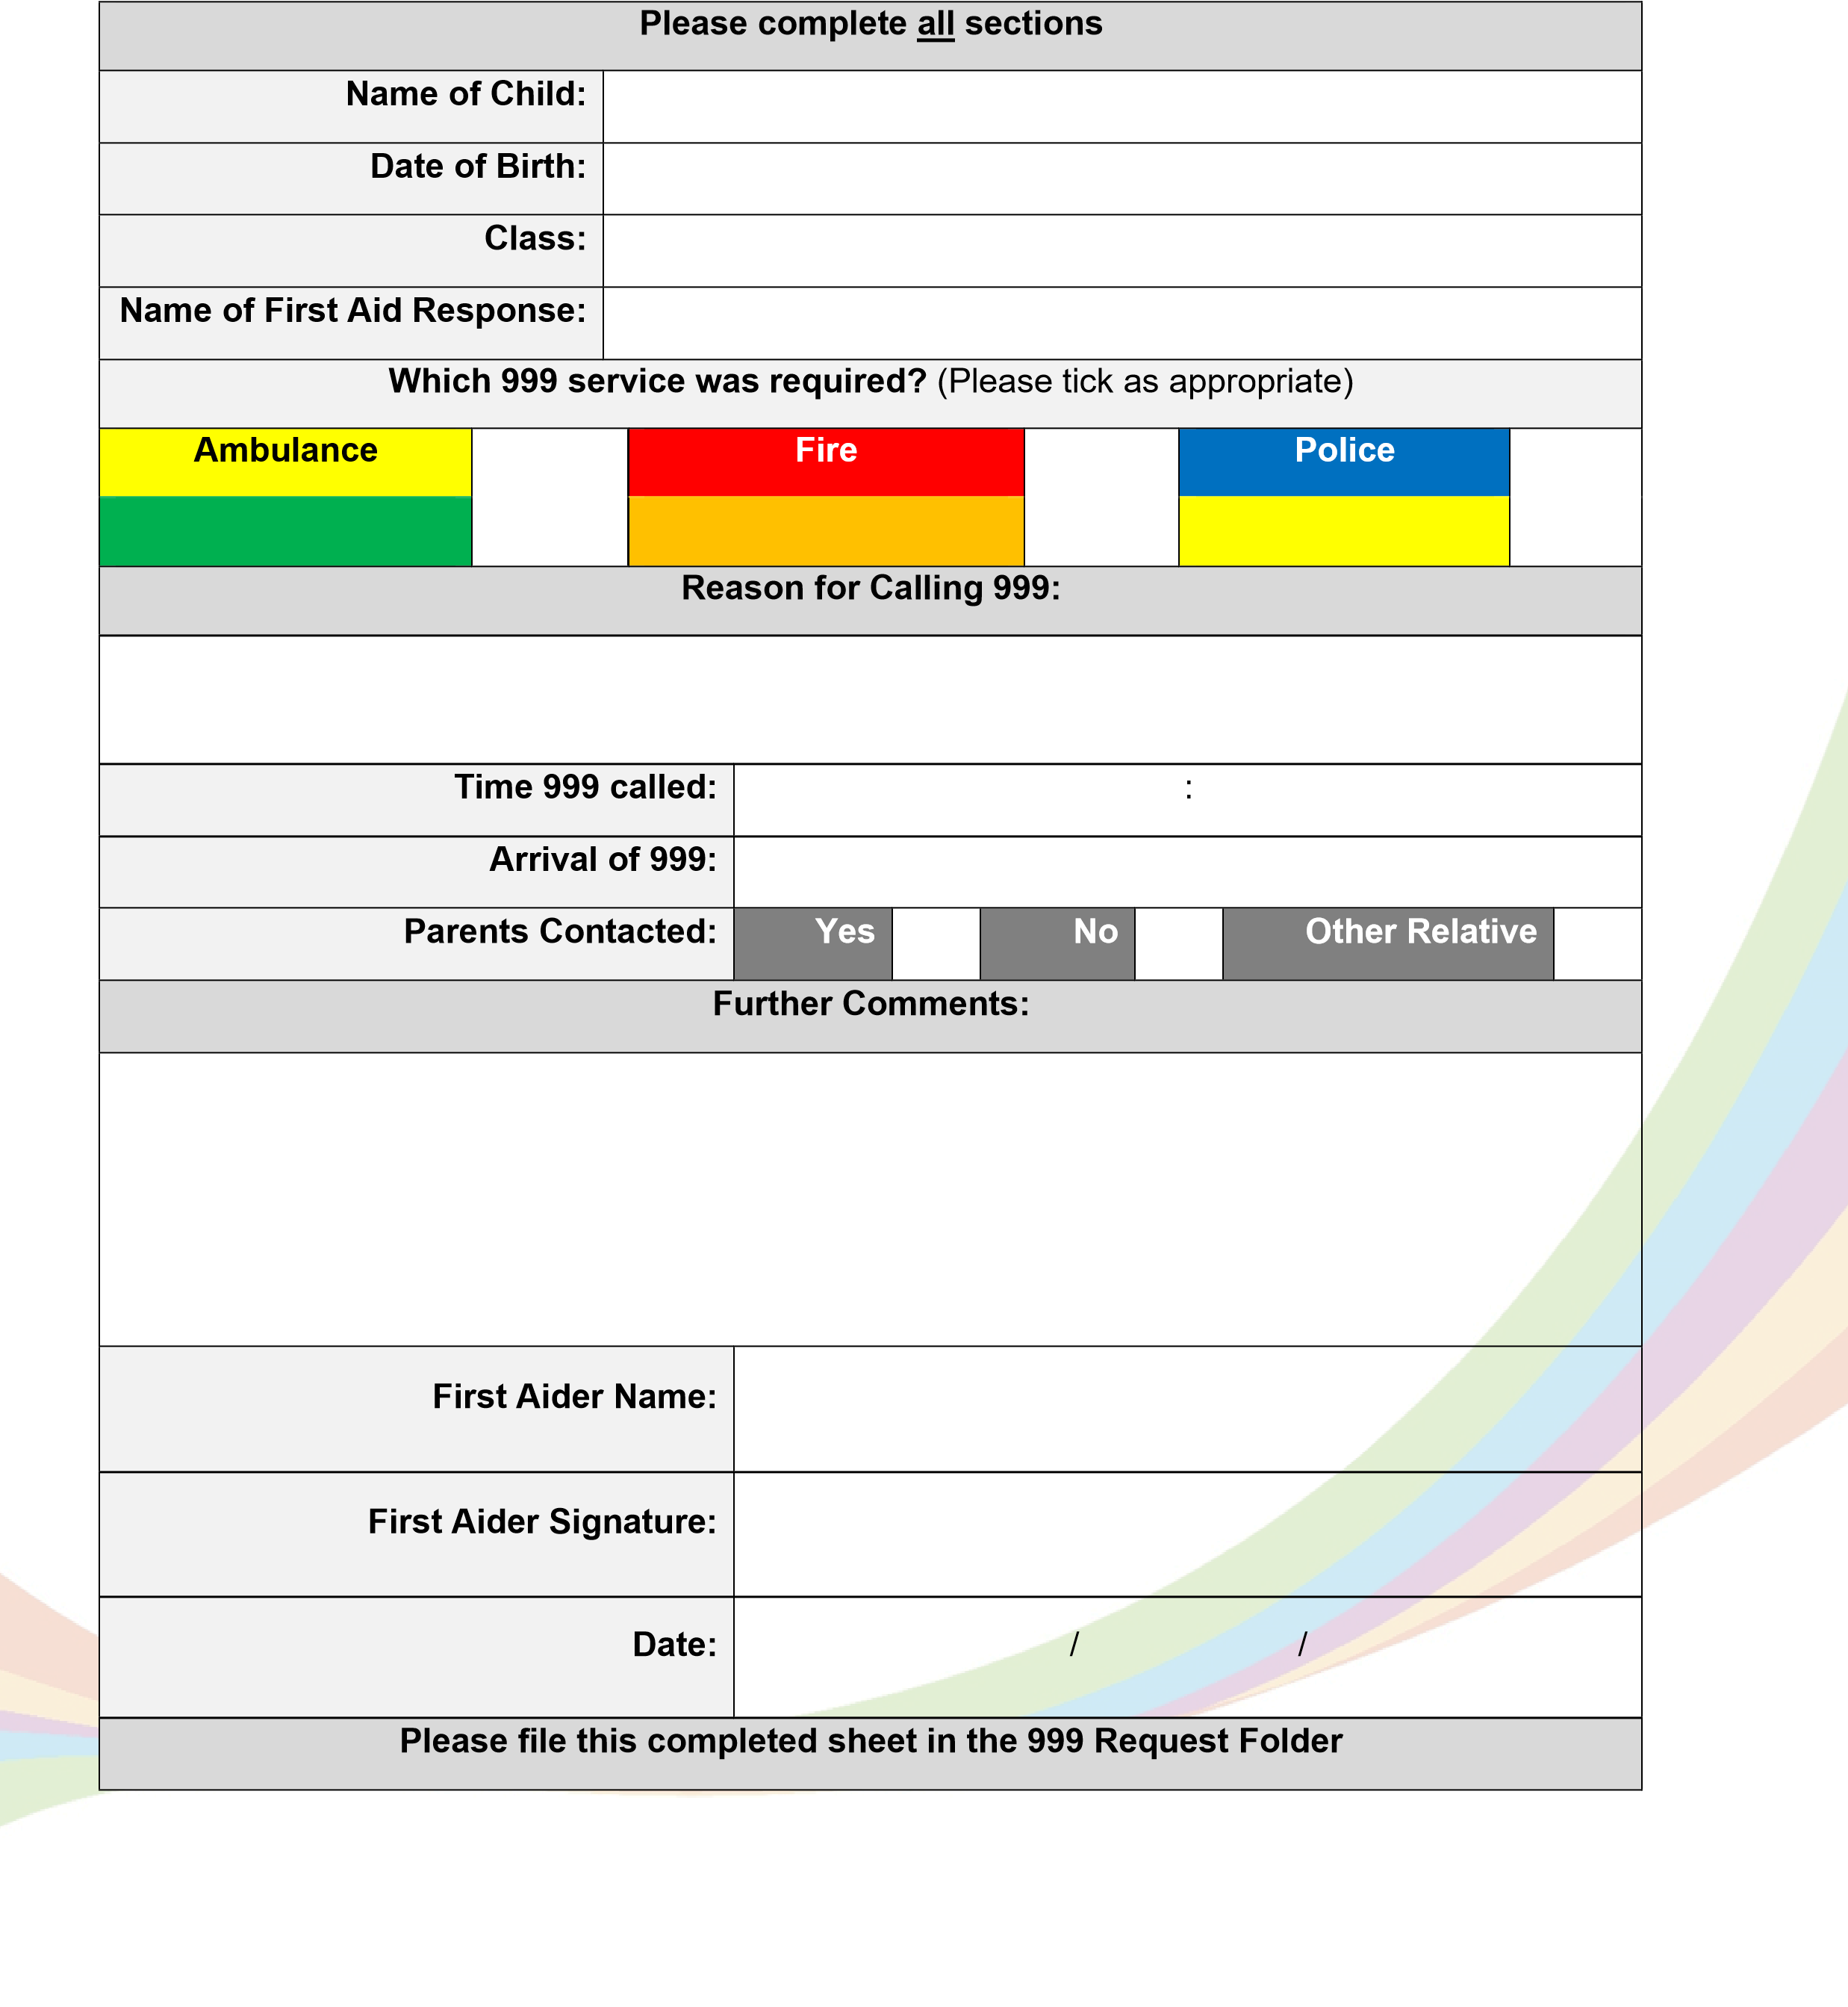

Appendix 5

Model letter inviting parents to contribute to

individual healthcare plan development
Thank you for informing us of your child’s medical condition. I enclose a copy of the school’s
policy for supporting
pupils at school with medical conditions for your information.

A central requirement of the policy is for an individual healthcare plan to be prepared, setting
out what support each pupil needs and how this will be provided. Individual healthcare plans
are

developed in partnership with the school, parents/carers, pupils, and the relevant
healthcare professional who can advise on your child’s case. The aim is to ensure that we
know how to support your child effectively and to provide clarity about what need
s to be done,
when and by whom. Although individual healthcare plans are likely to be helpful in the majority
of cases, it is possible that not all children will require one. We will need to make judgements
about how your child’s medical condition impacts
their ability to participate fully in school life,
and the level of detail within plans will depend on the complexity of their condition and the
degree of support needed.

A meeting to start the process of developing your child’s individual health care plan

has been
scheduled for
xx/xx/xx
. I hope that this is convenient for you and would be grateful if you could
confirm whether you are able to attend. The meeting will include
add details of team
. Please
let us know if you would like us to invite another med
ical practitioner, healthcare professional
or specialist and provide any other evidence you would like us to consider at the meeting as
soon as possible.

If you are unable to attend, it would be helpful if you could complete the attached individual
health
care plan template and return it, together with any relevant evidence, for consideration
at the meeting. I
or add name of other staff lead

would be happy for you contact me [them]
by email or to speak by phone if this would be helpful.

Yours sincerely,

Appendix 6
Step by Step Instructions – Administering Medication

- Right Patient: Verify the patient's identity using at least two approved identifiers (e.g., full name and date of birth) before giving any medication.

- Wash Your Hands: Use soap and water or an alcohol-based hand sanitiser before touching any medication or supplies.

- Right Medication: Check the Prescription/Medical Tracker: Compare the medication label against the prescription or Medical Tracker Information. Double-check the expiry date and look for any noted allergies. Have your witness double check the prescription order with you to avoid any errors.

- Right Dose: Confirm that the dosage is appropriate for the patient and accurately measured based on the Doctors prescription. Have your witness double check the dosing with you to avoid any errors.

- Right Route: Ensure the prescribed method of delivery (e.g., oral, intravenous, topical) is safe, appropriate for the patient, and matches the prescription order. Have your witness confirm the route that the medication will be taken and the desired amount of medication that is required.

- Oral (Liquids): Place the medicine cup on a flat, level surface and read the measurement at eye level (at the bottom of the fluid curve)

- Use a bottle adapter/bung: If your medication bottle has a plastic insert or bung, press the syringe tip firmly into the centre hole
- Draw the liquid: Turn the bottle completely upside down. Pull the plunger back slowly until the top black line of the rubber stopper aligns exactly with your prescribed dose line.
- Alternative (No adapter): If the bottle has no adapter, pour a small amount of liquid into a clean medicine cup and draw it up into the syringe from there.

- Pills/Tablets: Dispense correct number of tablets in a medication dispensing pot. Have your witness verify that this is the correct amount.

- Swallowing: Most tablets should be swallowed whole with water, milk or juice. If a tablet must be taken with or without food, this will be stated on the prescription label or patient information leaflet
- Do Not Alter: Never crush, chew or split tablets unless this has been authorised by a pharmacist.

- Topical (Creams/Patches): Wear gloves. Clean and dry the skin area before applying a thin layer of cream or placing the new medicated patch according to the instructions. Remove the old patch if applicable.

- Inhalers: Shake the inhaler, use a spacer/mask if necessary, and have the patient exhale completely. Have them breathe in slowly and deeply while pressing the canister, then hold their breath for about 10 seconds. Complete this step again if the inhaler is required for a second puff.

- Right Time: Give the medication at the correct prescribed frequency and time of day, verifying when the previous dose was administered to avoid delays or overdoses. Your witness can help get this ready for you to both check.

- Right Documentation: Immediately document the medication administration on the patient's record on Medical Tracker or RMU if offsite including the dose, time, route, and any specific notes. Have your witness double check the information you have inputted before submitting.
- Please send a notification home via Medical Tracker to parents/carers to let them know that the medication has been administered.
- Once you are back on site, please transfer the information from the RMU form onto medical tracker and repeat the previous step.

Recording the Administration of Medication
Appendix 7
Appendix 8
Process for Recording the Administration Medication on Medical Tracker after Offsite Activities (where there has been no access to the internet/Wifi
A video walkthrough of the process is available here: https://help.medicaltracker.co.uk/en/training-webinar-recording-incidents-and-medication-use-with-parent-notifications

A video walkthrough of the process is available here: https://help.medicaltracker.co.uk/en/training-webinar-recording-incidents-and-medication-use-with-parent-notifications

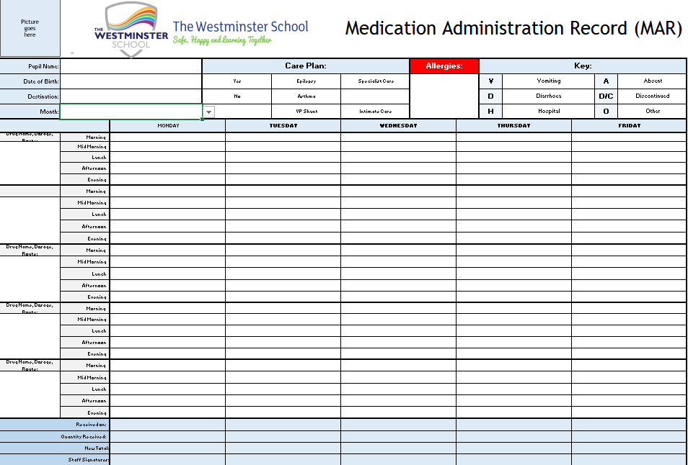
Appendix 8a

Please complete this Record Medical Use (RMU) form to document any medication which has been administered to a student. You must complete a separate from for each different type of medication being administered.
Appendix 9
Student receiving  Medication:* |  |  |  | Medication Use Date:* |  | Medication Use Time:*
Name of Medication:* |  |  |  |  | Exact dosage administered:*
Medication  Administered by Staff Name 1* |  | : |  |  | Medication Administered by:  Staff Name 2*
 |  | Any side effects experienced?
 |  | Notes:

Once this form is complete, please keep this safe until you return to site. Once on site please log this information as it appears above on Medical Tracker.
Logging this RMU Form on Medical Tracker
- Log into Medical Tracker (www.school.medicaltracker.co.uk). If you have forgotten your password, please click on the ‘Don’t remember your password?’ option.
- Click on ‘Medication Use’ option on the Menu Bar.
- Click on ‘New’ button located towards the top of the page.
- Replicate the information you have written above onto the Digital RMU form.
- Once completed click on the Save button.
- You can now post this in the RMU post box located within the medical room (WM-G-27)


Medical bag checklist for Rescue & Onsite Medication
Appendix 10
Please make sure you complete a thorough check of the rescue bags and onsite medication
Date | Pupil | Name of Medication | Medication contents correct and checked for expiry dates | Care plans up to date and checked for expiry dates | Staff signing out signature | Staff signing in signature

Medical bag checklist for Rescue & Offsite Medication
Appendix 11
Please make sure you complete a thorough check of the rescue bags and offsite medication
Date | Pupil | Destination | Name of Medication | Medication contents correct and checked for expiry dates | Care plans up to date and checked for expiry dates | Staff signing out signature | Staff signing in signature

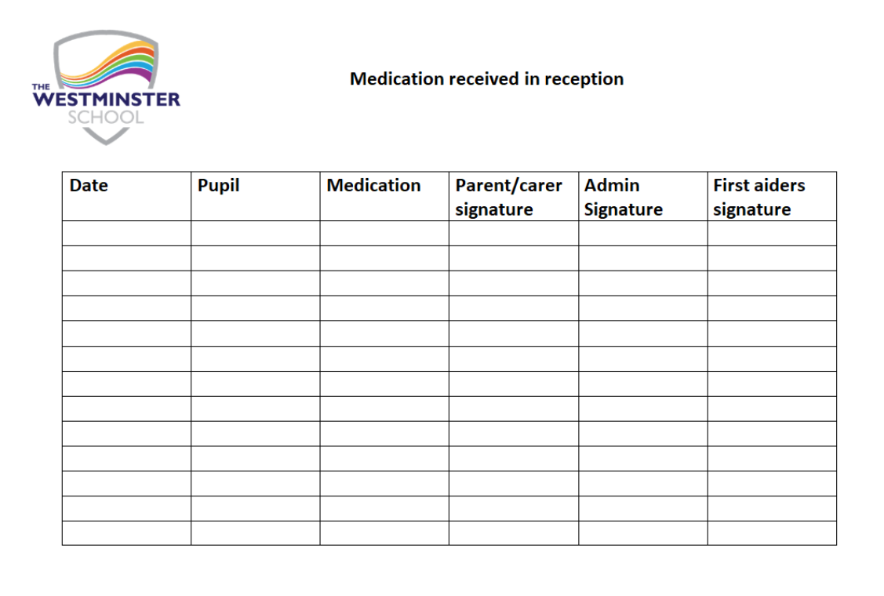
Appendix 12

Appendix 13

MEDICATION TO BE ADMINSTERED AT SCHOOL

Name of pupil
Date of birth
Class

Medication to be administered.
Medication (please complete for each medication) | Dosage | Time Given
Is this medication: (Please tick)
Short Term Use. __________ Long Term Use. __________
Any previous side effects or known allergies to any medications.

(Please tick) Is this medication to be kept in school _____ returned home daily ______
Signature of Parents/Carers _____________________________________
Print _______________________Date form completed____________________

Appendix 14
Paracetamol Medication Consent Form
As a school we have liquid and tablet form of paracetamol that our first aiders can administer if your child develops a temperature or needs some form of pain relief.
Some parents provide their own form of paracetamol for their child.
Please complete the form below to consent to your child receiving paracetamol from school.
Name of pupil:
Date of Birth:
Class:
Please Indicate | Dosage | Time
Tablet or Liquid | Directions will be followed according to age instructions on the back of bottle or packet. | When needed four hours apart with each dose.
Any previous/known allergies to paracetamol or side effects? Please list below:
Signed: _________________________ Print name: ________________________________
Date of form completed: _______________________________________________

Appendix 15
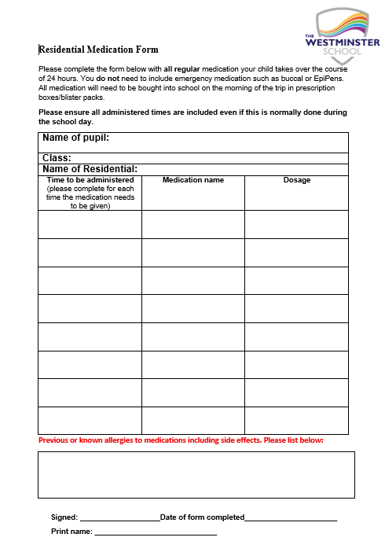

Allergy Management Risk Assessment for Individual Students
Appendix 16
This form should be completed by the setting in liaison with the parents/guardian and the student if appropriate. It should be shared with everyone who has contact with the student. It should be read alongside the student’s Health Care Plan that has been produced the Allergy clinic. A whole school approach is recommended in the management of allergy which would involve all staff to have awareness training in addition to key staff having adrenaline autoinjector (AAI) training.
Child/Young person: Click or tap here to enter text. |  | Date of Birth:
Setting/School: The Westminster School |  | Key Worker/Teacher/Tutor:
Allergies: Click or tap here to enter text.
Are reactions: Ingestion Direct contact: Indirect contact:
G.P  Name  Phone number |  | Clinic/Hospital:  Name: Click or tap here to enter text.  Phone number: Click or tap here to enter text.
Date | Review date: Click or tap here to enter text.
Who is responsible for providing support in school
People involved in writing this plan
Signatures:
Setting Manager/Head teacher:
Date:
Young Person :
I give permission for this risk assessment to be shared with anyone who needs this information to keep my child/young person safe.
I give permission for my child’s photograph to be displayed sensitively to keep my child safe.
I give permission for the school’s ‘spare’ AAI to be used on my child in an emergency where anaphylaxis is suspected
Parents: Date: Click or tap here to enter text.

Complete this risk assessment in discussion with the parent/guardian, student if appropriate and medical professional if available. Consider all situations that the student may be in and agree control measures. Use the risk analysis tool at the end of the document to assess probability and impact producing further control measures if necessary. This is intended to be dynamic document and should be updated annually or after an incident or near miss.
Can the student recognise a reaction for themselves?

What have been the symptoms of previous reactions

What are the hazards for each activity? | What are you already doing to control the risks? | Probability | Impact
Medication:
Storage:
Location of child’s medication
Location of generic ‘spare’ AAI

Food and drink:
Break time snacks including drinks

Lunch time:
Hot meals
Sandwiches
Drinks

Events involving food:
Cake sales
Parties
Other PTA events
Drinks

Celebrations: e.g. Birthdays, Easter

Curriculum activities:
Cooking
Creative activities: e.g. junk modelling, pasta
Music: instrument sharing (cross contamination issue)

Science activities:
PE:
Indoor
Outdoor
Forest Schools
Playtime:
Playground
Field

Offsite activities:
Curriculum visitors
Day trips

Residential visits
Other:

This must be completed for any activity that is medium with the aim of bringing the risk to LOW.

Activities that are High or Extreme must not happen unless action can be implemented to bring the risk to LOW.
Hazard | What further action do you need to take to control the risks? | Who needs to carry out the action? | What is the action needed by? | Completed
Break time snacks
Lunch time

Consequence |  | Minor | Moderate | Major | Critical | Catastrophic
Likelihood | Rare | Low | Low | Low | Low | Low
Likelihood | Unlikely | Low | Low | Medium | Medium | Medium
Likelihood | Possible | Low | Medium | Medium | High | High
Likelihood | Likely | Medium | Medium | High | High | Extreme
Likelihood | Certain | Medium | Medium | High | Extreme | Extreme

Consequence | Minor | Moderate | Major | Critical | Catastrophic
This is the impact of the action being allowed to happen | No reaction | Non anaphylactic reaction | Emergency response required, ambulance and hospital | Emergency response required, ambulance and hospital | Fatal, Death
Likelihood | Definition
Rare | May only occur in exceptional circumstances
Unlikely | Could occur in some circumstances, surprised if happened
Possible | Possible or likely to occur in most circumstances
Likely | Will occur in most circumstances
certain | It is expected to occur, inevitable

Appendix 17
Medication Errors Guidance

Medication Errors

A medication error is an incident where there has been an error in the process of preparing, dispensing, administering, monitoring or recording information about medicines. Staff must make every effort to ensure medication is administered and recorded accurately and appropriately.

This document provides guidelines as to how errors will be addressed with individual staff members.

All medication errors must be dealt with transparently, they must be:
• Reported to a member of SLT immediately
• Recorded on CPOMS.
• Appropriate medical advice must be sought.
If a pupil has sustained harm as a result of the error, then the incident must be reported to the LADO.

The School’s Procedures for Managing Children Protection Allegations/Concerns Against Staff must be followed.

Other examples of where these procedures will be followed are when an error has:

- Resulted in harm to pupil.
- Has not been reported within specified time or there are integrity issues.
- There is evidence of misconduct.
- There is evidence of significant recklessness or clear intentional deviation from procedural
guidance.

Whenever an error has been made, the member of staff will be suspended from administering medication until a full review is completed by the HR Manager.

Procedures following Medication Errors

- Suspend from medication duty until full review has been completed to identify the cause of the error and take action to prevent this happening again.
- Ensure member of staff understands the Supporting Pupils with Medical Conditions Policy.
- Make a record in StaffSafe and issue a letter of expectation or follow the Disciplinary Policy.
- Consider whether there are any organisational or process issues that needs to be addressed to prevent recurrence.
- Carry out risk assessment with member of staff.
- There must be learning outcomes, retraining and an action plan for the staff involved.
- Medication duties reinstated following the Executive Head Teacher’s authorisation and
confirmation that any identified actions were completed.
Emergency Kit Bag Checklist for Off-Site visits
Appendix 18

An emergency kit bag should be taken with you on every off-site visit. Please only take a bleed kit or a portable defibrillator if the site you are going to does not have access to them. Emergency AAI’s and Inhalers/spacers are now mandatory to take on your visits.
Please use the check list to support your visit
Equipment/Medication | Yes/No | Destination | Equipment/Medication used on visit | Staff sign out signature | Staff sign in signature
Portable defibrillator

Emergency AAI

Emergency Inhaler

Emergency Spacers

Large First aid kit

Bleed Kit

Ambulance style bag

