

Approved by Governing Body on: | 13/10/2026
Signed by Chair of Governors: | 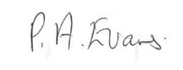
Executive Head Teacher: | O M Flowers
Lead Personnel: | J Flowers
Date of Review: | 13/10/2027



Child Protection and Safeguarding Policy
2026-2027
Building foundations and providing opportunities to create confident,
aspirational, and independent members of our community.
www.thewestminsterschool.co.uk

Contents

- Introduction and definitions

- Statutory Framework

- Roles and Responsibilities

- Family Help

- Abuse and Neglect

- Child on Child Abuse (including abuse in intimate personal relationships between peers and harassment and violence)

- Sexual Harassment and Sexual Violence

- Safeguarding Pupils/Students who are vulnerable to Extremism

- Safeguarding pupils/students who are vulnerable to exploitation(criminal, sexual or otherwise), modern slavery, forced marriage, honour-based abuse , female genital mutilation or trafficking

- Safeguarding Pupils/Students who are vulnerable to homelessness

- County Lines and Criminal Activity

- Serious Violence

- Young Carers

- Safeguarding Pupils/Students with family members in prison

- Children required to give evidence in court

- Contextual Safeguarding

- Children absent or missing from education

- Alternative provision

- Work Experience

- Private Fostering

- Safeguarding children with medical conditions

- Online Safety and Personal Electronic Devices, including filtering and monitoring

- Dealing with a Disclosure

- Making a Referral, Early Help

- Confidentiality

- Communication with Parents

- Record Keeping

- Allegations Involving School Staff/Volunteers

- Supply Staff

- Protecting yourself against allegations of abuse

- Physical Interventions

- Training

- Statutory Policies

- Other Recommended Safe Environment Policies

- Useful Telephone Numbers

- Useful links offering support and guidance

Appendix A Definitions of Abuse and Neglect
Appendix B Child Sexual Exploitation and Female Genital Mutilation
Appendix C Indicators of Vulnerability to Radicalisation
Appendix D Safer Guidelines
Appendix E Process Map
Appendix F Referral Flowchart
Appendix G Preventing Violent Extremism – Roles and Responsibilities of the Single
Point of Contact (SPOC)
Appendix H Making or sharing of nudes or semi-nude
Appendix I Aided Language Displays to support pupil voice for pupils with speech and language difficulties
Appendix J Step up/Step-down Flowchart

Statement of Intent
This School recognises its responsibility to promote, protect and safeguard the welfare of the children and young people entrusted to its care by establishing a safe and trusting environment in which children can learn and develop. The policy applies to all pupils at The Westminster School between the ages of 7-19 whose care and education comes within the remit of this school.
The staff and Governing Board of this School are committed to establishing and maintaining an environment where children feel secure, are encouraged to talk, are heard and feel listened to. We will ensure that children know that there are adults in the School who they can approach if they are worried and that the principles of confidentiality are made clear to children and young people. The school promotes a positive, supportive and secure ethos, giving pupils a sense of being valued.
Children with special educational needs or disabilities (SEND) or certain medical or physical health conditions can face additional safeguarding challenges both online and offline. This policy reflects that all of our children have SEND and our policy reflects the additional barriers that can exist when recognising abuse, neglect and exploitation.
All staff and stakeholders will adopt a zero-tolerance approach, and even if there are no reported cases, staff must not take the view that it does not happen in our setting.
The Designated Safeguarding Lead will ensure that the school’s Child Protection Policy is put on the agenda of the Governing Board once a year for discussion, monitoring, review and renewal. In this way the Governing Body authorises the DSLs for Child Protection to carry out his/her responsibilities as outlined in the statutory responsibilities.
Key contacts in school:

Role | Name | Contact details
Designated Safeguarding Leads | Joanne Flowers  Gemma Webb | 07973401292  07791 608490
Deputy Designated Safeguarding Leads | Sarah Southall  Leeanne Hocknull  Katy Harper | 07496290629  07951645075  0121 561 6884
PREVENT Lead | Joanne Flowers | 07973401292
Designated Lead for Children we care for | Gemma Webb | 07791 608490
Executive Headteacher | Oliver Flowers | 0121 561 6884
Head of School | Joanne Flowers | 07973401292
Mental Health Lead | Joanne Flowers | 07973401292
Online safety Lead | Oliver Flowers | 0121 561 6884
Relationship, Sex and Health Education Lead | Emma Payne and Amy Noke | 0121 561 6884

The Governing Board has overall responsibility for ensuring that there are sufficient measures in place to safeguard the children in their establishment. It is recommended that a nominated governor for child protection is appointed to take lead responsibility.

The nominated governor for child protection is:
NAME Pat Evans – 0121 561 6884

- Introduction and definitions

  - This document is the Child Protection Policy for The Westminster School and any extended services that it provides.
  - The terms “children” and “child” refer to anyone under the age of 18
  - For pupils aged 18 or over, the school will follow Local Safeguarding procedures for Adults.
  - Safeguarding and promoting the welfare of children is defined by the Department for Education as:
- protecting children from maltreatment, whether that is within or outside the home, including
online.
- preventing impairment of children’s mental and physical health or development
- Providing help and support to meet the needs of children as soon as problems emerge.
- ensuring children are growing up in circumstances consistent with the provision of safe and effective care and taking action to enable all children to have the best outcomes.
  - In accordance with the DfE’s guidance, “Sexual violence and sexual harassment between children in schools and Colleges” (2018), and for the purposes of this policy, the term ‘sexual harassment’ is used within this policy to describe any unwanted conduct of a sexual nature, both online and offline, which violates a child’s dignity and makes them feel intimidated, degraded or humiliated, and can create a hostile, sexualized or offensive environment.
  - For the purpose of this policy, the term ‘sexual violence’ encompasses acts including those pertaining to rape, assault by rape or penetration with an object and sexual assault. According to the Sexual Offences Act (2003), Sexual violence and sexual harassment can occur between children of any age and sex. It can also occur through a group of children sexually assaulting or sexually harassing a single child or group of children. Sexual violence refers to sexual offences and includes rape and sexual assault. Sexual harassment is any ‘unwanted conduct of a sexual nature’ that can occur online and offline. Sexual harassment is likely to: violate a child’s dignity, and/or make them feel intimidated, degraded or humiliated and/or to create a hostile, offensive or sexualised environment. Sexual assault is defined as: A person (A) commits an offence of sexual assault if: s/he intentionally touches another person (B), the touching is sexual, B does not consent to the touching, and A does not reasonably believe that B consents. (NOTE - sexual assault covers a very wide range of behaviour so a single act of kissing someone without consent or touching someone’s bottom/breasts/genitalia without consent, can still constitute sexual assault).
  - The term ‘teaching role’ is defined as planning and preparing lessons and courses for children; delivering lessons to children; assessing development, and reporting on the progress and attainment of children. These activities are not teaching work if the person carrying out the activity does so subject to the direction and supervision of a qualified teacher or other person nominated by the Headteacher to provide such direction and supervision.
  - Child protection is a part of safeguarding and promoting welfare. It refers to the activity that is undertaken to protect specific children who are suffering, or are likely to suffer, significant harm.
  - This policy applies to all staff (teaching and non-teaching), governors and volunteers, temporary and supply/visiting staff working in the school. It will be reviewed annually by the Governing Body and is in line with the expectations of Ofsted which inspects safeguarding arrangements as part of the School’s Leadership and Management.
  - The principles embedded in this policy link into other policies relating to Anti Bullying policy, Attendance policy, Behaviour and Wellbeing Policy, Drugs and Substance Misuse, E-Safety, Health and Safety, Intimate Care, Safer Recruitment, Supporting Pupils with Medical Conditions, Whistleblowing, Staff Code of Conduct, SEN Information Report and the Radicalisation and Extremism policy.
All staff have received, read and understood Keeping Children Safe in Education September 2026 Part 1 (full version).
2. Legal Framework
This policy reflects and acts in accordance with all relevant legislation and statutory guidance including the following:
2.1 Legislation
- The Children Act 1989
- The Children Act 2004
- Childrens Wellbeing and Schools Act (2026)
- Safeguarding Vulnerable Groups Act 2006
- The Education (School Teachers Appraisal ) (England) Regulations 2012
- Sexual Offences Act 2003
- Equality Act 2010
- Counter Terrorism and Security Act (2015)
- The Prevent Duty
- General Data Protection Regulation (Data Protection Act 2018)
- Domestic Abuse Act 2021
- Section 5B of the Female Genital Mutilation Act 2003
- Forced marriage (civil protection) Act (2007)
- Apprenticeships, Skills, Children and Learning Act 2009
- The Childcare (disqualification) Regulations (2018)
- Voyeurism (Offenders) Act (2019)
- The Education Act 2002 (section 175/157)
  - Section 175 of the Education Act 2002 requires local education authorities and the governors of maintained schools and further education (FE) colleges to make arrangements to ensure that their functions are carried out with a view to safeguarding and promoting the welfare of children.
  - Section 157 of the same act and the Education (Independent Schools Standards) (England) Regulations 2003 require proprietors of independent schools (including academies and city technology colleges) to have arrangements to safeguard and promote the welfare of children who are pupils at the school.
- Education and Training (Welfare of Children) Act 2021
- Children and Social Work Act (2017)
- General Data Protection legislation (2018)
- DfE Statutory guidance on Children Missing Education

2.2 Statutory Guidance
- The Prevent Duty (DfE 2015)
- Working Together to Safeguard Children (DfE2026)
- Disqualification under the Childcare Act (DfE 2006)
- Multi Agency statutory Guidance on female Genital Mutilation (HM Govnt 2020)
- Multi Agency statutory Guidance for dealing with forced marriage and Multi -Agency practice guidelines: Handling cases of forced marriage (2022)
- Keeping Children Safe in Education (September 2026)

2.3 Non Statutory guidance
- Information sharing advice for safeguarding practitioners (DfE 2018)
- What to do if you’re worried a child is being abused: advice for practitioners (DfE 2015)
- Teachers Standards (DfE 2021)
- Recruiting teachers from Overseas (DfE 2022)
- Virginity testing and hymenoplasty: multi agency guidance (DHSC 2022)
- Sharing nudes and semi nudes: advice for education settings working with children and young people (DfE 2020)
- Mental Health and Behaviour in Schools: Departmental Advice
- Sexual violence and sexual harassment between Children in Schools and Colleges advice document (OFSTED June 2021)
- Searching, Screening and Confiscation: Advice for Schools (DfE July 2022)
- Mult-agency Practice Principle for responding to child exploitation and extra-familial harm
- Additional links to resources and information (Child on child sexual violence and sexual harassment, Generative AI in Education, Gender questioning children) can be found in KCSIE 2026.
- Restrictive Interventions, including the use of Reasonable Force in Schools Guidance. (2026)

2.4 School Policies
- Allegations of Abuse Against Staff
- Anti-Bullying Policy
- Attendance Policy (includes Children Missing Education)
- Behaviour (Wellbeing and Engagement) Policy
- CCTV Policy
- Data Protection Policy for School staff
- Domestic Abuse Policy (to include Operation Encompass)
- E-Safety and Acceptable use Policy
- Intimate Care Policy
- Missing Child Policy
- Parental Use of Social Networking and Internet Sites Policy
- Radicalisation and Extremism Policy
- Safer Recruitment Policy
- Special Educational Needs Information Report
- Staff handbook
- Supporting Pupils with Medical Conditions
- Teacher Appraisal Policy
- Whistleblowing Policy
- Young Carers Policy
2.5 On arrival to the school, all visitors are given an information leaflet highlighting our safeguarding procedures. The Child Protection Policy and Safeguarding Policy is available on the school website or can be made available as a paper copy. “Working Together to Safeguard Children” (2026) requires all schools to follow the procedures for protecting children from abuse which are defined by Sandwell Children’s Safeguarding partnership and have appropriate procedures in place for responding to all concerns of actual or suspected abuse including allegations against members of staff in a position of trust. All visitors are expected to sign in using Inventory which includes an image of the visitor being taken. All visitors are issued with an appropriate lanyard. Staff are aware that if a visitor is wearing a red visitor lanyard, then they should be accompanied at all times on site. A yellow DSB lanyard indicates that the visitor is able to be unaccompanied in school and that we hold their details on our SCR.
2.6 “Keeping Children Safe in Education” 2026 places a number of statutory duties on all schools. A full copy of the document can be accessed by clicking on the following link:
Keeping children safe in education 2026

3. Role and Responsibilities
3.1 The Governing Body
The Governing Board has a duty to:
- Have strategic leadership responsibility for the school’s safeguarding arrangements
- Ensure the child protection policy and procedures are in place and reviewed annually.
- Ensure safe recruitment procedures are in place and reviewed annually.
- Ensure position of trust procedures are in place and reviewed annually.
- Ensure that all Governors have received appropriate safeguarding and child protection, including online/eSafety, training upon their induction and that this training is updated regularly.
- Guarantee that a DSL who is a senior member of school leadership team is appointed and notify the LA of any changes in personnel to this role.
- Appoint one or more deputy DSLs to provide support to the DSLs and ensure that they are trained to the same standard and that the role is explicit in their job description(s).
- Make sure that all staff (paid and unpaid) have an up to date enhanced Disclosure and barring service (DBS) certificate. All those carrying out teaching roles will require and additional check to ensure they are not prohibited from teaching.
- Ensure that enhanced DBS certificates will be in place for all serving governors and newly appointed governors within 21 days of their appointment. All Governors will be subject to section 128 checks
- Confirm a member of the Governing Body (usually the Chair) is nominated to be responsible in the event of an allegation of abuse being made against the Head Teacher.
- Make sure relevant safeguarding/child protection training is accessed by all school staff/volunteers according to their role and responsibilities which also includes specific training in relation to Online risks and eSafety
- Ensure that they receive an annual report from the DSLs regarding safeguarding/child protection work undertaken in the year which is shared with the LA or other appropriate body.
- Confirm that any deficiencies or weaknesses in safeguarding arrangements are remedied without delay, liaising with relevant bodies for support as required.
- Ensure there is a dedicated teacher for Looked after Children who have been appropriately trained. This staff member has a key role in promoting the educational achievement of Looked after Children and Post Looked after children and engaging with the DSLs.
- Support the Designated Member of Staff for Child Protection in carrying out his/her responsibilities as outlined in ‘Keeping Children Safe in Education’, (September 2026) and role in Job Description.
- Guarantee that the school contributes to inter-agency working in line with the statutory guidance.
- Understand the local criteria for action and the local protocol for assessment, and ensure these are reflected in the schools policies and procedures.
- Ensure staff have due regard to relevant data protection principles which allow them to share personal data.
- Make sure all relevant persons are aware of the schools local safeguarding arrangements and the Sandwell Children’s Safeguarding Partnership structure and organisation.
- Guarantee there are procedures in place to handle children’s allegations against other children.
- As schools and colleges increasingly work online, it is essential that children are safeguarded from potentially harmful and inappropriate online material. As such, governing bodies and proprietors should ensure appropriate filters and appropriate monitoring systems are in place.
- Governing bodies and proprietors should ensure that children are taught about safeguarding, including online safety. Schools should consider this as part of providing a broad and balanced curriculum. This may include covering relevant issues for schools through Relationships Education (for all primary pupils) and Relationships and Sex Education (for all secondary pupils) and Health Education (for all pupils in state-funded schools). Preventative education is most effective in the context of a whole-school approach that prepares pupils and students for life in modern Britain and creates a culture of zero tolerance for sexism, racism, misogyny/misandry, homophobia, biphobia, sexual violence/harassment, derogatory behaviour or other forms of physical violence and conflict.
- Be aware of their obligations under the Human Rights Act 1998, the Equality Act 2010 (including the Public Sector Equality Duty23), and their local multi-agency safeguarding arrangements. Under the HRA, it is unlawful for schools and colleges to act in a way that is incompatible with the Convention. The specific convention rights applying to schools and colleges are:
  - • Article 3: the right to freedom from inhuman and degrading treatment (an absolute right)
  - • Article 8: the right to respect for private and family life (a qualified right) includes a duty to protect individuals’ physical and psychological integrity
  - • Article 14: requires that all of the rights and freedoms set out in the Act must be protected and applied without discrimination,25 and
  - • Protocol 1, Article 2: protects the right to education.
- Governing bodies and proprietors should ensure relevant staff have due regard to the relevant data protection principles, which allow them to share (and withhold) personal information, as provided for in the Data Protection Act 2018 and the GDPR. This includes:
  - being confident of the processing conditions which allow them to store and share information for safeguarding purposes, including information which is sensitive and personal, and should be treated as ‘special category personal data’.
  - understanding that ‘safeguarding of children and individuals at risk’ is a processing condition that allows practitioners to share special category personal data. This includes allowing practitioners to share information without consent where there is good reason to do so, and that the sharing of information will enhance the safeguarding of a child in a timely manner but it is not possible to gain consent, it cannot be reasonably expected that a practitioner gains consent, or if to gain consent would place a child at risk.
  - for schools, not providing pupils’ personal data where the serious harm test under the legislation is met
- The Data Protection Act 2018 and GDPR do not prevent the sharing of information for the purposes of keeping children safe. Fears about sharing information must not be allowed to stand in the way of the need to safeguard and promote the welfare and protect the safety of children.
- Ensure that the school has appropriate filtering and monitoring systems in place, adhere to the DfE Guidance and review their effectiveness. This includes:
  - Making sure that the leadership team and staff are aware of the provisions in place, and that they understand their expectations, roles and responsibilities around filtering and monitoring as part of safeguarding training
  - Reviewing the DfE’s filtering and monitoring standards, and discussing with IT staff and service providers what needs to be done to support the school in meeting these standards
  - We aim to meet the DfE filtering monitoring standards and the cyber Security standards for schools and colleges in order to build cyber resilience.
- Take measures to safeguard children by protecting personal information and ensuring school has appropriate cyber security systems in place.

3.2 The Headteacher:
Is responsible (with the lead support of the Designated Safeguarding Lead) for ensuring safeguarding arrangements are implemented effectively in school.
This includes:
- Having the overarching responsibility of ensuring the effectiveness of our school safeguarding arrangements as outlined in this policy.
- Being accountable and reporting to the Governing Body (with the support of the Designated Safeguarding Lead) on the effectiveness of school safeguarding arrangements.
- Supporting and promoting a whole school safeguarding culture and ethos as outlined in our Safeguarding Statement. This includes ensuring that the Senior Leadership Team work effectively together and with the Designated Safeguarding Lead, to ensure a whole school approach to safeguarding.
- Take the lead role in Ensuring Safe Practice; including ensuring staff are knowledgeable and confident in their safeguarding practice; including making sure that their practice is in line with national and local requirements. The Headteacher is also the lead person responsible for receiving, managing, and referring to/liaising with the Local Authority Designated Officer (with the support of the Designated Safeguarding Lead) or any other authorities regarding allegations of abuse made against staff or other organisations/individual who use school premises.
- Enabling the Designated Safeguarding Lead and any deputy(ies) to carry out their roles effectively. This means ensuring they are given sufficient time, training, support, resources, including cover arrangements where necessary.
- Ensuring that all school policies including safeguarding policies and procedures and those required to be in place, are implemented and followed by all staff.
- Ensure the procedures for Filtering and Monitoring are robust, regularly monitored and fit for purpose relating to the changing eSafety landscape. Their effectiveness should be reviewed at least Annually. They should include checks that filtering is working appropriately on all internet-connected devices in all relevant locations, and a record should be kept of these checks. They should ensure that the leadership team and relevant staff have an awareness and understanding of the provisions in place and manage them effectively and know how to escalate concerns when identified.
- Coordinate a review of the Schools Filtering and Monitoring systems and report this to the Governing Board.

3.3 The Designated Safeguard Lead
It is the role of the Designated Safeguarding Lead for Child Protection to:
- Ensure that he/she receives training at least every two years to keep his or her
knowledge and skills up to date and this should be refreshed annually.
- Ensure that all staff who work with children undertakes appropriate training to equip them to carry out their responsibilities for safeguarding children and that this is refreshed annually which will enable them to recognise the signs and symptoms of abuse including, but not limited to, Domestic Abuse (DA), Child Sexual Exploitation (CSE), Child Criminal Exploitation (CCE), Female Genital mutilation (FGM), Honour-based Violence (HBV), Sexual violence (SV) and Forced Marriage (FM). This training should be updated bi-annually or as appropriate.
- All staff should receive regular and updated child protection and safeguarding training. Updates should be provided for staff throughout the year (for example, via email, e-bulletins, staff meetings)
- Ensure there is an effective induction in safeguarding and child protection for all adults working in the school, be they staff or volunteers, including supply agency staff which are to be undertaken no longer than 10 working days of commencement of their contract.
- Make sure that concerns are raised by staff/volunteers when necessary.
- The school will robustly monitor the attendance of children on roll in the school in line with the Attendance Policy and Working together to improve school attendance; Statutory Guidance (August 2024). When a safeguarding/child protection concern is raised, attendance concerns will be shared with partner agencies in accordance with local information sharing protocols
- Ensure that the names and contact details of the DSLs/Deputies are on display for all staff, parents, pupils and visitors to the School.
- Ensure that the Designated and Deputy Safeguarding Leads are not out of school (e.g. at training events) at the same time.
- Ensure that the telephone number for the contact centre is available and easily accessible to staff in case, for any reason, the DSLs and Deputies are not contactable, in order to ensure there is no unwarranted delay in referral.
- Discuss concerns as required with outside agencies e.g. specific agency for single need (e.g. speech and language, inclusion support), early intervention multi-agency (e.g. Family Help process) or Multi Agency Safeguarding Hub (MASH) /existing social worker (child protection/significant harm concerns).
- The designated safeguarding lead and any deputies should liaise with the three safeguarding partners and work with other agencies in line with Working Together to Safeguard Children. NPCC- When to call the police should help designated safeguarding leads understand when they should consider calling the police and what to expect when they do.
- Complete all necessary paperwork and correspondence including referral forms to the Family Help Assessment team or MASH with regard to safeguarding and child protection referrals.
- Ensure that the School is represented by a Designated Lead for Child Protection at child protection conferences, core groups and multi-agency meetings about ‘Children in Need’. It is a member of the Safeguarding team who should attend Child Protection Conferences rather than another representative. If no-one can attend apologies must be given and a written report must be submitted prior to the conference.
- Compile and submit a written report regarding children who are subject to child protection conferences. This should be shared with parents before the conference takes place.
- Ensure there is appropriate representation on Core Groups when a child is on a child protection plan. If the most appropriate person is a class teacher, there must be joint working with the Designated Lead – consider appropriate safeguarding supervision arrangements.
- Ensure that relevant staff are informed and advised about appropriate action when a child is subject to a Child Protection Plan.
- Ensure that safeguarding records are kept securely and confidentially (locked and with limited access or secure online).
- Ensure that safeguarding and child protection records are chronologically recorded, with significant incidents or events clearly highlighted. These records should be reviewed regularly and focus on outcomes for the child/children.
- Ensure that records are transferred when a child changes school within 5 days of them starting the new provision.
- Put mechanisms in place to support the Designated Leads for Child Protection in specific regard to their responsibilities .The DSLs will met with the wider Safeguarding team on a weekly basis.
- Keep the School’s SLT, Governors, and Local Authority informed about safeguarding and child protection issues as requested.
- Keep up to date with local plans and the multi-agency arrangement of three safeguarding partners.
- Act as the main point of contact with Sandwell Children’s Trust and with the three safeguarding partners.
- Provide guidance to parents, children and staff about obtaining suitable support.
- Discuss with new parents the role of the DSLs and the role of safeguarding in the school. Make parents aware of the safeguarding procedures used and how to access the Safeguarding and Child Protection Policy.
- Refer cases of Radicalisation to the Channel Programme.
- Hold the details of the LA personal advisor and liaise with them as necessary.
- Ensure all staff, Governors and parents are aware of Operation Encompass.
- Ensure the safeguarding team have a good understanding of the filtering and monitoring processes within the school and they are incorporated into the safeguarding functions of the school.
- Regularly monitor the schools monitoring system Securus and report any concerns through the Safeguard software as part of a weekly review.
- Ensure continuity of safeguarding responsibilities, schools should implement robust cover arrangements for periods when the designated safeguarding lead is unavailable due to illness, leave, or other circumstances. This is managed through a confidential shared email account and CPOMs to ensure that safeguarding concerns are received, monitored, and acted upon without delay.

3.4 All staff members, external providers and volunteers
All staff members, external providers and volunteers have a responsibility to:
- Be alert to the potential abuse of children both within their families and from other sources including members of the School community.
- Safeguard childrens wellbeing and maintain public trust in the teaching profession as part of their professional duties.
- Know who is part of the safeguarding team and how to contact them.
- Support external professionals to engage with pupils using their preferred method of communication
- Maintain appropriate levels of confidentiality when dealing with individual cases.
- Be confident of the processing conditions under relevent data protection legislation, including information which is sensitive and personal, and information that should be treated as special category data.
- Inform the Designated Safeguarding Lead immediately if any member of staff is concerned about a child. There is an absolute responsibility for all members of the school to respond to any suspected or actual abuse of a child in accordance with these procedures.
- Record information regarding the concerns on the safeguarding software as soon as possible and before the end of the day noting the date and time of the concern or disclosure. In the case of a serious concern, the DSLs must be notified immediately to ensure a timely response. If a concern is raised whilst a pupil is off site, the visit leader must phone the School immediately and inform the DSLs of their concern. The DSLs will then be responsible for deciding on the next course of action. A written record must be completed as soon as the staff member returns via the safeguarding software. The recording must be a clear, precise, factual account of the observations. This must be completed before the staff member leaves site. If the concern is raised during an offsite activity and a member of school staff is not present, the external provider must ensure that they telephone the School immediately and inform the DSLs. They should also follow their own safeguarding procedures.
- Be aware that a pupil may not feel ready or know how to tell someone that they are being abused, exploited or neglected and may not recognise their experiences as harmful.
- Be aware of signs and behaviours that may indicate a child has/or is at risk of suffering harm.
- Be aware that a child may need communication aids to support their disclosure.
- Monitor the attendance of children on roll in the school in line with the Attendance Policy. When a safeguarding/child protection concern is raised, attendance concerns will be shared with partner agencies in accordance with local information sharing protocols.
- Challenge senior leaders over any safeguarding concerns, where necessary.
All staff should be aware of the process for community-based Family Help assessments:
- the criteria, including the level of need, for when a case should be referred to Family Help support and services provided at:
• Targeted early help level (under sections 10 and 11 of the Children Act 2004), and
• Statutory services delivered under section 17 of the Children Act 1989 (children in need, including how this applies for disabled children)
- the criteria, including the level of need, for when a case should be referred to local authority children’s social care for assessment and for statutory services under Section 47 of the Children Act 1989 (reasonable cause to suspect a child is suffering or likely to suffer significant harm)
• Section 31 of the Children Act 1989 (care and supervision orders), and
• Section 20 of the Children Act 1989 (duty to accommodate a child)
and clear procedures and processes for cases relating to:
• the abuse, neglect, and exploitation of children
• children managed within the youth secure estate
• disabled children
- Be aware of the filtering and monitoring processes within the school and act accordingly with any specific eSafety or online concerns using the usual school safeguarding reporting mechanisms.
- Be aware of the Family Help process and understand their role in it.
- Teachers have a responsibility to safeguard pupils wellbeing and maintain public trust in the teaching profession as part of their professional duties, as outlined in the Teacher standards.
- Staff will oversee the safe use of electronic and social media by staff and pupils and take immediate action if they are concerned regards any bullying or risky behaviours.
- All staff will be informed of the risks posed by adults or young people who use the internet to bully, groom or abuse children
- All staff will have awareness training and briefings so they are alert to the signs and symptoms of abuse, including those that may signal a child is at risk from or involved with serious crime. They are made aware of the associated risks and understand the measures in place to manage them
- All school and college staff should be particularly alert to the potential need for additional support for a child who is disabled or has certain health conditions and has specific additional needs, has special educational needs (whether or not they have a statutory Education, Health and Care plan), has a mental health need, is a young carer, is pregnant and/or is a parent themselves, has exhibited early signs of abusive, violent and/or harmful behaviours, is showing signs of being drawn in to anti-social or criminal behaviour, including gang involvement and association with organised crime groups or county lines, is frequently missing/goes missing from education, home or care, has been repeatedly removed from the classroom, experienced multiple suspensions, is on a part-time timetable, is at risk of being permanently excluded from schools, colleges and in Alternative Provision or a Pupil Referral Unit.
4. Community Based Early Help assessment
4.1 There may be emerging needs or adversities faced by children and their families that
could be addressed through Family help. Sandwell’s Multi Agency Threshold document
should be used as a guide for what is the most appropriate level of
support for families based on their level of need. Qualified lead practitioners (i.e. not a social worker) who may lead assessments before statutory intervention can continue to lead work with families up to and including section 17.
4.2 The Designated Safeguarding Lead will decide whether the concerns should be referred to children’s social care via the MASH team. If it is decided to make a referral to children’s social care this will be discussed with the parents, unless to do so would place the child at further risk of harm, place a vulnerable adult at risk or compromise any enquiries that may need to be made.
4.3 Staff should be mindful that early information sharing is vital for the effective identification, assessment, and allocation of appropriate service provision, whether this is when problems first emerge, or where a child is already known to local authority children’s social care
4.4 Access to Family Help also includes those with a disability and specific additional needs including “certain health conditions”, children who have a mental health need, are at risk of ‘honour’-based abuse, has a parent in prison (or is affected by parental offending) or are persistently missing from education, children at risk of involvement with county lines, sexual or criminal exploitation, privately fostered.
4.5 Staff should have a greater awareness of the potential for multiple issues overlapping, be vigilant and report this.
4.6 Any child may benefit from Family Help, but all school staff should be alert to the potential need for Family help for a child who:
• is disabled or has certain health conditions and has specific additional needs
• has special educational needs (whether or not they have a statutory Education, Health and Care plan)
• has a mental health need
• is a young carer
• is showing signs of being drawn in to anti-social or criminal behaviour, including gang involvement and association with organised crime groups or county lines
• is frequently missing/goes missing from care or from home
• is at risk of modern slavery, trafficking, sexual or criminal exploitation
• is at risk of being radicalised or exploited
• has a family member in prison, or is affected by parental offending
• is in a family circumstance presenting challenges for the child, such as drug and alcohol misuse, adult mental health issues and domestic abuse
• is misusing alcohol and other drugs themselves
• has returned home to their family from care
• is at risk of so-called ‘honour’-based abuse such as Female Genital Mutilation or Forced Marriage
• is a privately fostered child
• is persistently absent from education, including persistent absences for part of the school day.
5. Abuse and Neglect
5.1 All staff and volunteers should be aware that the main categories of abuse are:
- Physical abuse
- Emotional abuse
- Sexual abuse
- Neglect

5.2 “Abuse” is defined as a form of maltreatment of a child which involves inflicting harm or failing to act to prevent harm. Harm can include ill treatment that is not physical as well as the impact of witnessing the ill treatment of others – this can be particularly relevant, for example, in relation to the impact on children of all forms of domestic abuse. Children may be abused in a family, institutional or community setting by those known to them or by others, e.g. via the internet. Abuse can take place wholly online, or technology may be used to facilitate offline abuse. Children may be abused by one or multiple adults or other children. All staff and volunteers should be concerned about a child if he/she presents with indicators of possible significant harm – see Appendices A,B and C for details.
5.3 All staff should have an awareness of safeguarding issues, some of which are listed below. All staff should be aware that safeguarding incidents and/or behaviours can be associated with factors outside the school or college and/or can occur between children outside of these environments. All staff, but especially the designated safeguarding lead (and deputies) should consider whether children are at risk of abuse or exploitation in situations outside their families. Extra-familial harms take a variety of different forms and children can be vulnerable to multiple harms including (but not limited to) sexual exploitation, criminal exploitation, and serious youth violence. Staff should be aware that behaviours linked to the likes of drug taking, alcohol abuse, truanting and making or sharing of nudes or semi-nudesput children in danger. All staff will be aware that technology is a significant component in many safeguarding and wellbeing issues, including online abuse, cyberbullying, and the making or sharing of nudes or semi-nude images.
Safeguarding issues can include, but are not limited to;
- bullying including cyberbullying
- children missing education
- child missing from home or care
- child sexual exploitation (CSE)
- domestic abuse
- drugs
- fabricated or induced illness
- faith abuse
- female genital mutilation (FGM)
- forced marriage
- gangs and youth violence
- gender-based violence/violence against women and girls (VAWG)
- hate
- mental health
- missing children and adults
- Online safety
- Child on child abuse (including harassment and violence)
- private fostering
- preventing radicalisation
- relationship abuse
- making or sharing of nudes or semi-nudes
- trafficking
- Modern Slavery
- Harmful sexual behaviour, sexual harassment and sexual violence
- Upskirting

5.4 Child sexual exploitation and (CSE) and Child Criminal Exploitation (CCE):
Both CSE and CCE are forms of abuse and both occur where an individual or group takes advantage of an imbalance in power to coerce, manipulate or deceive a child into sexual or criminal activity. Whilst age may be the most obvious, this power imbalance can also be due to a range of other factors including gender, sexual identity, cognitive ability, physical strength, status, and access to economic or other resources. In some cases, the abuse will be in exchange for something the victim needs or wants and/or will be to the financial benefit or other advantage (such as increased status) of the perpetrator or facilitator. The abuse can be perpetrated by individuals or groups, males or females, and children or adults. This can be committed or facilitated by an organised network or gang, and victims may identify as part of this group. The abuse can be a one-off occurrence or a series of incidents over time, and range from opportunistic to complex organised abuse. It can involve force and/or enticement-based methods of compliance and may, or may not, be accompanied by violence or threats of violence. Victims can be exploited even when activity appears consensual and it should be noted exploitation as well as being physical can be facilitated and/or take place online. CCE and CSE can affect children, both male and female, and can include children who have been moved (commonly referred to as trafficking) for the purpose of exploitation. This may constitute modern slavery, and further information is available in the Modern Slavery statutory guidance. In accordance with this guidance, a relevant child protection and modern slavery referral should be completed where a potential victim of CCE or CSE is identified.
CSE can affect any child who has been coerced into engaging in sexual activities. This includes 16- and 17-year-olds who can legally consent to have sex. This can be committed by an individual or an organised network and most sexual abuse is committed by those previously known to the victim. As with CCE, victims are not always recognised and can be criminalised for actions they take whilst under coercion.
5.5 Signs of abusive or neglectful behaviours in carers
In addition to the usual indicators of abuse / neglect, the following abusive behaviours must be considered:
- restraining a child without knowing how to do so safely
- rough handling
- using inappropriate kinds of discipline, such as withholding medication or food, restricting movement or removing essential equipment
- using medication in a way that has not been medically advised, including sedation, heavy tranquillisation
- deliberate failure to follow medically recommended regimes
- misapplication of programmes or regimes
- invasive procedures against the child’s will
- invasive procedures that are carried out by people without the right skills or against a child’s will
- using badly fitting or inappropriate equipment (e.g. callipers, sleep board, inappropriate splinting) which may cause pain or injury
- force feeding
- undignified age or culturally inappropriate intimate care practices.
The NSPCC has published a report which identifies key issues about safeguarding disabled children. It looks at why disabled children are particularly vulnerable; examines the policy context and the current state of safeguarding services in the UK; and sets out recommendations for improving the protection of disabled children. The full report can be found on the NSPCC website at learning.nspcc.org.uk/safeguarding-disabled-children-england
5.6 Mental Health:
- All staff should also be aware that mental health problems can, in some cases, be an indicator that a child has suffered or is at risk of suffering abuse, neglect or exploitation. They can, in some cases, develop into safeguarding concerns. This could include self-harm, suicidal ideation or risk of suicide.
- Only appropriately trained professionals should attempt to make a diagnosis of a mental health problem. Staff however, are well placed to observe children day-to-day and identify those whose behaviour suggests that they may be experiencing a mental health problem or be at risk of developing one. Potential warning signs could include significant changes in behaviour, ongoing difficulty sleeping, withdrawing from social situations, not wanting to do things they usually like, and physical signs of self-harm or neglecting themselves.
- Where children have suffered abuse and neglect, or other potentially traumatic adverse childhood experiences, this can have a lasting impact throughout childhood, adolescence and into adulthood. It is key that staff are aware of how these children’s experiences, can impact on their mental health, behaviour and education.
- If staff have a mental health concern about a child that is also a safeguarding concern, immediate action should be taken, following the child protection policy and speaking to the designated safeguarding lead or a deputy. If staff feel that a child is in danger, they should call 999 or arrange for them to be taken to A&E immediately by a parent/carer or other suitable person. If a child needs help urgently for their mental health, but it's not an emergency, staff can get help from NHS 111 online or call 111 and select the mental health option.
6. Child on Child Abuse (including abuse in intimate personal relationships between peers and harassment and violence)
All staff should be aware that safeguarding issues can manifest themselves via child on child abuse. This is most likely to include, but may not be limited to, bullying (including cyberbullying), gender based violence/sexual assaults, abuse in intimate personal relationships, and making or sharing of nudes or semi-nudes. Staff should follow the child protection referral procedures if they suspect child on child abuse.
All staff will be aware that child-on-child abuse can occur between pupils of any age and gender, both inside and outside of school, as well as online. All staff will be aware of the indicators of child-on-child abuse, how to identify it, and how to respond to reports. All staff will also recognise that even if no cases have been reported, this is not an indicator that child-on-child abuse is not occurring. All staff will speak to the DSLs if they have any concerns about child-on-child abuse. All staff will understand the importance of challenge inappropriate behaviour between peers, and will not tolerate abuse as “banter” or “part of growing up”. Child on Child abuse is a safeguarding issue for both victim and alleged perpetrator, it is preventable and it may involve serious physical harm or threats involving weapons.
As set out in Part one of the KCSIE guidance, all staff working with children are advised to maintain an attitude of ‘it could happen here’, and this is especially important when considering child-on-child abuse.
6.1 At The Westminster School we continue to ensure that any form of abuse or harmful behaviour is dealt with immediately and consistently to reduce the extent of harm to the young person, with full consideration to impact on that individual child’s emotional and mental health and well-being.
6.2 Children and young people may be harmful to one another in a number of ways which would be classified as child-on-child abuse. The purpose of this policy is to explore the many forms of child-on-child abuse and include a planned and supportive response to the issues.
6.3 Framework and Legislation
This policy is supported by the key principles of the Children’s Act (1989), Working Together to Safeguard Children (2026) and Keeping Children Safe in Education (2026).
6.4 Introduction to abuse and harmful sexual behaviour (HSB)
Abusive behaviour can happen to pupils in schools and settings and it is necessary to consider what abuse is and looks like, how it can be managed and what appropriate support and intervention can be put in place to meet the needs of the individual and what preventative strategies may be put in place to reduce further risk of harm.
HSB can occur between two or more children of any age and sex, from primary through to secondary stage and into college. It can occur also through a group of children towards a single child or towards another group of children. HSB exists on a continuum and may escalate into sexual harassment or sexual violence, it can occur online or face-to-face (both physically and verbally) and is never acceptable. Schools and colleges should be aware of the importance of:
- making clear that there is a zero-tolerance approach to sexual harassment and sexual violence; that it is never acceptable, and it will not be tolerated. It should never be passed off as “banter”, “just having a laugh”, “a part of growing up” or “boys being boys”. Failure to do so can lead to a culture of unacceptable behaviour, misogyny, an unsafe environment and in worst case scenarios, a culture that normalises abuse, leading to children accepting it as normal and not coming forward to report it,
- recognising, acknowledging, and understanding the scale of HSB, sexual harassment and sexual violence and that even if there are no reports it does not mean it is not happening, it may be the case that it is just not being reported,
- recognising the escalatory nature of misogyny and the benefits of early identification to support their approach to minimising the risk of HSB, sexual harassment and sexual violence,
- challenging behaviours, potentially criminal in nature, such as grabbing bottoms, breasts and genitalia, pulling down trousers, flicking bras and lifting up skirts. Dismissing or tolerating such behaviours risks normalising them, and
- taking a safeguarding approach in response to all incidents involving the sharing of nude or semi-nude images, regardless of whether they are consensual or non-consensual. All such incidents require a safeguarding response, with a proportionate approach that considers the age, development, and circumstances of the children involved, as well as any elements of coercion, exploitation or vulnerability.
Children who are victims of HSB, sexual harassment or sexual violence wherever it happens, may find the experience stressful and distressing. This will, in all likelihood, adversely affect their educational attainment and will be exacerbated if the alleged perpetrator(s) attends the same school or college.
Whilst any report of HSB, sexual harassment or sexual violence should be taken seriously, staff should be aware it is more likely girls will be the victims of sexual harassment and sexual violence and more likely it will be perpetrated by boys. Children with disabilities are also three times more likely to be abused than their peers.
Ultimately, it is essential that all victims are reassured that they are being taken seriously and that they will be supported and kept safe.
6.5 Types of abuse
There are many forms of abuse that may occur between peers and this list is not exhaustive. Each form of abuse or prejudiced behaviour is described in detail followed by advice and support on actions to be taken.
Physical abuse e.g. (biting, hitting, kicking, hair pulling etc.)
Physical abuse may include, hitting, kicking, nipping, shaking, biting, hair pulling, or otherwise causing physical harm to another person. There may be many reasons why a child harms another and it is important to understand why a young person has engaged in such behaviour, including accidently before considering the action or punishment to be undertaken. Such physical abuse can incorporate online abuse which facilitates, threatens and/ or encourages physical abuse. Children may also cause harm to other family members, often referred to as child to parent or care giver abuse
Sexually harmful behaviour/sexual abuse e.g. (inappropriate sexual language,
touching, sexual assault etc.)
Sexually harmful behaviour from young people is not always contrived or with the intent to harm others. There may be many reasons why a young person engages in sexually harmful behaviour and it may be just as distressing to the young person who instigates it as well as the young person it is intended towards. Sexually harmful behaviour may range from inappropriate sexual language, inappropriate role play, to sexually touching another or sexual assault/abuse. This can also include causing someone to engage in sexual activity without consent, such as forcing someone to strip, touch themselves sexually, or to engage in sexual activity with a third party. Such sexual abuse can incorporate online abuse which facilitates, threatens and/ or encourages sexual violence.
Inappropriate sexualised behaviour should always be reported to a DSLs who will decide on the best course of action.
Bullying (physical, name calling, homophobic etc.)
Bullying is unwanted, aggressive behaviour among school aged children that involves a real or perceived power imbalance. The behaviour is repeated, or has the potential to be repeated, over time. Both young people who are bullied and who bully others may have serious, lasting problems. Bullying can include prejudiced based and discriminatory bullying.
In order to be considered bullying, the behaviour must be aggressive and include:
- An Imbalance of Power: Young people who bully use their power—such as physical strength, access to embarrassing information, or popularity—to control or harm others. Power imbalances can change over time and in different situations, even if they involve the same people.
- Repetition: Bullying behaviours happen more than once or have the potential to happen more than once.
Bullying includes actions such as making threats, spreading rumours, attacking someone physically or verbally or for a particular reason e.g. size, hair colour, gender, sexual orientation, and excluding someone from a group on purpose.

Cyber bullying
Cyberbullying is the use of phones, instant messaging, e-mail, chat rooms or social networking sites such as Facebook and Twitter to harass threaten or intimidate someone for the same reasons as stated above.
It is important to state that cyber bullying can very easily fall into criminal behaviour under the Malicious Communications Act 1988 under section 1 which states that electronic communications which are indecent or grossly offensive, convey a threat or false information or demonstrate that there is an intention to cause distress or anxiety to the victim would be deemed to be criminal. This is also supported by the Communications Act 2003, Section 127 which states that electronic communications which are grossly offensive or indecent, obscene or menacing, or false, used again for the purpose of causing annoyance, inconvenience or needless anxiety to another could also be deemed to be criminal behaviour.
If the behaviour involves the use of making or sharing of nudes or semi-nudes of young people under the age of 18 then this is also a criminal offence under the Sexual Offences Act 2003. Outside of the immediate support young people may require in these instances, the school will have no choice but to involve the police to investigate these situations.
Domestic Abuse
Domestic abuse can be psychological, physical, sexual, financial or emotional. Children can be victims of domestic abuse. They may see, hear or experience the effects of abuse at home and/or suffer domestic abuse in their own intimate relationships (teenage relationship abuse – including physical, sexual, emotional abuse, and stalking). All of which can have a detrimental and long-term impact on their health, well-being, development, and ability to learn. Harm can include ill treatment that is not physical as well as the impact of witnessing ill treatment of others. This can be particularly relevant, for example, in relation to the impact on children of all forms of domestic abuse. Children may be abused in a family or in an institutional or community setting by those known to them or, more rarely, by others.
Making or sharing of nudes or semi-nudes is when someone sends or receives a sexually explicit text, image or video. This includes sending ‘nude/semi nude pics’, ‘rude pics’ or ‘nude/semi nude selfies’ and can be consensual or non-consensual. Pressuring someone into sending a nude/semi nude picture can happen in any relationship and to anyone, whatever their age, gender or sexual preference.
However, once the image is taken and sent, the sender has lost control of the image and these images could end up anywhere. By having in their possession, making or sharing of nudes or semi-nudes of a person under 18 on to someone else, young people are not even aware that they could be breaking the law as stated as these are offences under the Sexual Offences Act 2003.
Initiation/Hazing
Hazing is a form of initiation ceremony which is used to induct newcomers into an organisation such as a private school, sports team etc. There are a number of different forms, from relatively mild rituals to severe and sometimes violent ceremonies.
The idea behind this practice is that it welcomes newcomers by subjecting them to a series of trials which promote a bond between them. After the hazing is over, the newcomers also have something in common with older members of the organisation, because they all experienced it as part of a rite of passage. Many rituals involve humiliation, embarrassment, abuse, and harassment.
Prejudiced Behaviour
The term prejudice-related bullying refers to a range of hurtful behaviour, physical or emotional or both, which causes someone to feel powerless, worthless, excluded or marginalised, and which is connected with prejudices around belonging, identity and equality in wider society – in particular, prejudices to do with disabilities and special educational needs, ethnic, cultural and religious backgrounds, gender, home life, (for example in relation to issues of care, parental occupation, poverty and social class) and sexual identity (homosexual, bisexual, transsexual).
Teenage relationship abuse
Teenage relationship abuse is defined as a pattern of actual or threatened acts of physical, sexual, and/or emotional abuse, perpetrated by an adolescent (between the ages of 13 and 18) against a current or former partner. Abuse may include insults, coercion, social sabotage, sexual harassment, threats and/or acts of physical or sexual abuse, emotional abuse and stalking. The abusive teen uses this pattern of violent and coercive behaviour, in a heterosexual or same gender relationship, in order to gain power and maintain control over the partner.
Upskirting
Changes to the Voyeurism (Offences) Act 2019 now criminalises the act of ‘upskirting’ and it is now listed as a form of child on child abuse. Upskirting is defined as a colloquial term referring to the action of placing equipment such as a camera or mobile phone beneath a person’s clothing to take a voyeuristic photograph without their permission. It is not only confined to victims wearing skirts or dresses and equally applies when men or women are wearing kilts, cassocks shorts or trousers. It is often performed in crowded public places, for example on public transport or at music festivals, which can make it difficult to notice offenders.
6.6 Expected action taken from all staff
Although the type of abuse may have a varying effect on the victim and initiator of the harm, these simple steps can help clarify the situation and establish the facts before deciding the consequences for those involved in perpetrating harm.
It is important to deal with a situation of peer abuse immediately and sensitively. It is necessary to gather the information as soon as possible to get the true facts around what has occurred as soon after the child(ren) may have forgotten. It is equally important to deal with it sensitively and think about the language used and the impact of that language on both the children and the parents when they become involved. For example; do not use the word perpetrator, this can quickly create a ‘blame’ culture and leave a child labelled.
In all cases of child-on-child abuse it is necessary that all staff are trained in dealing with such incidents, talking to young people and instigating immediate support in a calm and consistent manner. Staff should not be prejudiced, judgemental, dismissive or irresponsible in dealing with such sensitive matters.
6.7 Gather the Facts
Speak to all the young people involved separately, gain a statement of facts from them and use consistent language and open questions for each account. The easiest way to do this is not to have a line of questioning but to ask the young people to tell you what happened. Only interrupt the young person from this to gain clarity with open questions, ‘where, when, why, who’. (What happened? Who observed the incident? What was seen? What was heard? Did anyone intervene?)
Consider the Intent (begin to Risk Assess)
Has this been a deliberate or contrived situation for a young person to be able to harm another?
6.8 Decide on your next course of action
If you believe any young person has been a victim of child on child abuse (including harassment and violence) you must make a safeguarding referral to your DSLs. Refer to the Child Protection policy for further information about referral procedures.
6.9 For the young person who has been harmed
What support they require depends on the individual young person. It may be that they wish to seek counselling or one to one support via a mentor. It may also be that they feel able to deal with the incident(s) on their own or with support of family and friends. In which case it is necessary that this young person continues to be monitored and offered support should they require it in the future. If the incidents are of a bullying nature, the young person may need support in improving peer groups/relationships with other young people or some restorative justice work with all those involved may be required.
Other interventions that could be considered may target a whole class or year group for example a speaker on cyber bullying, relationship abuse etc. It may be that through the continued curriculum of RSHE and SHaLT that certain issues can be discussed and debated more frequently.
If the young person feels particularly vulnerable it may be that a risk assessment can be put in place for them whilst in school so that they have someone named that they can talk to, support strategies for managing future issues and identified services to offer additional support.
6.10 For the young person who has displayed harmful behaviour
In this circumstance it is important to find out why the young person has behaved in such a way. It may be that the young person is experiencing their own difficulties and may even have been harmed themselves in a similar way. In such cases support such as one to one mentoring or counselling may also be necessary. Particular support from identified services may be necessary through an Family help referral and the young person may require additional support from family members.
Once the support required to meet the individual needs of the young person has been met, it is important that young person receives a consequence for their behaviour. This may be in the form of restorative justice e.g. making amends with the young person they have targeted if this has been some form of bullying. In the cases of sexually harmful behaviour it may be a requirement for the young person to engage in one to one work with a particular service or agency (if a crime has been committed this may be through the police or youth offending service). If there is any form of criminal investigation ongoing it may be that this young person cannot be educated on site until the investigation has concluded. In which case, the young person will need to be provided with appropriate support and education whilst off site.
Even following the conclusion of any investigation the behaviour that the young person has displayed may continue to pose a risk to others in which case an individual risk assessment may be required. This should be completed via a multiagency response to ensure that the needs of the young person and the risks towards others are measured by all of those agencies involved including the young person and their parents. This may mean additional supervision of the young person or protective strategies if the young person feels at risk of engaging in further inappropriate or harmful behaviour.
The school may also choose a consequence such as exclusion or internal exclusion for a period of time to allow the young person to reflect on their behaviour.

6.11 After care
It is important that following the incident the young people involved continue to feel supported and receive help even if they have stated that they are managing the incident. Sometimes the feelings of remorse, regret or unhappiness may occur at a much later stage than the incident. It is important to ensure that the young people do not engage in any further harmful behaviour either towards someone else or to themselves as a way of coping (e.g. self-harm). In which case, regular reviews with the young people following the incident(s) are imperative.
6.12 All staff should have an awareness of safeguarding issues that often overlap and can put children at risk of harm (including but not limited to those listed below). The following behaviours and indicators can be signs that children are at risk:
• drug taking and/or alcohol misuse
• unexplainable and/or persistent absences from education
• serious violence, criminal exploitation (including that linked to county lines), radicalisation, and
• consensual and non-consensual making or sharing of nudes or seminudes
7. Sexual harassment and sexual violence
7.1 Schools and colleges should be aware of the importance of:
• making clear that sexual violence, and sexual harassment is not acceptable, will never be tolerated and is not an inevitable part of growing up;
• not tolerating or dismissing sexual violence or sexual harassment as “banter”, “part of growing up”, “just having a laugh” or “boys being boys”;
• challenging behaviour (potentially criminal in nature), such as grabbing bottoms, breasts and genitalia and flicking bras and lifting up skirts. Dismissing or tolerating such behaviours risks normalising them; and
• understanding that all of the above can be driven by wider societal factors beyond the school and college, such as everyday sexist stereotypes and everyday sexist language.
7.2 Expert and professional organisations are best placed to provide up-to-date guidance and practical support on specific safeguarding issues. For example, information can be found on the TES, MindEd and the NSPCC websites.
7.3 Whilst not the focus of this advice, schools and colleges should be aware that their staff can be victims of sexual violence and sexual harassment. Schools and colleges should have arrangements in place to protect their staff from such abuse, including clear reporting and support mechanisms.
7.4 The initial response to a report from a child is important. It is essential that all victims are reassured that they are being taken seriously and that they will be supported and kept safe. A victim should never be given the impression that they are creating a problem by reporting sexual violence or sexual harassment. Nor should a victim ever be made to feel ashamed for making a report. If staff have a concern about a child or a child makes a report to them, they should follow the school safeguarding referral process.
7.5 Children’s sexual behaviour exists on a wide continuum, ranging from normal and developmentally expected to inappropriate, problematic, abusive and violent. Problematic, abusive and violent sexual behaviour is developmentally inappropriate and may cause developmental damage. A useful umbrella term is “harmful sexual behaviour” (HSB). The term has been widely adopted in child protection and is used in this advice. HSB can occur online and/or face-to-face and can also occur simultaneously between the two. HSB should be considered in a child protection context.
7.6 The Westminster School has a zero tolerance approach to sexual violence and sexual harassment.
More detail can be found in Part Five of KCSIE 2026 – Child-on-child sexual violence and sexual harassment
8. Safeguarding pupils/students who are vulnerable to extremism
8.1 Since the Government published the Prevent Strategy, there has been an awareness of the specific need to safeguard children, young people and families from violent extremism. There have been several occasions both locally and nationally in which extremist groups have attempted to radicalise vulnerable children and young people to hold extreme views including views justifying political, religious, sexist or racist violence, or to steer them into a rigid and narrow ideology that is intolerant of diversity and leaves them vulnerable to future radicalisation.
8.2 The Westminster School follows the 2015 Prevent guidance which is the duty in the Counter Terrorism and Security Act 2015 on specified authorities, in the exercise of their functions, to have due regard to the need to prevent people from being drawn into terrorism.
8.3 The Westminster School values freedom of speech and the expression of beliefs/ ideology as fundamental rights underpinning our society’s values. Both pupils/students and teachers have the right to speak freely and voice their opinions. However, freedom comes with responsibility and free speech that is designed to manipulate the vulnerable or that leads to violence and harm of others goes against the moral principles in which freedom of speech is valued. Free speech is not an unqualified privilege; it is subject to laws and policies governing equality, human rights, community safety and community cohesion.

8.4 The current threat from terrorism in the United Kingdom may include the exploitation of vulnerable people, to involve them in terrorism or in activity in support of terrorism. The normalisation of extreme views may also make children and young people vulnerable to future manipulation and exploitation. The Westminster School is clear that this exploitation and radicalisation should be viewed as a safeguarding concern.
8.5 Definitions of radicalisation and extremism, and indicators of vulnerability to
radicalisation are in Appendix C.

7.6 The Governing Body, the Head Teacher and the Designated Safeguarding Leads will assess the level of risk within the School and put actions in place to reduce that risk. Risk assessment may include consideration of the school’s RE/SHaLT curriculum, the use of school premises by external agencies, integration of pupils by gender and SEN, anti-bullying policy and other issues specific to the school’s profile, community and philosophy.

8.7 When any member of staff has concerns that a pupil may be at risk of radicalisation or involvement in terrorism, they should speak with the DSLs and report their concerns via the safeguarding software. The procedure for reporting such concerns is the same as any other safeguarding concern.
9. Safeguarding pupils/students who are vulnerable to exploitation(criminal, sexual or otherwise), modern slavery, forced marriage, honour-based abuse , female genital mutilation or trafficking

9.1 Our safeguarding policy provides the basic platform to ensure children and young people are given the support to respect themselves and others, stand up for themselves and protect each other. Our School keeps itself up to date on the latest advice and guidance provided to assist in addressing specific vulnerabilities and forms of exploitation.

9.3 Our staff are supported to recognise warning signs and symptoms in relation to specific issues and includes such issues in an age appropriate way in their curriculum. Our School works with and engages our families and communities to talk about such issues.

9.4 It is a crime to carry out any conduct whose purpose is to cause a child to marry before their 18th birthday, even if violence, threats or coercion are not used. This applies to non-binding, unofficial ‘marriages’, as well as legal marriages.

9.5 Our staff are supported to talk to families about sensitive concerns in relation to their children and to find ways to address them together wherever possible.

9.6 Our Designated Safeguarding Person knows where to seek and get advice as necessary.
Where staff have concerns regarding these issues, they should report it to the DSLs immediately. Refer to Appendix B for further information about these types of abuse.

9.7 The National Referral Mechanism (NRM) is the UK’s system for identifying victims of modern slavery and human trafficking. If a first responder106 has concerns that a child may be a potential victim of modern slavery or human trafficking (including through county lines) then a referral should be made to the NRM, as soon as possible. A child’s consent is not needed for a referral to be made.

9.8 Additional guidance can be found in our radicalisation policy.

10. Safeguarding pupils/students who are vulnerable to homelessness
10.1 The DSLs and Deputy DSLs(s) will be aware of the contact details and referral routes in to the Local Housing Authority so that concerns over homelessness can be raised as early as possible.
10.2 Indicators that a family may be at risk of homelessness include the following
- Household debt
- Rent arrears
- Domestic abuse
- Anti-social behaviour
- Any mention of a family moving home because “they have to”

10.3 Referrals to the Local Housing Authority do not replace referrals to social care where a child is being harmed or ay risk of harm. For 16 and 17 year olds, homelessness may not be family based and referral to social care will be made as necessary where concerns are raised.
11. County Lines Criminal Activity
11.1 For the purpose of this policy, ‘County lines criminal activity’ refers to drug networks or gangs grooming and exploiting children to carry drugs and money from urban areas to suburban areas, rural areas and market and seaside towns.
11.2 Staff will be made aware of children with absence marks who may have been trafficked for the purpose of transporting drugs.
11.3 Staff members who suspect a child may be vulnerable to, or involved in, this activity will immediately report all concerns to the DSLs.
11.4 The DSLs will consider referral to the National Referral Mechanism on a case by case basis.
11.5 Indicators that a child may be involved in county lines active include the following:
- Persistently going missing or being found out of their usual area
- Unexplained acquisition of money, clothes or mobile phones
- Excessive receipt of texts or phone calls
- Relationships with controlling or older individuals or groups
- Leaving home without explanation
- Evidence of physical injury or assault that cannot be explained
- Carrying weapons
- Sudden decline in school results
- Becoming isolated from peers or social networks
- Self-harm or significant changes in mental state
- Parental reports of concern

12. Serious Violence
12.1 Serious violence is a continuing safeguarding concern. It may involve physical assault, carrying, threatening with, or using weapons, often in the context of peer conflict or bullying, and it can also be associated with criminal exploitation. Staff should report any concerns about a child carrying or using a weapon (or expressing intent to do so) to the designated safeguarding lead (or a deputy). The designated safeguarding lead should assess the risk to both the individual pupil and others in the school, considering wider information or concerns, and take appropriate action. Depending on the risk, they should put in place a safety and support plan, and where relevant, consider action to de-escalate peer conflict
12.2 Schools play a key role in protecting children from violence, safeguarding victims, as well as those who may be at risk of, or are involved in committing violence (who may also be victims themselves). Staff should be alert to signs that a child may be at risk of or involved in serious violence. These risks are higher for children with disrupted education (e.g. suspensions, permanent exclusions, time in alternative provision) or a history of offending. Schools should also try to be alert to when children might be at highest risk around the school day (for example, immediately after school).
12.3 Early, evidence-based support for those considered at risk, as well as at critical points when concerns emerge, is vital. This includes access to trusted adults, social and emotional skill support, and, where available, targeted interventions such as mentoring or therapeutic support.
13. Young Carers
Schools and colleges should be alert to the needs of young carers, recognising that caring responsibilities can impact on their attendance, attainment, behaviour and wellbeing. Early identification is essential to ensure young carers receive support at the right time and by the appropriate services including additional support from external partners, or local authority and health services.
14. Safeguarding pupils/students with family members in prison
14.1 Children with a family member in prison will be offered pastoral support as necessary
14.2 Children will receive a copy of ‘Are you a young person with a family member in prison’ from Action for Prisoners Families where appropriate and allowed the opportunity to discuss questions and concerns.
15. Children required to give evidence in Court
15.1 Children required to give evidence in criminal courts, either for crimes committed against them or crimes they have witnessed, will be offered appropriate pastoral support.
16. Contextual safeguarding

16.1 Safeguarding incidents can occur outside of school and can be associated with outside factors. School staff will always consider the context of incidents – this is known as contextual safeguarding.

16.2 Contextual safeguarding recognises that the different relationships that young people form in their neighbourhoods, schools and online can feature violence and abuse. Parents and carers have little influence over these contexts, and young people’s experiences of extra-familial abuse can undermine parent-child relationships.

16.3 It is important to remember that children may be vulnerable to multiple harms including (but not limited to) sexual exploitation, criminal exploitation, and serious youth violence

17. Children absent or missing from education

17.1 Definitions:
- Children absent from education are on the school roll, but are regularly not attending
- Children missing from education aren’t on any school roll or being educated elsewhere

17.2 All staff should be aware that children going missing, particularly repeatedly, can act as a vital warning sign of a range of safeguarding possibilities. This may include abuse and neglect, which may include sexual abuse or exploitation and child criminal exploitation. It may indicate mental health problems, risk of substance abuse, risk of travelling to conflict zones, risk of female genital mutilation or risk of forced marriage.

17.3 Early intervention is necessary to identify the existence of any underlying safeguarding risk and to help prevent the risks of a child going missing in future.

17.4 Staff should be aware of the schools unauthorised absence and children missing from education procedures. The school will inform the Local Authority of any child who fails to attend regularly or has been absent without schools permission for a continuous period of 10 days.

17.5 Attendance concerns should be raised with the Attendance Officer.

18. Alternative Provision

18.1 The school will remain responsible for safeguarding the child during their time at an alternative provider.

18.2 When placing a child with an alternative provider, the school will obtain written confirmation that the provider has conducted all relevant safeguarding checks on staff and has appropriate safeguarding policies and procedures in place. This includes written confirmation that the alternative provider will inform the commissioning school of any arrangements that may put the child at risk (i.e. staff changes), so that school can assure itself that appropriate safeguarding checks have been carried out on new staff.
18.3 Schools should always know where a child is based during school hours. This includes having records of the address of the alternative provider and any subcontracted provision or satellite sites the child may attend. They should regularly review the alternative provision placements they make. Where safeguarding concerns arise, the placement should be immediately reviewed, and terminated, if necessary, unless or until those concerns have been satisfactorily addressed.
18.4 The department has issued two pieces of statutory guidance to which commissioners of Alternative Provision should have regard:
• Alternative Provision, and
• Education for children with health needs who cannot attend school

19. Work Experience

19.1 When a child is sent on work experience, the school will ensure that the provider has the appropriate safeguarding policies and procedures in place.

20. Private Fostering

20.1 Where the school becomes aware of a child being privately fostered, they will notify the LA as soon as possible to allow the LA to conduct any necessary checks.

21. Safeguarding children with medical conditions.

21.1 An incident relating to the management of a child or young person’s medical condition (including allergies) would not in and of itself warrant a referral to local safeguarding partners. A safeguarding referral would only be needed where an incident highlighted concern that the child or young person might be at an increased risk of being neglected, abused or exploited by persons inside or outside of their family unit because of their medical condition. This might occur where relevant information about a child or young person’s medical condition is not provided to a school, college or setting, or where they are repeatedly sent without essential medication, thereby putting the individual at risk.
22. Online Safety and Personal Electronic devices including filtering and monitoring
22.1 Staff and pupils will follow the schools E-Safety policy at all ties.
22.2 Through training, all staff members will be made aware of:
- Pupil attitudes and behaviours which may indicate they are at risk of potential harm online.
- The procedure to follow when they have a concern regarding a pupil’s online activity.
22.3 Staff will be aware of the filtering systems in place and will know how to escalate concerns where they are identified. Filtering and monitoring systems protect pupils and staff from harmful and inappropriate content online.

22.4 Harmful content may be legal or illegal, and could include:
- Pornography
- Promotion of self harm and/or suicide
- Misogyny/misandry
- Racism
- Fake news
- Extremist views
22.5 All staff should follow policies, procedures and report any concerns using Safeguard software
22.6 Staff should be familiar with the contents of the Online Safety Policy and know what to do if they have any concerns
22.7 Our approach to online safety is based on addressing the following categories of risk:
- Content – being exposed to illegal, inappropriate, or harmful content, for example: pornography, racism, misogyny, self-harm, suicide, antisemitism, radicalisation, extremism, extreme sexual or physical violence, misinformation, disinformation (including fake news) and conspiracy theories
- Contact – being subjected to harmful online interaction with other users or generative AI applications that simulate this; for example: peer to peer pressure, commercial advertising and adults posing as children or young adults with the intention to groom or exploit them for sexual, criminal, financial or other purposes
- Conduct – online behaviour that increases the likelihood of, or causes, harm; for example, making, sending and receiving explicit images, including those generated using AI and online bullying, and
- Commerce – risks such as online gambling, inappropriate advertising, phishing and or financial scams. If you feel your pupils, students or staff are at risk, please report it to the Anti-Phishing Working Group (https://apwg.org/).
Guidance to understand safety considerations and legal responsibilities if they choose to use Generative AI (either teacher-facing or pupil-facing) can be found at Generative artificial intelligence in education.
22.8 To meet our aims and address the risks above, we will provide a specific eSafety curriculum for our students which is regularly reviewed and updated based on emerging trends and risks.
This portfolio of work can be found in the SHaLT component within the My Community Area of Learning. The areas of coverage include, but are not limited to:
- Educating pupils about online safety as part of our curriculum. For example:
  - The safe use of social media, the internet and technology
  - Keeping personal information private
  - How to recognise unacceptable behaviour online
  - How to report any incidents of cyber-bullying, ensuring pupils are encouraged to do so, including where they’re a witness rather than a victim
- Train staff, as part of their induction, on safe internet use and online safeguarding issues including cyber-bullying, the risks of online radicalisation, and the expectations, roles and responsibilities around filtering and monitoring. All staff members will receive refresher training as required and at least once each academic year
- Make sure staff are aware of any restrictions placed on them with regards to the use of their mobile phone and cameras, for example that:
  - Staff are allowed to bring their personal phones to school for their own use, but will limit such use to non-contact time when pupils are not present
  - Staff will not take pictures or recordings of pupils on their personal phones or cameras
  - Communication is to be made with other members of the school team using a school device or allocated device using Microsoft Teams.
- Make sure all staff, pupils and parents/carers are aware that staff have the power to search pupils’ phones, as set out in the DfE’s guidance on searching, screening and confiscation
- Put in place robust filtering and monitoring systems to limit children’s exposure to the 4 key categories of risk (described above) from the school’s IT systems. This will be completed and reviewed in conjunction with our ICT Service Provider Agilisys and Internet Service Provider LGfL.
- Carry out an annual review of our approach to online safety, supported by an annual risk assessment that considers and reflects the risks faced by our school community. This wil be conducted in conjunction with the 360 Safe Review Tool (https://360safe.org.uk/).
- Provide regular safeguarding and children protection updates including online safety to all staff, at least annually, in order to continue to provide them with the relevant skills and knowledge to safeguard effectively
- Review the child protection and safeguarding policy, including online safety, annually and ensure the procedures and implementation are updated and reviewed regularly
22.9 School expects parents to be aware of, and responsible for, their child’s online interactions when at home. The school will provide regular updates through the text service, email system and newsletter relating to emerging online safety trends.

22.9.1 School should be a mobile phone free environment. The Mobile Phone policy ensure that pupils do not have access to their mobile phone throughout the school day including during lessons, the time between lessons, breaktimes and lunchtime.

23. Dealing with a Disclosure
23.1 Children with disabilities may struggle to let people know they are being harmed. This can be due to difficulties they may have with communication. Other barriers to protecting children with disabilities include confusion of abuse indicators with symptoms of their disability. Children with learning difficulties may find it difficult to recall and recount events that have happened to them or may be more vulnerable to exploitation and abuse as a result of their learning needs. Consideration should be given to how non-verbal communication is interpreted, and by whom. Each child should be assessed carefully and supported where relevant to communicate, using communication facilitation techniques such as Aided Language displays (see Appendix I) or another preferred method of communication
23.2 Where a pupil actually discloses that he/she has been abused all staff (including supply staff and volunteers) the following guidelines must be followed:
RECEIVE
- If a child wants to talk to you, never ask them to come back later. Ask them what they want to talk to you about and, if you are concerned about their welfare, give them the time to speak to you.
- Never promise confidentiality, inform the child that you are happy to talk to them but if they tell you anything that you believe may be putting them at harm that you will have to talk to someone.
- Listen carefully to the child. Do not stop a child who is freely recalling information.
- Where a child is visibly upset or has an obvious injury, It is good practice to ask a child why they are upset or how an injury was caused, or respond to a child wanting to talk to you to help clarify vague concerns and result in the right action being taken.

REACT
- If you need to clarify information ask open-ended questions e.g.” Is there anything you'd like to tell me?", “Can you explain to me…”, Can you describe to me….”
- Never ask leading or suggestive questions e.g. 'Did he/she do anything that they shouldn't have done?'
- Never ask 'accusing' questions e.g.” Why didn't you tell someone earlier?"
- Never criticise the alleged perpetrator, it may be someone that they will continue to live with.
- Never ask the pupil to repeat their disclosure for any other member of staff, it is your responsibility to share the information
- These four factors may compromise enquiries that need to be made later by children’s social care or Police.

REASSURE
- Ensure that the child is aware that they have done the right thing in talking to you and that they have not done anything wrong.
- If you have any concerns that the child has been, or is at risk of harm, you must tell them that you will speak to someone to get help.

RECORD
- Record your concerns on CPOMs as soon as possible afterwards using the words that the child has used.
- Do not record your assumptions and interpretations, just what you heard and saw.
- Do not destroy original notes even if you later write things up more neatly and fully.
- Record the date, time and place of the disclosure.
- Sign (if appropriate) any written records and identify your position in the school setting (if CPOMs isn’t working).
- Do not ask a child to write an account or sign any of your documentation as this may compromise enquiries that need to be made later by children’s social care or Police.
- Any written notes must be retained by the DSLs and uploaded onto CPOMs.
REFER
- Immediately inform the Designated Safeguarding Leads for child protection, Joanne Flowers and Gemma Webb or in their absence the Deputy Designated Safeguarding Leads for child protection, Leeanne Hocknull, Sarah Southall and Abbie Katy Harper, who will be responsible for following the appropriate procedures. In the absence of anyone being available in school, contact Sandwell Childrens Trust on 0121 569 3100, where you will be able to speak to a qualified social worker. If the pupil does not reside in Sandwell, identify the contact number for their home Local Authority from a google search.

23.3 To consult with your Designated Safeguarding Lead for child protection does not mean a referral has been made. This decision is the responsibility of the Designated Safeguarding Lead for child protection who will contact the appropriate agency as and when required.
23.4 If you are unhappy about the response you receive from your Designated Senior
Person for child protection contact the MASH Contact Centre on 0121 569 3100 (Sandwell) or alternative Local Authority where you may be put through to speak to a qualified social worker.
23.5 Referrals should be made to the child’s home authority – that is, the Local Authority in which they reside. Links can be found below:
- Sandwell - https://www.sandwellcsp.org.uk/
- Dudley - https://dudleysafeguarding.org.uk/children/
- Birmingham - https://lscpbirmingham.org.uk/
- Walsall - https://www.mywalsall.org/index.php?view=directory&did=271
- Worcester - https://www.worcestershire.gov.uk/worcestershire-children-first-education-services/support-services/safeguarding-children
23.6 If the referral is for a young adult aged 18 or above, the Adult safeguarding referral procedure should be followed. Details can be found below:
- Sandwell - https://www.sandwell.gov.uk/info/200216/adults_and_older_people/2213/safeguarding_adults
- Dudley - https://dudleysafeguarding.org.uk/adults/
- Birmingham - https://www.birmingham.gov.uk/info/20018/adult_social_care/111/report_possible_abuse_or_neglect_of_an_adult_with_care_and_support_needs
- Walsall - https://www.wcld.co.uk/kb5/walsall/asch/service.page?id=QaCeGrbrHtw

UNDER NO CIRCUMSTANCES SHOULD YOU LEAVE SCHOOL WITHOUT DISCUSSING YOUR CONCERNS WITH SOMEONE.
24. Making a Referral
24.1 A referral involves sharing information in line with Multi Agency Threshold Document to either the Family Help Team (Strengthening families), with the consent of the parents/carers, Multi Agency Safeguarding Hub (MASH) or the Police in matters of immediate risk (see Appendix F).
Parents/carers should be informed if a referral is being made except in the circumstances outlined in communication with parents. (It puts a child at further risk of harm).
24.2 Inability to inform parents for any reason should not prevent a referral
being made to children’s social care via the MASH Service. It would then become a joint decision with Children's Services about how and when the parents should be approached and by whom.
24.3 If low level multi agency support is required for a child and/or their family, the Designated Safeguarding Lead for child protection will, with consent of the parent/carer, refer to the Early Help Team to enable the most appropriate services and support to be identified. This will be targeted multi-agency support to help the family resolve any identified concerns. A lead Practitioner will be identified from the professionals currently working with the family.
24.4 If the concerns are more complex and require statutory intervention then the Designated Safeguarding Lead for child protection will refer the matter to children’s social care via the MASH service where a decision will be made whether any enquiries are needed under Section 17 (child in need enquiry) or Section 47 (child protection enquiry) of the Children Act 1989. A flowchart can be found at Appendix E detailing the referral procedure. A child in need is defined under the Children Act 1989 as a child who is unlikely to achieve or maintain a reasonable level of health or development, or whose health and development is likely to be significantly or further impaired, without the provision of services; or a child who is disabled. Local authorities are required to provide services for children in need for the purposes of safeguarding and promoting their welfare
24.5 If a referral needs to be made for a pupil aged 18 or over, the Adult Safeguarding referral procedure will need to be followed. This is Local Authority specific and details of how to refer can be found on Local Authority websites.
How to make a referral to Childrens Social Care (Sandwell residents)
- Step 1 – Complete a Multi-Agency Referral Form (MARF) and send into the MASH secure email address on the front of the form. Be prepared to give as much of the following information as possible using the SAFER guidelines (see Appendix D).

- Step 2 – If a child is at imminent significant risk of harm/immediate danger (and reporting concerns cannot wait an hour while a MARF is completed) the referrer should consider telephoning 999 and children’s social care’s contact centre (0121 5693100). A MARF will also need to be completed without delay.

Accurately record the action agreed following the referral or that no further action is to be taken and the reasons for this decision noting with whom discussions were held and who made the decisions on the students chronology.
24.6 Concerns re: Terrorism/Radicalisation
Contact can be made with the confidential Anti-Terrorist Hotline 0800 789 321 or contact can be made with the Local Authority;
  - Under 18: Email West Midlands Police at CTU_GATEWAY@west-midlands.pnn.police.uk, Multi-Agency Safeguarding Hub (MASH) at Access_Team@sandwellchildrenstrust.org and Sandwell Council at Prevent_Inbox@sandwell.gov.uk
  - 18 and over: Email West Midlands Police CTU_GATEWAY@west-midlands.pnn.police.uk and Sandwell Council at Prevent_Inbox@sandwell.gov.uk

25. Confidentiality
25.1 Safeguarding children raises issues of confidentiality that must be clearly understood by all staff/volunteers in schools.
25.2 All staff in schools, both teaching and non-teaching staff, have a responsibility to share relevant information about the protection of children with other professionals, particularly children’s social care and the Police.
25.3 If a child wishes to confide in a member of staff/volunteer and requests that the information is kept secret, the member of staff/volunteer will tell the child, in an appropriate manner to the individual needs of the child, that they cannot promise confidentiality and may need to pass the information on to help keep the child or other children safe.
25.4 Staff/volunteers who receive information about children and their families in the course of their work should share that information within the expectations of the school’s confidentiality policy and other relevant policies e.g. the safeguarding and safeguarding and child protection policy and Local Authority procedures
26. Communication with Parents
26.1 The School will always discuss concerns with parents/carers unless to do so would:
- place the child at risk of significant harm or further risk of significant harm
- place a vulnerable adult at risk of harm
- compromise and enquiries that need to be undertaken by children’s social care or the police

26.2 The school will endeavour to ensure that parents have an understanding of the responsibilities placed on the school and staff for safeguarding children.
27. Record Keeping
27.1 The importance of good clear child welfare and child protection record keeping has been highlighted in the learning from serious case reviews. Good up to date record keeping of concerns and action taken is essential for two main reasons:
- It helps schools identify causes for concern at an early stage. Often it is only when a number of seemingly minor issues are seen as a whole, that a pattern can be seen indicating safeguarding or child protection concern.
- It helps schools monitor and manage their safeguarding policy and practice.

27.2 A record of concern, suspicion or allegation should be made at the time of or as soon as possible after the event using the online safeguarding software. Any member of staff receiving a disclosure of abuse from a child or young person, or noticing signs or symptoms of possible abuse in a child or young person, will make a written record within the hour recording the disclosure using the child’s own words, what was said or seen and the location both of the abuse and the disclosure. Dates and times of events should be recorded as accurately as possible.
27.3 A record should be made of any visible marks or injuries to a child that give cause for concern, this may be completed on a body map. The child should not be examined intimately or pictures taken of any injuries/marks.
27.4 All incidents or concerns need to be recorded on the safeguarding software before the end of the working day. If the child is at immediate risk then this should be communicated to a member of the safeguarding team immediately once the child is in a safe place.
27.5 Children MUST NOT be asked to write a written statement themselves or to sign any records.
27.6 A chronology of significant events will be maintained online. 24.7 A clear defensible decision on action will be recorded whether a referral was or was not made to other services.
27.7 The Designated Safeguarding Lead will ensure that all safeguarding records are managed and transferred in accordance with the Education (Pupil Information) (England) Regulations 2005. All Safeguarding files for children moving provision will be transferred within five days of them starting at the new placement.
28 Allegations Involving School Staff/Volunteers (including supply staff, trainee teachers, volunteers, and contractors)
28.1 An allegation relates to an adult who works with children (in a paid or
unpaid capacity) and they have:
- behaved in a way that has harmed or may have harmed a child
- possibly committed a criminal offence against, or related to, a child
- behaved towards a child or children in a way that indicates he or she would pose a risk of harm if they work regularly or closely with children; or
- behaved or may have behaved in a way that indicates they may not be suitable to work with children.

28.2 In these circumstances, the allegation should be taken seriously and the Head Teacher, who has the responsibility for managing allegations against persons in a position of trust in school, should be informed immediately.
28.3 It is not the responsibility of the person receiving the allegation to make any enquiries or discuss the allegation with any one other than the Head Teacher.
28.4 As with all other concerns about the welfare of children, the member of staff receiving the allegation should make a written record of the allegation using the informant's words - including time, date and place where the alleged incident took place, brief details of what happened, what was said and who was present. This record should be signed, dated and immediately passed on to the Head Teacher.
28.5 Under no circumstances should the informant be asked to make a written record of the allegation or asked to sign any documentation. This is the responsibility of the person receiving the allegation.

28.6 The Head Teacher will not investigate the allegation itself, or take written or detailed statements, but will consult with the Local Authority Child Protection Officers, when appropriate, and if necessary, a referral will be made to the LADO (Local Authority Designated Officer). The School reserves the right to use CCTV images to investigate and report allegations (Ref CCTV Policy).
28.7 If the Head Teacher is implicated in the concerns, Chair of Governors should be informed immediately or, in their absence, the Vice Chair.
The Chair of Governors in this school is:
NAME: Pat Evans CONTACT NUMBER: 0121 561 6884
The Vice Chair in this school is:
NAME: Phil Coldicott CONTACT NUMBER: 0121 561 6884
29. Supply staff:
- Whilst schools and colleges are not the employer of supply teachers, they should ensure allegations are dealt with properly. In no circumstances should a school or college decide to cease to use a supply teacher due to safeguarding concerns, without finding out the facts and liaising with the local authority designated officer (LADO) to determine a suitable outcome. Governing bodies and proprietors should discuss with the agency whether it is appropriate to suspend the supply teacher, or redeploy them to another part of the school, whilst they carry out their investigation.
- Agencies should be fully involved and co-operate in any enquiries from the LADO, police and/or children’s social services. The school will usually take the lead because agencies do not have direct access to children or other school staff, so they will not be able to collect the facts when an allegation is made, nor do they have all the relevant information required by the LADO as part of the referral process. Supply teachers, whilst not employed by the school or college, are under the supervision, direction and control of the governing body or proprietor when working in the school or college. They should be advised to contact their trade union representative if they have one, or a colleague for support. The allegations management meeting which is often arranged by the LADO should address issues such as information sharing, to ensure that any previous concerns or allegations known to the agency are taken into account by the school during the investigation.
- When using an agency, schools and colleges should inform the agency of its process for managing allegations. This should include inviting the agency’s human resource manager or equivalent to meetings and keeping them up to date with information about its policies.

29.9 To reduce the risk of allegations, all staff should be aware of safer working practice and should be familiar with the guidance contained in the staff handbook, school code of conduct or Government document ‘Guidance for Safer Working Practice for Adults who work with Children and Young People in Education Settings’.
29.10 If you have safeguarding or child protection concerns relating to the parents/carers of children and you are aware that they work with children, young people or vulnerable adults, you must inform the Headteacher. This will allow for consideration to be given as to whether the position of trust process needs to be applied as a result of ‘Transferrable Risk’.
29.11 If it is decided that the allegation meets any of the three criteria outlined above, procedures will be followed in accordance with inter-Agency Procedures. If it is decided that the allegation does not meet the threshold for safeguarding, it will be handed back to the employer for consideration via the school’s internal procedures. The Head Teacher should, as soon as possible, and after consulting with the Local Authority Designated Officer inform the person against whom the allegation has been made of the concern.
29.12 Low level concerns are those concerns that do not meet the threshold for harm as detailed above but we always take them seriously. They will be dealt with as all allegations/concerns in a timely and appropriate manner. Our management of low level concerns procedure is detailed within our Low level concern policy.
29.11 ‘Staff’ are defined as any person working at The Westminster School and include, but not limited to teaching staff, support staff, supply staff, externally contracted staff, visiting organisations etc.
Further information can be found in our “Procedures for Managing Child Protection Allegations/Concerns Against Staff” Policy.
30. Protecting yourself against Allegations of Abuse
30.1 ‘Keeping Children Safe in Education’ 2026 says that all staff members should be aware of systems within the School which support safeguarding and these should be explained to them as part of staff induction. This includes the School’s various policies such as the Intimate Care Policy, the Behaviour Policy and the Staff Code of Conduct.
30.2 You should seek to keep your personal contact with children under review and seek to minimise the risk of any situation arising in which misunderstandings can occur. The following sensible precautions can be taken when working alone with children:
- Work in a room where there is a glass panel in the door or leave the door open
- Make sure that other adults visit the room occasionally
- Avoid working in isolation with children unless thought has been given to safeguards
- Never give out personal mobile numbers or private email addresses
- Do not give pupils lifts home in your car (unless this has been specifically agreed by senior management) and always have 2 adults in the car.
- Do not arrange to meet pupils outside of school activities
- Never ‘befriend’ or chat to pupils on social network sites
- Under the Sexual Offences Act 2003 it is a criminal offence for anyone working in an education setting to have a sexual relationship with a pupil even when the pupil is over the age of consent but under 18 years of age.
30.3 In the event of an allegation being made against you, further guidance can be found in the LADO Guidance for Employees/Volunteers Subject to POT procedures – January 2019
For more information or advice contact 0121 569 4770 or email sandwell_lado@sandwellchildrenstrust.org or visit Management of Allegations - Sandwell CSP.
31. Physical Interventions
31.1 There are limited circumstances when it is appropriate for staff in schools to use ‘reasonable force’ to safeguard children. The term ‘reasonable force’ covers the broad range of actions used by staff that involve a degree of physical contact to control or restrain children. This can range from guiding a child to safety by the arm, to more extreme circumstances such as breaking up a fight or where a child needs to be restrained to prevent violence or injury. ‘Reasonable’ in these circumstances means ‘using no more force than is necessary for the least amount of time’, the application of which will depend on the circumstances.
31.2 Section 93 of the Education and Inspections Act 2006 enables school staff to use ‘reasonable force’ to prevent a pupil from:
- Committing any offence (or, for a pupil under the age of criminal responsibility, what would be an offence for an older pupil);
- Causing personal injury to, or damage to the property of, any person (including the pupil himself); or
- Prejudicing the maintenance of good order and discipline at the school or among any pupils receiving education at the school, whether during the teaching session or otherwise.
31.3 When using ‘reasonable force’ in response to risks presented by incidents involving children with SEND, mental health problems or with medical conditions, schools should, in considering the risks carefully, recognise the additional vulnerability of these groups. They should also consider their duties under the Equality Act 2010 for example in relation to making reasonable adjustments and their Public Sector Equality Duty. By planning positive and proactive behaviour support, for instance through drawing up individual behaviour plans for more vulnerable children, and agreeing them with parents, schools can reduce the occurrence of challenging behaviour and the need to use ‘reasonable force’.
31.4 Further guidance can be found here: https://assets.publishing.service.gov.uk/media/6943dad6501cdd438f4cf5aa/Restrictive_interventions_including_use_of_reasonable_force_in_schools.pdf
31.5 All Physical (safety) interventions must be recorded in the Bound book and on CPOMs. Parents should also be informed.
31.6 Physical restraint or Safety interventions should be avoided as far as possible and should only be used if there are good reasons for believing that immediate action is necessary to prevent a child or young person causing significant injury or death to themselves or to others, or causing serious damage to property which could lead to someone being significantly injured or killed. Where possible, staff should use Verbal Intervention techniques to support de-escalating behaviour. When deciding if a Safety Intervention approach is needed, staff should use the Risk Decision Matrix to decide on the most appropriate course of action.
32. Training
30.1 All staff members will complete Level 1 safeguarding and child protection training. This will take place every September. Staff members who join mid way through the year will complete online training as designated by the DSLs. All staff are also required to read Keeping Children Safe in Education 2026 – Part 1.
32.2 Induction training will cover:
- The Child Protection and Safeguarding Policy
- The Wellbeing and Engagement Policy
- The Staff Code of Conduct
- The safeguarding response to children who go missing or are absent from education
- The identity of the DSLs and any deputies
- The role of the DSLs and deputy DSLs
- eSafety and Acceptable Use Policy

32.3 Child protection and Safeguarding training will cover Level One content and also cover, as a minimum:
- The issues surrounding sexual violence and sexual harassment
- Contextual safeguarding
- How to keep previously LAC safe
- Child criminal exploitation and the need to refer cases to the National Referral Mechanism
- Online Safety including filtering and monitoring
32.4 The DSLs and their deputies will undergo online safety training to help them recognise the additional risks that children with SEND face online to ensure they have the capability to support these children to stay safe online.
32.5 All staff will have access to a suite of training using the National College platform throughout the year.
33. Statutory School Policies
33.1 A full list of statutory policies can be found at:
Statutory policies for schools and academy trusts - GOV.UK (www.gov.uk)
33.2 A full list of school policies relating to The Westminster School can be found at:
https://thewestminsterschool.co.uk/parents/school-policies/
34. Other Recommended Safe Environment Policies
Anti-bullying | RSHE curriculum
Drugs and substance misuse | Race, Disability and Equality Policy
E-Safety (including Acceptable Use Policies and Use of Digital Images) | Recruitment and selection
First Aid (including management of medical conditions, intimate care)
Management of allegations against staff
Behaviour and Wellbeing
Data Protection and Freedom of Information

35. Useful Telephone Numbers
Sandwell Contact Centre (MASH) – 0121 569 3100
West Midlands Police – 101
Local Authority Child Protection Officers for Education – 07747118729 (Lisa Harvey), 07775360203 (Beverley Need), 07341795787 (Louise Atkinson), 07393009664 (Jemma Jones)
Local Authority Designated Officer – 0121 569 4770
Horizons Exploitation Safeguarding Team – 0121 5692524/8391 or CE_team@sandwellchildrenstrust.org
NSPCC Helpline – 08085000
NSPCC Whistleblowing Helpline – 08000280285
Counter Terrorism Helpline – 0800 789321 or counter.extremism@education.gov
Local Authority Teams:
Tipton Strengthening Families Team – 0121 569 7291
Wednesbury Strengthening Families Team – 0121 569 7294
West Bromwich Central Strengthening Families Team – 0121 569 7293
Oldbury Strengthening Families Team – 0121 569 7295
Rowley Strengthening Families Team – 0121 569 7296
Smethwick Strengthening Families Team – 0121 569 7297

36. Useful links offering support and guidance

Safeguarding issue or category | Link to Guidance/Advice
Abuse | www.gov.uk/government/publications/what-to-do-if-youre-worried-a-child-is-being-abused--2
Abuse | www.gov.uk/domestic-violence-and-abuse
Abuse | www.gov.uk/government/publications/national-action-plan-to-tackle-child-abuse-linked-to-faith-or-belief
Abuse | www.disrespectnobody.co.uk/relationship-abuse/what-is-relationship-abuse/
Bullying | www.gov.uk/government/publications/preventing-and-tackling-bullying
Children and the courts | http://formfinder.hmctsformfinder.justice.gov.uk/ywp-5-11-eng.pdf
Children and the courts | http://formfinder.hmctsformfinder.justice.gov.uk/ywp-12-17-eng.pdf
Children missing from education, home or care | www.gov.uk/government/publications/children-missing-education
Children missing from education, home or care | www.gov.uk/government/publications/children-who-run-away-or-go-missing-from-home-or-care
Children missing from education, home or care | www.gov.uk/government/publications/missing-children-and-adults-strategy
Children with family members in prison | www.nicco.org.uk/
Child Exploitation | www.gov.uk/government/publications/criminal-exploitation-of-children-and-vulnerable-adults-county-lines
Child Exploitation | www.gov.uk/government/publications/child-sexual-exploitation-definition-and-guide-for-practitioners
Child Exploitation | www.gov.uk/government/publications/safeguarding-children-who-may-have-been-trafficked-practice-guidance
Domestic Violence | https://blackcountrywomensaid.co.uk/
Drugs | www.gov.uk/government/publications/drugs-advice-for-schools
Drugs | www.gov.uk/government/publications/drug-strategy-2017
Drugs | www.talktofrank.com/
“Honour Based Abuse” | www.gov.uk/government/collections/female-genital-mutilation
“Honour Based Abuse” | www.gov.uk/government/publications/multi-agency-statutory-guidance-on-female-genital-mutilation
“Honour Based Abuse” | www.gov.uk/forced-marriage
Health and Wellbeing | www.gov.uk/government/publications/safeguarding-children-in-whom-illness-is-fabricated-or-induced
Health and Wellbeing | www.pshe-association.org.uk/curriculum-and-resources/resources/rise-above-schools-teaching-resources
Health and Wellbeing | www.gov.uk/government/publications/supporting-pupils-at-school-with-medical-conditions--3
Health and Wellbeing | www.gov.uk/government/publications/mental-health-and-behaviour-in-schools--2
Homelessness | www.gov.uk/guidance/homelessness-code-of-guidance-for-local-authorities
Online | www.gov.uk/government/groups/uk-council-for-child-internet-safety-ukccis
Private fostering | www.gov.uk/government/publications/children-act-1989-private-fostering
Radicalisation | www.gov.uk/government/publications/prevent-duty-guidance
Radicalisation | www.gov.uk/government/publications/protecting-children-from-radicalisation-the-prevent-duty
Radicalisation | http://educateagainsthate.com/
SENDIASS support for parents | www.sandwellsendiass.co.uk
SEND Code of Practice 0-25 years | www.gov.uk/government/publications/send-code-of-practice-0-to-25
Violence | www.gov.uk/government/publications/advice-to-schools-and-colleges-on-gangs-and-youth-violence
Violence | www.gov.uk/government/publications/strategy-to-end-violence-against-women-and-girls-2016-to-2020
Violence | www.gov.uk/government/publications/violence-against-women-and-girls-national-statement-of-expectations
Violence | www.gov.uk/government/publications/sexual-violence-and-sexual-harassment-between-children-in-schools-and-colleges
Violence | www.gov.uk/government/publications/serious-violence-strategy

Acronyms

COG – Community Operating Group
CCE – Child Criminal Exploitation
CSC – Child Sexual Exploitation
CWCF – Child we care for
DBS – Disclosure and barring service
DfE – Department for Education
DSLs – Designated Safeguarding Lead
FH – Family Help
EHCP – Education, Health and Care Plan
FGM – Female Genital Mutilation
HBA – Honour based abuse
HSB – Harmful Sexual Behaviour
LA – Local Authority
LAC – Looked After Child
PLAC – Previously Looked after child
MARF – Multi Agency Referral Form
MASH – Multi Agency Safeguarding Hub
NPCC – National Police Chiefs Council
NSPCC – National Society for Prevention of Cruelty to Children
RSHE – Relationship, Sex and Health education
SLT – Senior Leadership Team
SCSP – Sandwell Children’s Safeguarding Partnership

Appendix A - Definitions of Abuse and Neglect
Physical Abuse
Physical abuse may involve hitting, shaking, throwing, poisoning, burning or scalding, drowning, suffocating, or otherwise causing physical harm to a child. Physical harm may also be caused when a parent or carer fabricates the symptoms of, or deliberately induces, illness in a child. Children may also cause harm to other family members, often referred to as child to parent or care giver abuse.

Signs of possible physical abuse
Any injuries not consistent with the explanation given for them
- Injuries which occur to the body in places which are not normally exposed to falls or rough games
- Injuries which have not received medical attention
- Reluctance to change for, or participate in, games or swimming
- Bruises, bites, burns and fractures, for example, which do not have an accidental explanation
- The child gives inconsistent accounts for the cause of injuries
- Frozen watchfulness
Possible effects of physical abuse
Physical abuse can lead directly to neurological damage, physical injuries, disability and in extreme cases death. Physical abuse has been linked to aggressive behaviour in children, emotional and behavioural problems and learning difficulties.
Emotional Abuse
Emotional abuse is the persistent emotional maltreatment of a child such as to cause severe and persistent adverse effects on the child’s emotional development.
- It may involve conveying to children that they are worthless or unloved, inadequate, or valued only insofar as they meet the needs of another person.
- It may include not giving the child opportunities to express their views, deliberately silencing them or ‘making fun’ of what they say or how they communicate.
- It may feature age or developmentally inappropriate expectations being imposed on children. These may include interactions that are beyond the child’s developmental capability, as well as overprotection and limitation of exploration and learning, or preventing the child participating in normal social interaction.
- It may involve seeing or hearing the ill-treatment of another.
- It may involve serious bullying (including cyber bullying),
- It may include verbal abuse, such as persistent criticism, belittling, or name-calling, as well as not giving the child opportunities to express their views, deliberately silencing them or ‘making fun’ of what they say or how they communicate.
- causing children frequently to feel frightened or in danger, or
- the exploitation or corruption of children.

Some level of emotional abuse is involved in all types of maltreatment of a child, though it may occur alone.
Signs of possible emotional abuse
- Depression, aggression, extreme anxiety, changes or regression in mood or behaviour, particularly where a child withdraws or becomes clingy
- Obsessions or phobias
- Sudden underachievement or lack of concentration
- Seeking adult attention and not mixing well with other children
- Sleep or speech disorders
- Negative statements about self
- Highly aggressive or cruel to others
- Extreme shyness or passivity
- Running away, stealing and lying
Possible effects of emotional abuse
If a child suffers sustained emotional abuse there is increasing evidence of adverse long-term effects on their development. Emotional abuse has a significant impact on a developing child's mental health, behaviour and self-esteem. It can be especially damaging in infancy and can be as important as the other more visible forms of abuse, in terms of its impact on the child. Domestic violence, adult mental health problems and parental substance misuse may be features in families where children are exposed to such abuse.
Sexual Abuse
Sexual abuse involves forcing or enticing a child or young person to take part in sexual activities, not necessarily involving a high level of violence, whether or not the child is aware of what is happening.
- The activities may involve physical contact, including assault by penetration (for example, rape, oral sex or penetration with an object) or non-penetrative acts such as masturbation, kissing, rubbing and touching outside of clothing.
- They may also include non-contact activities, such as involving children in looking at, or in the production of, sexual images, watching sexual activities,
- encouraging children to behave in sexually inappropriate ways,
- grooming a child in preparation for abuse (including via the internet).

Sexual abuse is not solely perpetrated by adult males. Women can also commit acts of sexual abuse, as can other children.

Child Sexual Exploitation (CSE) is also included in this category and if practitioners believe a child or young person is at risk of or is being sexually exploited then they should complete the CSE screening tool and contact Sandwell’s CSE team.
Signs of possible sexual abuse
- Any allegations made by a child concerning sexual abuse
- The child has an excessive preoccupation with sexual matters and inappropriate knowledge of adult sexual behaviour for their age, or regularly engages in sexual play inappropriate for their age
- Sexual activity through words, play or drawing
- Repeated urinary infections or unexplained stomach pains
- The child is sexually provocative or seductive with adults
- Inappropriate bed-sharing arrangements at home
- Severe sleep disturbances with fears, phobias, vivid dreams or nightmares which sometimes have overt or veiled sexual connotations
- Eating disorders such as anorexia or bulimia.
Possible effects of sexual abuse
Disturbed behaviour including self-harm, inappropriate sexual behaviour, sadness, depression and loss of self-esteem has all been linked to sexual abuse. Its adverse effects may last long into adult life. The severity of the impact on the child is believed to increase the longer the abuse continues, the more serious the abuse, the younger the child at the start, and the closeness of the relationship to the abuser. The child's ability to cope with the experience of sexual abuse, once recognised, can be strengthened by the support of a non-abusive adult carer who believes the child, helps the child understand the abuse, and is able to offer help and protection. Some adults who sexually abuse children were themselves sexually abused as children.
Neglect
Neglect is the persistent failure to meet a child’s basic physical and/or psychological needs, likely to result in the serious impairment of the child’s health or development.
Neglect may occur during pregnancy as a result of maternal substance abuse. Once a child is born, neglect may involve a parent or carer failing to:
- provide adequate food, clothing and shelter (including exclusion from home or abandonment);
- protect a child from physical and emotional harm or danger;
- ensure adequate supervision (including the use of inadequate care-givers); or
- ensure access to appropriate medical care or treatment.
It may also include neglect of, or unresponsiveness to, a child’s basic emotional needs.
Signs of possible neglect
- Dirty skin, body smells, unwashed, uncombed hair and untreated lice
- Clothing that is dirty, too big or small, or inappropriate for weather conditions
- Frequently left unsupervised or alone
- Frequent diarrhoea
- Frequent tiredness
- Untreated illnesses, infected cuts or physical complaints which the carer does not respond to
- Frequently hungry
- Overeating junk food
Possible effects of neglect
Neglect can seriously impair a child's health, physical and intellectual growth and development, and can cause long term difficulties with social functioning, relationships and educational progress. Extreme cases of neglect can cause death.

Appendix B
Child Sexual Exploitation
Child sexual exploitation (CSE) is a form of child sexual abuse and involves exploitative situations, contexts and relationships where young people receive something (for example food, accommodation, drugs, alcohol, gifts, money or in some cases simply affection) as a result of engaging in sexual activities (physical contact and non contact). It can include vehicle crime and threatening/committing serious violence Children Sexual exploitation can take many forms ranging from the seemingly ‘consensual’ relationship where sex is exchanged for affection or gifts, to serious organised crime by gangs and groups. What marks out exploitation is an imbalance of power in the relationship. The perpetrator always holds some kind of power over the victim which increases as the exploitative relationship develops. Sexual exploitation involves various degrees of coercion, intimidation or enticement, including unwanted pressure from peers to have sex, sexual bullying including cyber bullying and grooming. However, it is also important to recognise that some young people who are being sexually exploited do not exhibit any external signs of this abuse and may not realise that they’ve been exploited. If a member of staff identifies causes for concern linked to possible CSE they will alert the DSLs immediately.
Children may become trapped as they or their families may be threatened with violence and they may be coerced or entrapped into debt or into carrying weapons. They may carry weapons as a form of protection. Children involved in criminal exploitation need to be treated as victims themselves (particularly older children), even though they may commit crimes themselves. You should be aware that girls are at risk of criminal exploitation too, even though their experience may be different.
Female Genital Mutilation
Some of the following signs may be indicators of risk of FGM or a child has undergone FGM.

- Knowing that the family belongs to a community in which FGM is practised and is making preparations for the child to take a holiday, arranging vaccinations or planning absence from school.
- The child may talk about a special procedure /ceremony taking place.
- Prolonged absence from school or other activities with noticeable behaviour change on return, possibly with menstrual or bladder problems.
- Children finding it difficult to sit still and look uncomfortable or complaining about pain between the legs.
- Spend longer in the bathroom or toilet.
- Appear withdrawn, anxious or depressed.
- Have unusual behaviour after an absence from school or college.
- If a child suspects FGM is going to happen she may run away from home or miss school.
- Talking about somebody doing something to them that they aren’t able to talk about

In Africa, FGM is known to be practiced among certain communities in 29 countries: Benin, Burkina Faso, Cameroon, Central African Republic, Chad, Cote d’Ivoire, Democratic Republic of Congo, Djibouti, Egypt, Eritrea, Ethiopia, Gambia, Ghana, Guinea, Guinea-Bissau, Kenya, Liberia, Mail, Mauritania, Niger, Nigeria, Senegal, Sierra Leone, Somalia, Sudan, Tanzania, Togo, Uganda and Zambia.
Certain ethnic groups in Asian countries practice FGM, including in communities in India, Indonesia, Malaysia, Pakistan and Sri Lanka.
In the Middle East, the practice occurs in Oman, the United Arab Emirates and Yemen, as well as Iraq, Iran, the State of Palestine and Israel.
In Eastern Europe, recent info shows that certain communities are practising FGM in Georgia and the Russian Federation.

In South America, certain communities are known to practice FGM in Columbia, Ecuador, Panama and Peru.
And in many western countries, including Australia, Canada, New Zealand, the United States, the United Kingdom and various European countries, FMG is practiced among diaspora populations form areas where the practice is common.
- Abuse linked to a Belief in Spirit Possession whereby the perpetrators believe that an evil spirit has entered a child and is controlling him or her. Sometimes the term “Witch” is used and is defined here as the belief that a child is able to use an evil force to harm others. Terms used may be black magic, kindoki, the evil eye, djinns, voodoo, obeah, demons, and child sorcerers. In all these cases genuine beliefs can be held by families, carers, religious leaders, congregations and the children themselves that evil forces are at work. Abuse often occurs when an attempt is made to “exorcise” or “deliver” the child.

Honour based abuse

So-called ‘honour-based’ abuse (HBA) encompasses incidents or crimes which have been committed to protect or defend the honour of the family and/or the community, including female genital mutilation (FGM), forced marriage, and practices such as breast ironing.
Abuse committed in the context of preserving “honour” often involves a wider network of family or community pressure and can include multiple perpetrators. It is important to be aware of this dynamic and additional risk factors when deciding what form of safeguarding action to take.
All forms of HBA are abuse (regardless of the motivation) and should be handled and escalated as such. Professionals in all agencies, and individuals and groups in relevant communities, need to be alert to the possibility of a child being at risk of HBA, or already having suffered HBA.
Actions If staff have a concern regarding a child that might be at risk of HBA or who has suffered from HBA, they should speak to the designated safeguarding lead (or deputy). As appropriate, they will activate local safeguarding procedures, using existing national and local protocols for multi-agency liaison with police and children’s social care.

Forced Marriage
Forced marriage is a marriage where one or both spouses do not consent to the marriage but are coerced into it. Force can be physical, psychological, financial, sexual and emotional pressure. A lack of full and free consent can be where a person does not consent or where they cannot consent, e.g. due to some forms of SEND. Where an individual lacks the capacity to consent to marriage, coercion is not required for a marriage to be forced.
All staff will be alert to the indicators that a pupil is at risk of, or has undergone, forced marriage, including, but not limited to, the pupil:
- Being absent from school – particularly where this is persistent.
- Requesting for extended leave of absence and failure to return from visits to country of origin.
- Being fearful about forthcoming school holidays.
- Being subjected to surveillance by siblings or cousins at school.
- Demonstrating a decline in behaviour, engagement, performance, exam results or punctuality.
- Being withdrawn from school by their parents.
- Being removed from a day centre when they have a physical or learning disability.
- Not being allowed to attend extracurricular activities.
- Suddenly announcing that they are engaged to a stranger, e.g. to friends or on social media.
- Having a family history of forced marriage, e.g. their older siblings have been forced to marry.
- Showing signs of mental health disorders and behaviours, e.g. depression, self-harm, anorexia.
- Displaying a sudden decline in their educational performance, aspirations or motivation.
Staff who have any concerns regarding a pupil who may have undergone, is currently undergoing, or is at risk of forced marriage will speak to the DSLs or headteacher and local safeguarding procedures will be followed – this could include referral to CSCS, the police or the Forced Marriage Unit. The DSLs or headteacher will ensure the pupil is spoken to privately about these concerns and further action taken as appropriate. Pupils will always be listened to and their comments taken seriously. Advice will be sought from the Forced Marriage Unit following any suspicion of forced marriage among pupils.
The school will support any victims to seek help by:
- Making them aware of their rights and choices to seek legal advice and representation.
- Recording injuries and making referrals for medical examination where necessary.
- Providing personal safety advice.
- Developing a safety plan in case they are seen, e.g. by preparing another reason for why the victim is seeking help.

Virginity Testing and Hymenoplasty
Under the Health and Care Act 2022, it is illegal to carry out, offer or aid and abet virginity testing or hymenoplasty in any part of the UK. It is also illegal for UK nationals and residents to do these things outside the UK.
Virginity testing - Also known as hymen, ‘2-finger’ or vaginal examination, this is defined as any examination (with or without contact) of the female genitalia intended to establish if vaginal intercourse has taken place. This is irrespective of whether consent has been given. Vaginal examination has no established scientific merit or clinical indication.
Hymenoplasty - A procedure which can involve a number of different techniques, but typically involving stitching or surgery, undertaken to reconstruct a hymen with the intent that the person bleeds the next time they have vaginal intercourse. Hymenoplasty is different to procedures that may be performed for clinical reasons, e.g. surgery to address discomfort or menstrual complications.
Virginity testing and hymenoplasty are forms of violence against women and girls and are part of the cycle of HBA, and can be precursors to child or forced marriage and other forms of family and/or community coercive behaviours, including physical and emotional control. Victims are pressurised into undergoing these procedures, often by family members or their intended husbands’ family to fulfil the requirement that a woman remains ‘pure’ before marriage. Those who ‘fail’ to meet this requirement are likely to suffer further abuse, including emotional and physical abuse, disownment and even honour killings.
The procedures are degrading and intrusive, and can result in extreme psychological trauma, provoking conditions such as anxiety, depression and PTSD, as well as physical harm and medical complications. Staff will be alert to the possible presence of stress, anxiety and other psychological or behavioural signs, and mental health support should be made available where appropriate.
Victims face barriers in coming forward, e.g. they may not know that the abuse was abnormal or wrong at the time, and may feel shameful, having been taught that speaking out against family and/or the community is wrong, or being scared about the repercussions of speaking out. The school will educate pupils about the harms of these practices and dispel myths, e.g. the belief that virginity determines the worth of a woman, and establish an environment where pupils feel safe enough to make a disclosure.
Pupils aged 13 and older are considered to be most at risk, but it can affect those as young as 8, and anyone with female genitalia can be a victim regardless of age, gender identity, ethnicity, sexuality, religion, disability or socioeconomic status. All staff will be aware of the following indicators that a pupil is at risk of or has been subjected to a virginity test and/or hymenoplasty:
- A pupil is known to have requested either procedure or asks for help
- Family members disclose that the pupil has already undergone the practices
- Pain and discomfort after the procedures, e.g. difficulty in walking or sitting for a long period of time which was not a problem previously
- Concern from family members that the pupil is in a relationship, or plans for them to be married
- A close relative has been threatened with either procedure or has already been subjected to one
- A pupil has already experienced or is at risk of other forms of HBA
- A pupil is already known to social services in relation to other safeguarding issues
- A pupil discloses other concerns that could be an indication of abuse, e.g. they may state that they do not feel safe at home, that family members will not let them out the house and/or that family members are controlling
- A pupil displays signs of trauma and an increase in emotional and psychological needs, e.g. withdrawal, anxiety, depression, or significant change in behaviour
- A pupil appears fearful of their family or a particular family member
- Unexplained absence from school, potentially to go abroad
- Changes in behaviour, e.g. a deterioration in schoolwork, attendance, or attainment
The above list is not exhaustive, but if any of these indicators are identified, staff members will immediately raise concerns with the DSLs. An assessment of the risk they face will be undertaken. If there is believed to be immediate danger, the police will be contacted without delay.
The school will not involve families and community members in cases involving virginity testing and hymenoplasty, including trying to mediate with family or using a community member as an interpreter, as this may increase the risk of harm to the pupil, including expediting arrangements for the procedure.

Modern Slavery
For the purposes of this policy, “modern slavery” encompasses human trafficking and slavery, servitude, and forced or compulsory labour. This can include CCE, CSE, and other forms of exploitation. All staff will be aware of and alert to the signs that a pupil may be the victim of modern slavery. Staff will also be aware of the support available to victims of modern slavery and how to refer them to the National Referral Mechanism.

Appendix C Indicators of vulnerabilty to radicalisation
1. Radicalisation refers to the process by which a person comes to support terrorism and forms of extremism leading to terrorism.

2. Extremism is defined by the Government in the Prevent Strategy as:
Vocal or active opposition to fundamental British values, including democracy, the rule of law, individual liberty and mutual respect and tolerance of different faiths and beliefs. We also include in our definition of extremism calls for the death of members of our armed forces, whether in this country or overseas.

3. Extremism is defined by the Crown Prosecution Service as:
The demonstration of unacceptable behaviour by using any means or medium to express views which:
- Encourage, justify or glorify terrorist violence in furtherance of particular beliefs;
- Seek to provoke others to terrorist acts;
- Encourage other serious criminal activity or seek to provoke others to serious criminal acts; or
- Foster hatred which might lead to inter-community violence in the UK.

4. There is no such thing as a “typical extremist”: those who become involved in extremist actions come from a range of backgrounds and experiences, and most individuals, even those who hold radical views, do not become involved in violent extremist activity.

5. Pupils may become susceptible to radicalisation through a range of social, personal and environmental factors - it is known that violent extremists exploit vulnerabilities in individuals to drive a wedge between them and their families and communities. It is vital that school staff are able to recognise those vulnerabilities.

6. Indicators of vulnerability include:
- Identity Crisis – the student / pupil is distanced from their cultural / religious heritage and experiences discomfort about their place in society;
- Personal Crisis – the student / pupil may be experiencing family tensions; a sense of isolation; and low self-esteem; they may have dissociated from their existing friendship group and become involved with a new and different group of friends; they may be searching for answers to questions about identity, faith and belonging;
Personal Circumstances – migration; local community tensions; and events affecting the student / pupil’s country or region of origin may contribute to a sense of grievance that is triggered by personal experience of racism or discrimination or aspects of Government policy;
- Unmet Aspirations – the student / pupil may have perceptions of injustice; a feeling of failure; rejection of civic life;
- Experiences of Criminality – which may include involvement with criminal groups, imprisonment, and poor resettlement / reintegration;
- Special Educational Need – students / pupils may experience difficulties with social interaction, empathy with others, understanding the consequences of their actions and awareness of the motivations of others.

7. However, this list is not exhaustive, nor does it mean that all young people experiencing the above are at risk of radicalisation for the purposes of violent extremism.

8. More critical risk factors could include:
- Being in contact with extremist recruiters;
- Accessing violent extremist websites, especially those with a social networking element;
- Possessing or accessing violent extremist literature;
- Using extremist narratives and a global ideology to explain personal disadvantage;
- Justifying the use of violence to solve societal issues;
- Joining or seeking to join extremist organisations; and
- Significant changes to appearance and / or behaviour;
- Experiencing a high level of social isolation resulting in issues of identity crisis and / or personal crisis.
Appendix D – Safer Guidelines

Aide-memoire for Professionals to support efficient and appropriate telephone referrals of children who may be suffering, or are likely to suffer, significant harm

Situation
- I am (give your name / designation / base). I am calling about (child’s name(s) / date of birth / address, or mother’s details if an unborn child).
- I am calling because I believe this child is at risk of harm.
- The parents are/aren’t aware of the referral.
Assessment and actions
- I have assessed the child and the specific concerns are (provide specific factual evidence, ensuring the points in Section A are covered).
- Or: I fear for the child’s safety because (provide specific facts – what you have seen, heard and/or been told).
- A Family Help referral has/hasn’t been completed/followed prior to this referral.
- The child is now (describe current condition and whereabouts).
- I have not been able to assess the child but I am concerned because ..
- I have (actions taken to make the child safe).

Family factors
- Specific family factors making this child at risk of significant harm are (base on the Assessment of Need Framework i.e. parenting capacity, family/environment, child’s developmental needs)
- Additional factors creating vulnerability are …
- Although not enough to make this child safe now, the strengths in the family situation are … .
Expected response
- In line with “Keeping Children Safe in Education” 2026 Working Together to Safeguard Children” 2026 and Section 17 and/or Section 47 of the Children Act I recommend that a specialist social care assessment is undertaken (urgently?).
- Other recommendations.
- Ask: Do you need me to do anything now?

Referral and recording,
- I will follow up with a written referral (Family Help referral ) and would appreciate it if you would get back to me as soon as you have decided your course of action.
- Exchange names and contact details with the person taking the referral.
- Now complete the Family Help referral ensuring that it is sent within 24 hours and record details and time and outcomes of telephone referral.
Appendix E – Process Map
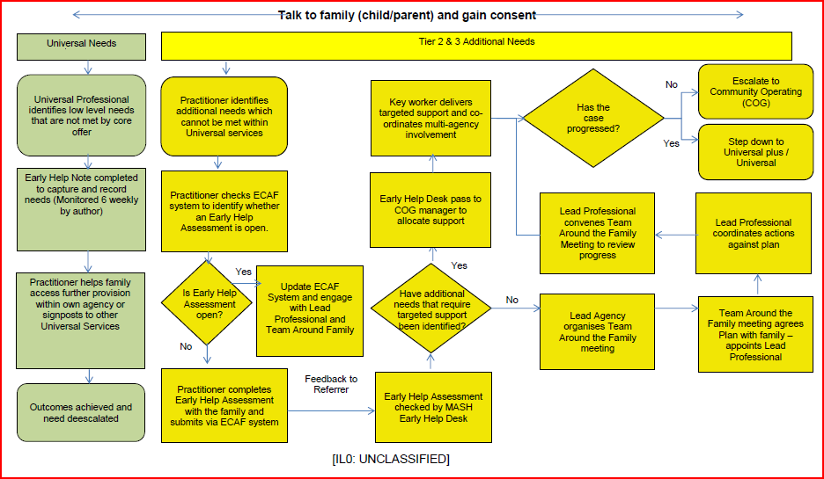
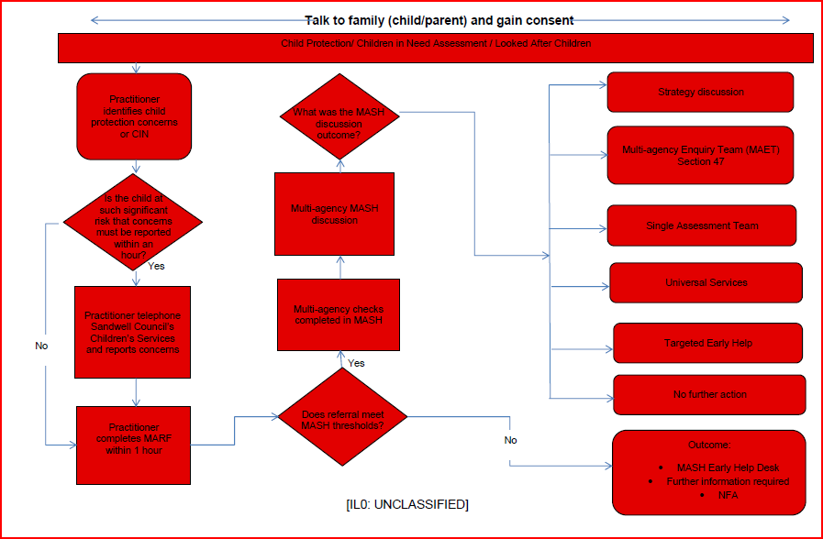

Appendix F – Safeguarding and Promoting Children’s Welfare Procedural Flowchart

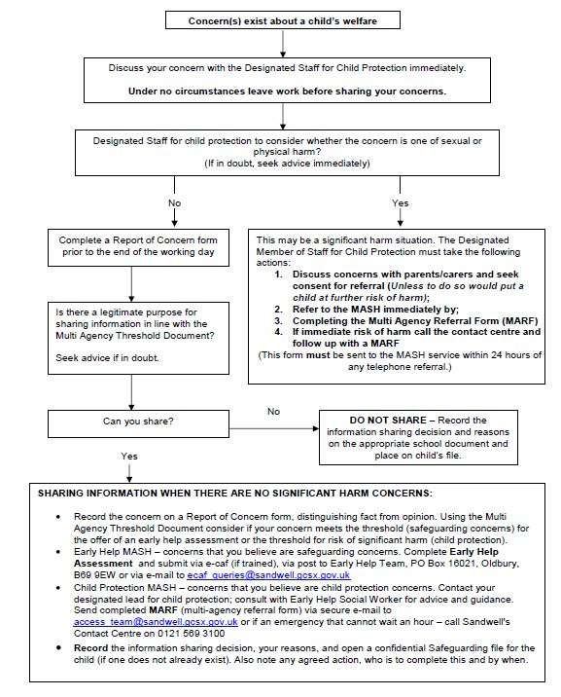

Appendix G: Preventing Violent Extremism – Roles and Responsibilities of the Single Point of Contact (SPOC)
The SPOC for The Westminster School is Joanne Flowers, who is responsible for:
- Ensuring that staff of the school are aware that you are the SPOC in relation to protecting students/pupils from radicalisation and involvement in terrorism;
- Maintaining and applying a good understanding of the relevant guidance in relation to preventing students/pupils from becoming involved in terrorism, and protecting them from radicalisation by those who support terrorism or forms of extremism which lead to terrorism;
- Raising awareness about the role and responsibilities of (School / Service) in relation to protecting students/pupils from radicalisation and involvement in terrorism;
- Monitoring the effect in practice of the school’s RE curriculum and assembly policy to ensure that they are used to promote community cohesion and tolerance of different faiths and beliefs;
- Raising awareness within the school about the safeguarding processes relating to protecting students/pupils from radicalisation and involvement in terrorism;
- Acting as the first point of contact within the school for case discussions relating to students / pupils who may be at risk of radicalisation or involved in terrorism;
- Collating relevant information from in relation to referrals of vulnerable students/pupils into the Channel* process;
- attending Channel* meetings as necessary and carrying out any actions as agreed;
- Reporting progress on actions to the Channel* Co-ordinator; and
- Sharing any relevant additional information in a timely manner.
*Channel is a multi-agency approach to provide support to individuals who are at risk of being drawn into terrorist related activity. It is led by the West Midlands Police Counter-Terrorism Unit, and it aims to:
  - Establish an effective multi-agency referral and intervention process to identify
  - vulnerable individuals;
  - Safeguard individuals who might be vulnerable to being radicalised, so that they are not at risk of being drawn into terrorist-related activity; and
  - Provide early intervention to protect and divert people away from the risks they face and reduce vulnerability.
Appendix H – Making or sharing of nudes or semi-nude

Guidance refers to the making or sharing of nudes or semi-nudes and involves young people sharing sexual images that they, or another young person, have created of themselves. Making or sharing of nudes or semi-nudes of someone under the age of 18 which is ‘indecent’ is illegal. This includes imagery of yourself if you are under 18. This is outlined in the protection of Children Act 1978(England and Wales) and the Sexual Offences Act 2003 (England and Wales).
If an incident involving making or sharing of nudes or semi-nudes comes to your attention in school, the Child Protection Policy should be followed.
- The incident should be reported to the DSLs as soon as possible Using Safeguard Software
- A meeting should be held by the DSLs and relevant school staff.
- Parents should be informed at an early stage and involved in the process unless there is good reason to believe that involving parents would put the young person at risk of harm.
- At any point in the process if there is a concern a young person has been harmed or is at risk of harm a referral should be made to children’s social care and/or the police immediately.
- If any devices need to be seized and passed onto the police then the device should be confiscated and the police should be called. The device should be turned off and placed under lock and key until the police are able to come and retrieve it. Schools have power under the Education Act 2011 to search, screen and confiscate devices.
- Adults should not view nudes or semi-nudes unless there is good and clear reason to do so. Wherever possible responses to incidents should be based on what DSLss have been told about the content of the imagery.

This advice is developed further in the ‘Sharing nudes and semi-nudes: advice for education settings working with children and young people’ (www.gov.uk/government/uploads/system/uploads/attachment_data/file/551575/6.2439_KG_NCA_Sexting_in_Schools_WEB__1_.PDF)
Further information and advice can also be found on the following internet sites:
www.childline.org.uk/Talk/Chat/Pages/OnlineChat.aspx
www.ceop.police.uk/safety-centre
www.nspcc.org.uk/preventing-abuse/keeping-children-safe/sexting/1
www.thinkuknow.co.uk

Appendix I – Information Sharing
Information sharing is vital in identifying and tackling all forms of abuse, neglect, and exploitation, and in promoting children’s welfare, including in relation to their educational outcomes. When deciding what information to share, schools and colleges should consider:
• the relevancy of the information, including to the current safeguarding risk,
• what is necessary for the receiving setting to know, and
• whether it is clearly presented and appropriately contextualised.
In addition to the child protection file, the designated safeguarding lead should also consider if it would be appropriate to share any information with the new school or college in advance of a child leaving particularly where the information would support an assessment of risk to others in the school as well as the individual pupil. For example, information that would allow the new school or college to continue supporting children who have had a social worker and been victims of abuse, or those who are currently receiving support through the ‘Channel’ programme and can have that support in place for when the child arrives or incidents that may indicate concerns about serious violence or harmful behaviours.
Where information indicates a risk to others and/or the individual pupil, for example where a pupil has previously carried, threatened with, or used a knife or weapon, it is incumbent on the receiving school to assess risk, and accordingly, put in place a safety and support plan for when the child arrives. t would be good practice for a conversation to take place between the designated safeguarding leads at both settings, where there are issues or concerns.
The data protection laws do not prevent the sharing of information for the purposes of keeping children safe.
Fears about sharing information must not be allowed to stand in the way of the need to safeguard and promote the welfare and protect the safety of children.

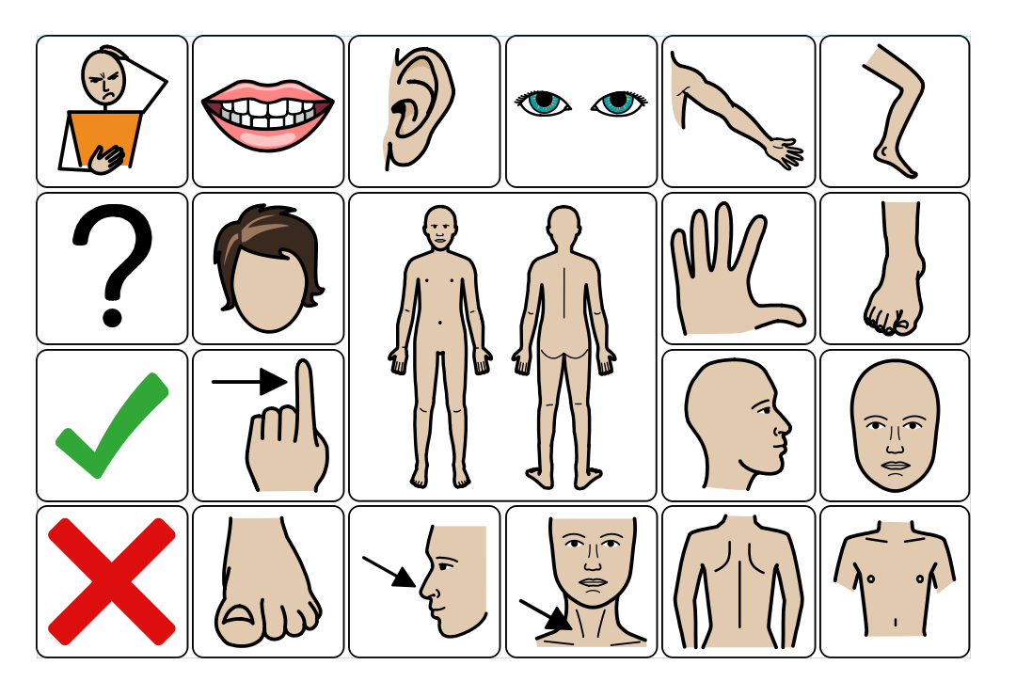
Appendix I - Aided Language Displays to support pupil voice for pupils with speech and language difficulties

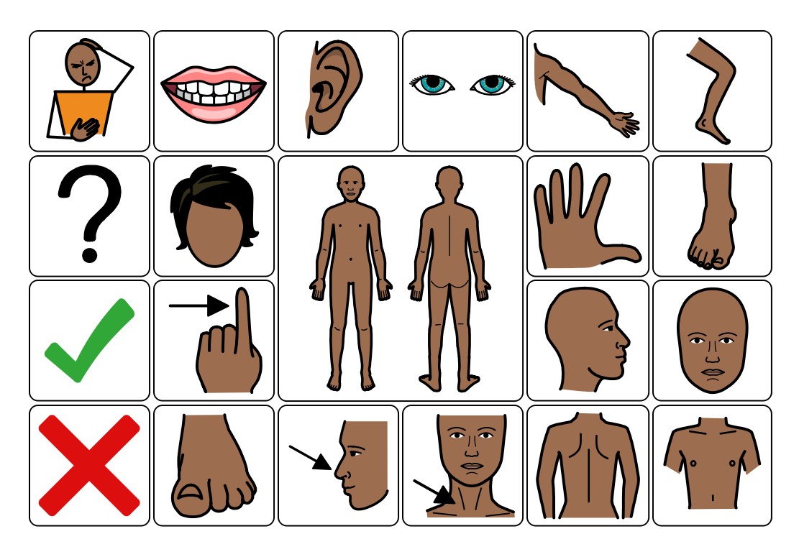
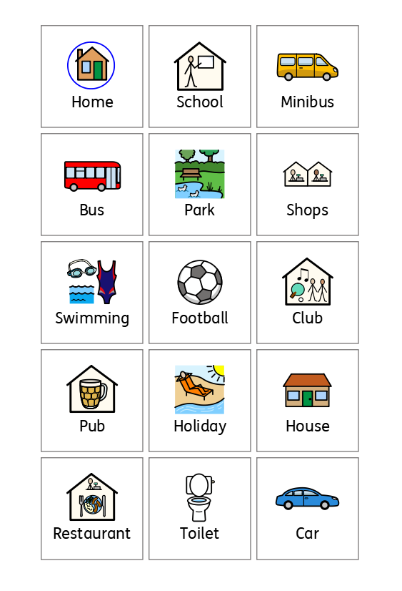
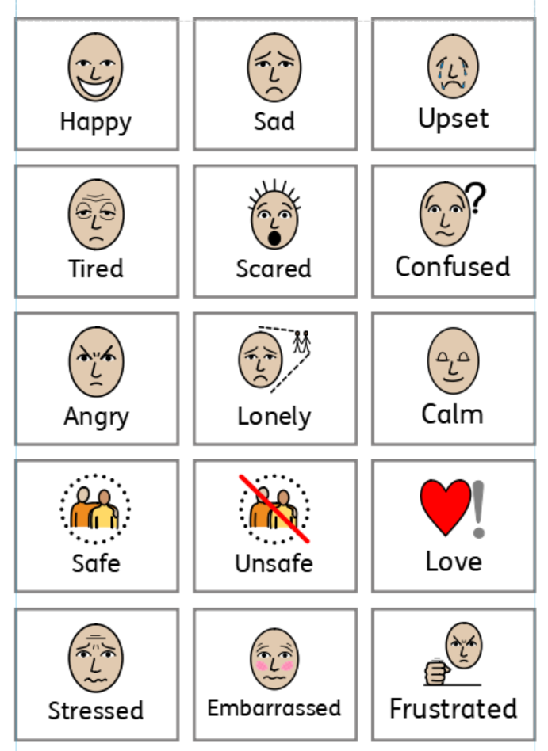

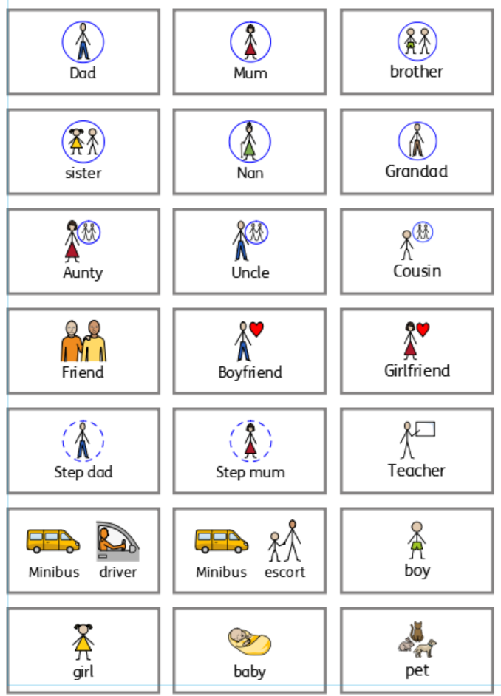

Appendix J – Step up/Step-down Flowchart
