

Approved by Governing Body on: | 13/10/2026
Signed by Chair of Governors: | 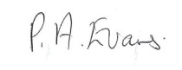
Executive Head Teacher: | O M Flowers
Lead Personnel: | G Webb
Date of Review: | 13/10/2027


www.thewestminsterschool.co.uk
Attendance Policy
2026/2027
Building foundations and providing opportunities to create confident,
aspirational, and independent members of our community.
Contents
1. Aims 3
2. Legislation and guidance 3
3. Roles and responsibilities 4
4. Recording attendance 9
5. Authorised absence 13
6. Strategies for promoting attendance 14
7. Supporting pupils with poor attendance 15
8. Supporting pupils who are absent or returning to school 16
9. Attendance monitoring 18
10. Monitoring arrangements 20
11. Sandwell Local Authority 20
12. Links with other policies 20
Appendix 1: attendance codes 21
Appendix 2: Leave of Absence (LOA) Form- Sandwell. 24
Appendix 3: Sandwell Local Authority – Legal Action Information. 27

1. Aims
The Westminster School is committed to providing a Safe, Happy and Learning environment for all pupils. This policy outlines our commitment to meeting our obligations with regard to school attendance, including those laid out in the statutory guidance on Working together to improve school attendance from the Department for Education (DfE). We aim to achieve this through our whole-school culture and ethos that values good attendance and recognises its importance for pupils’ learning, wellbeing and future opportunities, which includes:
- Setting high expectations for the attendance and punctuality of all pupils
- Promoting good attendance and the benefits of good attendance
- Reducing absence, including persistent and severe absence
- Ensuring every pupil has access to the full-time education to which they are entitled
- Acting early to address patterns of absence
- Building strong relationships with families to make sure pupils have the support in place to attend school
Improving attendance is a shared responsibility. We work in partnership with pupils, families, staff and external professionals to ensure that all pupils are supported to attend school regularly and on time.
We recognise that some pupils, particularly those with additional needs, may face challenges that affect their attendance. We are committed to working closely with families and other professionals to understand these challenges and provide the right support.
Parents have a legal duty to ensure that their child attends school regularly. We will support families to meet this responsibility and will work together to promote positive attendance habits.
We also promote and support punctuality, as arriving on time helps pupils to feel settled and ready to learn.
Why regular attendance matters
Attending school regularly plays an important role in helping your child succeed. It supports both their learning and wellbeing, and helps to build positive habits that will benefit them throughout their life.
Regular attendance gives your child the opportunity to:
- Build friendships and feel part of the school community
- Learn new things and develop important skills
- Grow in confidence and self-esteem
- Improve their social and communication skills
- Achieve their potential and, where appropriate, gain qualifications
- Develop the skills and habits that support future education, employment and independence
Being in school every day helps children feel secure, make progress, and get the most out of their education.

2. Legislation and guidance
This policy is based on the DfE’s statutory guidance on Working together to improve school attendance and School attendance parental responsibility measures. The guidance is based on the following pieces of legislation, which set out the legal powers and duties that govern school attendance:
- Part 6 of the Education Act 1996
- Maintained schools: Part 3 of the Education Act 2002
- Part 7 of the Education and Inspections Act 2006
- The School Attendance (Pupil Registration) (England) Regulations 2024
- https://www.legislation.gov.uk/uksi/2006/1751/contentsThe Education (Penalty Notices) (England) (Amendment) Regulations 2013
- The Equality Act 2010
https://www.legislation.gov.uk/uksi/2013/757/regulation/2/madeIt also refers to:
- School census guidance
- Keeping Children Safe in Education
- Mental health issues affecting a pupil's attendance: guidance for schools
- Ofsted’s 2025 framework toolkit

A child must start full time education once they reach compulsory school age. This is on the 31st December, 31st March or 31st August following their fifth birthday – whichever comes first. A young person can leave full time education on the last Friday in June if they will be 16 by the end of the school summer holidays. They must then do one of the following until they are 18:
- Stay in full-time education, for example at a college
- Start an apprenticeship or traineeship
- Spend 20 hours or more a week working or volunteering, while in part-time education or training.

3. Roles and responsibilities
3.1 The Governing Board
The governing board is responsible for:
- Setting high expectations of all school leaders, staff, pupils and parents/carers
- Making sure school leaders fulfil expectations, statutory duties and comply with the law on school attendance, including:
- Making sure the school records attendance accurately in the register, and shares the required information with the DfE and local authority
- Making sure the school works effectively with local partners to help remove barriers to attendance, and keeps them informed regarding specific pupils, where appropriate
- Recognising and promoting the importance of school attendance across the school’s policies and ethos
- Making sure the school’s attendance management processes are delivered effectively, and that consistent support is provided for pupils who need it most by prioritising staff and resources
- Making sure the school has high aspirations for all pupils, but adapts processes and support to pupils’ individual needs
- Regularly reviewing and challenging attendance data and helping school leaders focus improvement efforts on individual pupils or cohorts who need it most
- Working with school leaders to set goals or areas of focus for attendance and providing support and challenge
- Monitoring attendance figures for the whole school and repeatedly evaluating the effectiveness of the school’s processes and improvement efforts to make sure they are meeting pupils’ needs
- Where the school is struggling with attendance, working with school leaders to develop a comprehensive action plan to improve attendance
- Making sure all staff receive adequate training on attendance as part of the regular continued professional development offer, so that staff understand:
- The importance of good attendance
- That absence is almost always a symptom of wider issues
- The school’s legal requirements for keeping registers
- The school’s strategies and procedures for tracking, following up on and improving attendance, including working with partners and keeping them informed regarding specific pupils, where appropriate
- Making sure dedicated training is provided to staff with a specific attendance function in their role, including in interpreting and analysing attendance data
- Holding the Head of School to account for the implementation of this policy
As school attendance is a vital component to pupil wellbeing and progress the remit of attendance falls under the portfolio of the safeguarding governor who is the Chair of Governors – Pat Evans.

3.2 Head of School
The Head of School has overall accountability for ensuring that this policy is implemented effectively and that attendance remains a priority across the school.
The Head of School is responsible for:
- Monitoring the implementation and impact of this policy across the school
- Ensuring that attendance is prioritised and supported at all levels of leadership and practice
- Supporting staff in monitoring and improving the attendance of individual pupils, particularly where concerns arise
- Reviewing the effectiveness of attendance strategies and ensuring that appropriate actions are taken to improve outcomes
- Ensuring that appropriate systems and resources are in place to support good attendance
- Issuing penalty notices, where appropriate, in line with statutory guidance, or authorising a senior leader to do so on their behalf

The Head of School will work closely with the Senior Attendance Champion to ensure a consistent and effective whole-school approach to attendance.

3.3 The ‘Senior Attendance Champion’ - designated senior leader responsible for attendance
The Senior Attendance Champion provides strategic leadership for attendance across the school. They are responsible for setting the vision, driving improvement, and ensuring that effective systems are in place to promote and sustain high levels of attendance for all pupils.
The Senior Attendance Champion is responsible for:
- Leading and promoting a whole-school culture that values good attendance and punctuality
- Setting a clear vision and high expectations for attendance, and communicating these regularly to pupils, families and staff
- Monitoring and evaluating whole-school attendance data, including identifying patterns, trends and priority groups
- Reporting attendance data and progress to governors
- Ensuring robust systems and processes are in place to monitor, track and improve attendance, and that these are consistently followed by all staff
- Regularly reviewing the impact of attendance strategies and interventions

They will also:

- Oversee the identification of pupils whose attendance is a concern, including vulnerable groups, and ensure appropriate support is in place
- Work closely with pupils, parents/carers and external agencies to address barriers to attendance and promote sustained improvement
- Support the development of individual attendance, intervention or reintegration plans where needed
- Ensure that pupils with special educational needs and/or disabilities (SEND) receive appropriate, tailored support to attend regularly, including addressing in-school barriers and transport issues
- Communicate and work with the local authority where attendance concerns relate to pupils with Education, Health and Care (EHC) plans or where additional support is required
- Chair the weekly Attendance Monitoring Group (AMG) to ensure a coordinated and consistent approach to attendance

The Senior Attendance Champion will ensure that the school meets its statutory duties by:

- Sharing required attendance information with the local authority
- Notifying the local authority when a pupil is added to or removed from the admission register outside of normal transition points
- Reporting pupils who fail to attend regularly or who have 10 or more consecutive days of unauthorised absence
- Informing the local authority where a pupil is expected to miss 15 days or more due to illness
- The Senior Attendance Champion will ensure that attendance is considered alongside safeguarding, and that concerns are escalated appropriately where there is a risk of harm or educational neglect.

The designated senior leader responsible for attendance is Gemma Webb who can be contacted at the school on 0121 561 6884 or via email attendance@westminster.sandwell.sch.uk.

3.4 Attendance Team
The school’s Attendance Team plays a key role in the day-to-day monitoring and improvement of attendance across the school. They ensure that attendance is accurately recorded, concerns are identified early, and appropriate action is taken to support pupils and families. The school Attendance Officers are responsible for:
- Monitoring daily attendance across the school and at an individual pupil level
- Ensuring attendance registers are accurate and that the correct codes are applied in line with statutory guidance
- Checking and reconciling transport (e.g. taxi) registers with school attendance records
- Following up on all unexplained absences on the first day, including making phone calls or arranging home visits where appropriate, and recording outcomes clearly
- Identifying patterns and trends in attendance and punctuality, including persistent and severe absence
- Analysing attendance data and benchmarking it to identify priorities for improvement
- Providing regular attendance reports to staff and raising concerns with the Senior Attendance Champion and wider leadership team
- Contributing to weekly Attendance Monitoring Group (AMG) meetings and supporting the planning of appropriate interventions
- Working with parents and carers to understand barriers to attendance and arranging meetings to agree supportive strategies and next steps
- Identifying pupils who require additional support and coordinating appropriate interventions
- Working in partnership with the Local Authority and Education Welfare Officers to address persistent absence
- Liaising closely with the safeguarding team where attendance is a concern, ensuring that appropriate action is taken in line with safeguarding procedures
- Supporting the development and implementation of plans such as School Support Plans, Early Help assessments, or multi-agency interventions where attendance concerns meet safeguarding thresholds
- Advising senior leaders on the use of formal interventions, including fixed penalty notices, where appropriate
The Attendance Team recognise that barriers to attendance can be complex, particularly for pupils with additional needs. Their role is to ensure that responses are timely, consistent and focused on supporting pupils and families to improve attendance.
The Attendance Team consists of a range of staff from across the school including Safeguarding, WESTies, family liaison officer and school administrative staff.
The team includes: Habibur Abdulnoor, Lydia Capper, Leeanne Hocknull, Sarah Southall and Denise Taylor who can be contacted at the school on 0121 561 6884 or via email attendance@westminster.sandwell.sch.uk.

3.5 The Attendance Monitoring Group (AMG)
The Attendance Monitoring Group (AMG) meets weekly to oversee and improve attendance across the school. The group is chaired by the Senior Attendance Champion and includes the school’s Attendance Team.
The purpose of the AMG is to ensure a coordinated, timely and supportive approach to attendance, with a strong focus on early identification and intervention.
- Monitor and review whole-school attendance and punctuality data on a weekly basis
- Identify and analyse patterns and trends, including persistent and severe absence
- Identify individual pupils whose attendance or punctuality is a cause for concern
- Agree and implement appropriate interventions to support pupils and their families
- Work with parents and carers to understand the reasons for absence and agree clear support plans, including strategies and review timescales
- Ensure that attendance concerns are considered alongside safeguarding, and escalate where appropriate
- Support communication with families, including receiving and recording absence information in line with school procedures
- Develop and promote initiatives that raise awareness of the importance of good attendance across the school community

We recognise that barriers to attendance can be complex, particularly for pupils with additional needs. The AMG ensures that responses are tailored, supportive and involve relevant professionals where needed.

3.6 Teaching and Learning Support Staff
Teachers and Learning Support Staff who are responsible for leading a session must ensure that attendance is recorded accurately and on time for all lessons.
They are responsible for:
- Recording attendance for all pupils in their lesson using the correct attendance codes (see Appendix 1 – where the reason for absence is known and accepted by the school in advance class staff will input the appropriate absence code, where the reason is not known class teachers will mark with an N. Once registers are closed a member of the Attendance Team will follow up on all N coded absences) as close to the start of the lesson as possible but no later than 15 minutes after the scheduled start time of each lesson or double lesson.
- Completing AM and PM registers (Statutory Registers) promptly and submitting them by:
  - 09:15 for morning form sessions
  - 13:30 for afternoon sessions.
- Ensuring that any inaccuracies or concerns about attendance are reported to the Attendance Officers without delay, this can be via phone or via email to the registers email address, unless the concern is that a pupil who was previously believed to be on site but has not arrived to the lesson and there is no explanation, in which case staff should follow the missing child procedures which must be actioned immediately by contacting a member of the WEST team or SLT directly (Teams, Telephone or direct conversation NOT by email).

3.7 School admin/office staff
School administrative and office staff play a key role in ensuring that attendance information is recorded accurately and communicated effectively. They support the day-to-day management of attendance systems and processes.
They are responsible for:
- Receiving and recording absence information from parents/carers on the school system (SIMS)
- Directing calls or queries to the Attendance Officers where more detailed support or follow-up is required
- Managing the administration of leave of absence requests in line with school procedures
- Monitoring attendance records and alerting staff to any inconsistencies or concerns regarding register coding
- Cross-checking transport (e.g. taxi) registers against school attendance registers and reporting any discrepancies or missing pupils immediately to senior staff or Attendance Officers
- Liaising with work experience providers and alternative education providers to ensure that pupil attendance records are accurately maintained, liaising with senior staff or Attendance Officers if pupils are absent
- Communicating updates regarding school transport, including delays to local authority transport vehicles, where information is received from transport providers
- Supporting the analysis of attendance data by producing reports for individuals, groups, classes, year groups and the whole school, as required
- Preparing attendance data and summaries for annual reports and other statutory or school reporting requirements, as required
- Supporting the Attendance Monitoring Group (AMG) by preparing correspondence, and arranging meetings with parents/carers as required
- Producing and issuing termly attendance reports to parents/carers
Accurate administration and timely communication are essential to ensure that attendance is effectively monitored and that any concerns are identified and addressed promptly.

3.8 Parents
Where this policy refers to a parent, it refers to the adult the school and/or local authority decides is most appropriate to work with, including:
- All natural parents, whether they are married or not
- All those who have parental responsibility for a child or young person
- Those who have day-to-day responsibility for the child (i.e. lives with and looks after them)

Parents are expected to:

- Make sure their child attends on time every day that school is open to pupils.
- Call the school to report their child’s absence before 09.15 on the day of the absence and each subsequent day of absence, and advise when they are expected to return. If your child is ill, read the NHS advice Is my child too ill for school? - NHS to help decide whether they can go to school. If they are too ill to attend, you are not breaking the law and will not be penalised.
- Provide the school with more than 1 emergency contact number for their child
- Ensure that, where possible, appointments for their child are made outside of the school day
- Keep to any attendance contracts that they make with the school and/or local authority
- Seek support, where necessary, for maintaining good attendance, by contacting the school Attendance Team who can be contacted at the school on 0121 561 6884 or via email attendance@westminster.sandwell.sch.uk.

Parents and carers can support good attendance by showing their child that school is important. This might include talking with them about their day—what they have learned, what they have enjoyed, and anything they may have found challenging.
Supporting consistent and positive morning routines can also help pupils feel prepared and ready for the day ahead. This may include:
- Being ready for collection by Local Authority-provided transport at the allocated pick-up time
- Travelling to school with a parent or carer
- Travelling to school independently, where appropriate
We recognise that every family is different, and routines will look different for each household. Establishing routines that work for you can help your child start the day calmly and arrive at school feeling settled and ready to learn.

3.9 Pupils
Pupils are expected to:
- Attend school every day, on time.
- Attend every timetabled lesson, on time.

4. Recording attendance
4.1 Attendance register
We will keep an electronic attendance register, and place all pupils on this register.
The school records attendance in two ways:
- AM and PM Registration (Statutory Registers)
Attendance is recorded twice each day:
- Once in the morning (AM session)
- Once in the afternoon (PM session)
These are the official registers required by law. They are used to record whether a pupil is present, absent, or late, using nationally recognised attendance codes (See Appendix 1).

- Lesson Registers (Internal Monitoring)

In addition to the statutory registers, staff take registers throughout the day at the start of each lesson or double lesson.
These lesson registers:
- Help the school to monitor attendance and punctuality within the school day
- Support safeguarding by ensuring pupils are where they are expected to be
- Allow staff to quickly identify and respond to any concerns
Lesson registers do not replace the AM and PM registers, but provide additional information to support pupils’ safety and engagement.
Attendance registers will mark, using the appropriate national attendance and absence codes from the School Attendance (Pupil Registration) (England) Regulations 2024, whether every pupil is:
- Present
- Attending a place other than school
- Absent
- Absent – unable to attend due to unavoidable causes
Any amendment to the attendance register will include:
- The original entry
- The amended entry
- The reason for the amendment
- The date on which the amendment was made
- The name and position of the person who made the amendment
See Appendix 1 for the DfE attendance codes.
We will also record:
- Whether the absence is authorised or not
- The nature of the activity, where a pupil is attending an approved educational activity
- The nature of circumstances, where a pupil is unable to attend due to exceptional circumstances
We will keep every entry on the attendance register for 6 years after the date on which the entry was made.
The school day starts at 08.50 and ends at 15.05.
Pupils must arrive in school by 08.50 on each school day.
Pupils are expected to arrive at school on time and be ready to learn at the start of each session.
Teaching staff are expected to complete and submit registers within the first 15 minutes of each lesson. This ensures that attendance is recorded promptly and supports effective safeguarding. However, this does not mean that the statutory register is closed.
For statutory purposes, the AM and PM registers remain ‘open’ for 30 minutes to allow for pupils who arrive late via the school reception.
If a pupil arrives late, they must report to the school reception so that their attendance can be recorded accurately and safely.
- Pupils arriving after the register has opened but before it closes will be recorded as late, using the appropriate national attendance code (L)
- Pupils arriving after the register has closed will be recorded as having an unauthorised absence for that session, using the appropriate national attendance code (U), unless there is an agreed exceptional reason
The timings for the opening and closing of registers are:
- Morning (AM) register: opens at 08:50 and closes at 09:20
- Afternoon (PM) register: Opens at 13:15 and closes at 13:45
This process ensures that attendance is recorded accurately and that all pupils arriving late are accounted for in line with safeguarding procedures.
Where a pupil is regularly arriving late, the school will work with parents and carers to understand any barriers and provide appropriate support.

4.2 Unplanned absence
The pupil’s parent/carer must notify the school of the reason for the absence on the first day of an unplanned absence by 09.15, or as soon as practically possible, by calling the school attendance team, who can be contacted via telephone on 0121 561 6884 and choosing the option ‘to report a pupil absence’/option 1. Alternative arrangements can be made for parents who have issues with using a phone (e.g. hearing loss) for example using SchoolComms app or email to attendance@westminster.sandwell.sch.uk. Where absence is unplanned, it is expected that parents contact the school on each subsequent day of absence to discuss the pupil’s progress and advise when they are expected to return.
We will mark absence due to physical or mental illness as authorised, unless the school has a genuine concern about the authenticity of the illness.
Where there are doubts about the authenticity of the illness, the school will ask for medical evidence, such as a doctor’s note, prescription, appointment card or other appropriate form of evidence. We will not ask for medical evidence unnecessarily.

4.3 Planned absence
Attending a medical or dental appointment will be counted as authorised as long as the pupil’s parent notifies the school in advance of the appointment.
Parents can request a ‘Leave of Absence’ by calling and requesting a leave of absence form (see appendix 2) be sent home, these requests should be made as far in advance as possible of the requested absence. This can be requested in person or by calling the school on 0121 561 6884 and speaking to any member of the school administration team. Alternatively requests and information for planned absence can also be requested via email to attendance@westminster.sandwell.sch.uk.
However, we encourage parents to make medical and dental appointments out of school hours where possible. Where this is not possible, the pupil should be out of school for the minimum amount of time necessary.
The pupil’s parent must also apply for other types of term-time absence as far in advance as possible of the requested absence. See section 5 to find out which term-time absences the school can authorise.

4.4 Lateness and punctuality
A pupil who arrives late:
- Before the register has closed will be marked as late, using the appropriate code (L)
- After the register has closed will be marked as absent, using the appropriate code (U although other codes may be more appropriate, for example if at a medical appointment then M codes would be used)
Where a pupil is regularly arriving late to school, the Attendance Team may arrange a meeting with parents/carers to discuss any barriers to punctuality and identify appropriate support strategies. Parents/carers are encouraged to contact the school if they require support in helping their child arrive at school on time.

4.5 Following up unexplained absence
Where any pupil we expect to attend school does not attend, or stops attending, without reason, the school will:
- Contact parents/carers on the first day of absence to establish the reason. Where necessary, and on occasions where the school has been unable to contact parents/carers directly, the school may contact emergency contacts, relevant professionals (including social workers), undertake home visits, or request a welfare check from police as part of its safeguarding responsibilities
- Identify whether the absence is approved or not
- Identify the correct attendance code to use and input it as soon as the reason for absence is ascertained – this will be no later than 5 working days after the session(s) for which the pupil was absent
- Call the parent on each day that the absence continues without explanation, to make sure proper safeguarding action is taken where necessary
- Where relevant, report the unexplained absence to the pupil’s social worker and/or youth offending team officer
- Where appropriate, offer support to the pupil and/or their parents to improve attendance
- Identify whether the pupil needs support from wider partners, as quickly as possible, and make the necessary referrals
- If after 3 days of absence the pupil has not been seen and contact has not been made with the school, all reasonable enquiries will be made by the school to establish contact with the parents/carers of the pupil, including making enquiries to known friends and extended family. In addition, a home visit will be made by a member of the attendance and/or safeguarding team to check the safety and wellbeing of the pupil and to find out the reason for absence. Pupils who the school assesses as being at greater risk of harm may receive more frequent visits.
- Where support is not appropriate, not successful, or not engaged with issue a notice to improve, penalty notice or other legal intervention (see section 7 below), as appropriate
Where a pupil’s whereabouts are unknown or the school has concerns that the pupil may be missing education, the school will make all reasonable enquiries promptly and follow the local authority’s Children Missing Education procedures. The school will not wait for a fixed period before making a referral where there are safeguarding concerns.
The school will only remove a pupil’s name from the admission register where one of the statutory grounds in the School Attendance (Pupil Registration) (England) Regulations 2024 applies and all required enquiries and notifications have been completed. This includes the specific statutory provisions relating to a pupil who fails to return following authorised leave and a pupil who has been continuously absent without authorisation.

4.6 Reporting to parents
The school will regularly inform parents/carers about their child’s attendance through termly attendance reports/letters. These will include the pupil’s overall attendance percentage, the number of sessions missed, any unauthorised absence and the number of late marks recorded.

5. Authorised absence
5.1 Approval for term-time absence
The Head of School will only grant a leave of absence to a pupil during term time if the request meets the specific circumstances set out in the 2024 school attendance regulations. These circumstances are:
- Taking part in a regulated performance, or regulated employment abroad
- Attending an interview for employment or for admission to another educational institution
- Study leave
- A temporary, time-limited part-time timetable
- Exceptional circumstances
A leave of absence is granted at the Head of School’s discretion, including the length of time the pupil is authorised to be absent for.
We define ‘exceptional circumstances’ as rare and unexpected circumstances which are unlikely to reoccur. Examples include:
- Medical emergencies
- Family emergencies (e.g. death of a relative)
- Attendance at a funeral
- Respite care of a looked after child
- Housing emergency which prevents attendance
Leave of absence will not be granted for a pupil to take part in protest activity during school hours.
As a leave of absence will only be granted in exceptional circumstances, it is unlikely a leave of absence will be granted for the purposes of a family holiday.
The school considers each application for term-time absence individually, taking into account the specific facts, circumstances and relevant background context behind the request.
Any request should be submitted as soon as it is anticipated and, where possible, at least 4 weeks before the absence, and in accordance with any leave of absence request form, accessible via request from the school reception or a member of the attendance team. The Head of School may require evidence to support any request for leave of absence. If a pupil is over compulsory school age, leave can be requested by the pupil or parent they normally live with – we still ask that pupils complete a leave of absence form in line with the rest of the school.

5.2 Other reasons for authorised absence
Other valid reasons for authorised absence include (but are not limited to):
- Illness (including mental-health illness) and medical/dental appointments (see sections 4.2 and 4.3 for more detail)
- Religious observance – where the day is exclusively set apart for religious observance by the religious body to which the pupil’s parent(s) belong(s). If necessary, the school will seek advice from the parent’s religious body to confirm whether the day is set apart for religious observance
- Parent(s) travelling for occupational purposes – a pupil is a mobile child if their parent is travelling in the course of their trade or business and the pupil is travelling with them. In these circumstances a pupil will be considered as a mobile child, provided they are of compulsory school age and have no fixed abode and whose parent is in a trade or business that requires them to travel from place to place
- If the pupil is currently suspended or excluded from school (and no alternative provision has been made)

5.3 Absences from the school site (which are not classified as absences)
The Head of School will allow pupils to be absent from the school site for certain educational activities, or to attend other schools or settings. These are not classified as absences. Reasons include (but are not limited to):
- Attending an offsite approved educational activity, sporting activity or visit or trip arranged by the school
- Attending another school at which the pupil is also registered (dual registration)
- Attending provision arranged by the local authority
- Attending work experience
- If there is any other unavoidable cause for the pupil not to attend school, such as disruption to travel caused by an emergency, Local Authority provided transport not available, a lack of access arrangements, or because the school premises are closed (i.e. INSET days or inclement weather closure).

6. Strategies for promoting attendance
The school is committed to promoting and encouraging good attendance through a positive, inclusive and supportive approach. Regular attendance is important in helping pupils to make progress, develop socially and emotionally, and achieve their potential.
Good attendance and punctuality are expected and encouraged across the school and are recognised and celebrated appropriately by staff and within classes. The school aims to support and motivate pupils to attend regularly through an engaging and inclusive school experience, rather than relying solely on sanctions for poor attendance.
This includes:
- Providing an exciting, engaging and meaningful curriculum
- Delivering accessible and appropriately adapted lessons that meet pupils’ individual needs
- Building positive, respectful and trusting relationships between pupils, families and staff
- Creating a safe, supportive and welcoming learning environment
- Treating all pupils and families with dignity and respect
- Modelling positive relationships between home and school, recognising that strong partnerships are the foundation of good attendance
Class teachers and form tutors play an important role in encouraging attendance and maintaining regular communication with pupils and families regarding attendance, absence and engagement with school.
The school recognises that some pupils, particularly those with SEND or medical needs, may require regular medical appointments, treatments or procedures which can affect attendance. An inclusive approach is taken when monitoring and celebrating attendance to ensure that pupils are supported fairly and appropriately.
Attendance and punctuality are monitored throughout the school year to identify patterns, trends and areas where further support may be required. Information about attendance initiatives and whole-school attendance priorities may be shared with parents/carers through newsletters, reports and other school communications.
The school has an overall attendance target of 94% and aims to continually improve attendance across the school community.

7. Supporting pupils with poor attendance
The school will use a graduated approach to improve attendance, beginning with understanding barriers and providing appropriate support. Where support is unsuccessful, inappropriate or not engaged with, the school will consider formal intervention in line with statutory guidance. Our school will make use of the full range of support and potential sanctions – including, but not limited to, those listed below – to tackle poor attendance. Decisions will be made on an individual, case-by-case basis.

7.1 Attendance contract
We use attendance contracts as a form of attendance support.
An attendance contract is a formal written agreement between a parent and the school to address irregular attendance at school. An attendance contract is not legally binding, but it provides a more formal route where previous support has not worked or would not have been appropriate.
Parents cannot be compelled to enter an attendance contract, and the school cannot agree an attendance contract in a parent’s absence.
Where an attendance contract would be an appropriate form of support, the school will arrange a meeting with the parent and the pupil, in a manner appropriate to their age, understanding and communication needs to discuss how we can work in partnership to improve the pupil’s attendance.
Where parents fail to comply with an agreed attendance contract, the school may seek an alternative course of action. In the first instance, this will include discussions with the parents to seek explanations and determine whether the attendance contract remains useful. Where there is further non-compliance following these discussions, the school may take further action.

7.2 Education supervision order
In cases where voluntary early help plans and attendance contracts have been unsuccessful, we may work with the local authority to issue an education supervision order. If an education supervision order is considered, the local authority will inform the parent(s) in writing and will set up a meeting.
An education supervision order is a formal intervention but not criminal prosecution.
An education supervision order initially lasts for 1 year, but it can be extended within the last 3 months for a period of up to 3 years at a time.
In cases where parents persistently fail to meet the directions given under the education supervision order, they may be liable to a fine of up to £1,000 upon conviction.

7.3 Notice to improve
If the national threshold has been met and support is appropriate, but parents do not engage with offers of support, the school may offer a notice to improve to give parents a final chance to engage with support.
A notice to improve will be issued in line with processes set out in the local code of conduct for the local authority area in which the pupil attends school.
It will include:
- Details of the pupil’s attendance record and of the offences
- The benefits of regular attendance and the duty of parents under section 7 of the Education Act 1996
- Details of the support provided so far
- Opportunities for further support or to access previously provided support that was not engaged with
- A clear warning that a penalty notice may be issued, or prosecution considered, if attendance doesn’t improve within the improvement period, along with details of what sufficient improvement looks like, which will be decided on a case-by-case basis
- A clear timeframe of between 3 and 6 weeks for the improvement period
- The grounds on which a penalty notice may be issued before the end of the improvement period

7.4 Penalty notices
The Head of School (or a deputy or assistant headteacher, authorised by the head teacher), local authority or the police can fine parents for the unauthorised absence of their child from school, where the child is of compulsory school age, by issuing a penalty notice.
If the school issues a penalty notice, we will check with the local authority before doing so, and send the local authority a copy of any penalty notice issued.
Before issuing a penalty notice, the school will consider the individual case, including:
- Whether the national threshold for considering a penalty notice has been met (10 sessions of unauthorised absence in a rolling period of 10 school weeks)
- Whether a penalty notice is the best available tool to improve attendance for that pupil
- Whether further support, a notice to improve or another legal intervention would be a more appropriate solution
- Whether any obligations that the school has under the Equality Act 2010 make issuing a penalty notice inappropriate
Each parent who is liable for the pupil’s offence(s) can be issued with a penalty notice, but this will usually only be the parent/parents who allowed the absence.
The payment must be made directly to the local authority, regardless of who issues the notice. If the payment has not been made after 28 days, the local authority can decide whether to prosecute or withdraw the notice.
If issued with a first penalty notice, the parent must pay £80 within 21 days, or £160 within 28 days.
If a second penalty notice is issued to the same parent in respect of the same pupil, the parent must pay £160 if paid within 28 days.
A third penalty notice cannot be issued to the same parent in respect of the same child within 3 years of the date of the issue of the first penalty notice. In a case where the national threshold is met for a third time within those 3 years, alternative action will be taken instead.
A penalty notice may also be issued where parents allow their child to be present in a public place during school hours without reasonable justification, during the first 5 days of a suspension or exclusion (where the school has notified the parents that the pupil must not be present in a public place on that day). These penalty notices are not included in the National Framework, not subject to the same considerations about support being provided, and do not count towards the limit as part of the escalation process.
In these cases, the parent must pay £60 within 21 days, or £120 within 28 days.

8. Supporting pupils who are absent or returning to school
8.1 Pupils absent due to complex barriers to attendance
The school is committed to identifying barriers to attendance at the earliest opportunity and working in partnership with pupils, parents/carers and external professionals to provide appropriate support. See 8.3 below for further details and examples.

8.2 Pupils absent due to mental or physical ill health
The school recognises that mental health needs, physical health conditions and emotional wellbeing can have a significant impact on attendance. We are committed to identifying these barriers at the earliest opportunity and working in partnership with pupils, parents/carers and external professionals to provide appropriate and supportive interventions.
Where health concerns affect attendance, the school will work closely with families, pupils and relevant professionals to understand and remove barriers to attendance, while maintaining high aspirations for each pupil’s engagement, wellbeing and progress. Parents/carers are encouraged to work in partnership with the school and engage with the support offered.
The school has staff trained in first aid, and some staff have received additional specialist training to support pupils with medical and healthcare needs. This includes supporting pupils who may require emergency or rescue medication, the administration of medication during the school day, support with intimate care, specialist diets, and the implementation of physiotherapy or occupational therapy programmes. The school works closely with families and health professionals to ensure that pupils’ medical needs are supported safely and appropriately whilst in school.
Where recommended by health professionals, the school may also implement a range of reasonable adjustments and supportive measures to help pupils attend school as regularly as possible. This may include part-time timetables, adjusted start or finish times, or alternative education provision. Any adjustments or alternative arrangements will be reviewed regularly, in partnership with families and relevant professionals, with the aim of supporting pupils to increase their attendance and engagement with school over time.

8.3 Pupils absent due to other barriers to attendance
The school recognises that some pupils may face additional barriers to attendance and may therefore require enhanced support to attend and engage with school regularly. This may include pupils who have special educational needs and/or disabilities (SEND), pupils who are disadvantaged, pupils who are known or previously known to children’s social care, and pupils with other responsibilities or challenges, such as young carers.
The school is committed to identifying barriers to attendance at the earliest opportunity and providing timely, appropriate and targeted support and reasonable adjustments to meet individual needs. This happens via the weekly AMG meetings. Pupils who meet this criterion often require a multidisciplinary approach to support, in this situation pupils will be referred to our internal triage system. This involves a weekly meeting that comprises senior leaders from across the school, including the Deputy Headteachers responsible for every key stage, the SENCO, Educational Psychologist, specialist teacher for complex communication and autism and representatives from the AMG and Safeguarding teams. The Triage meeting is a place to discuss pupils who may be facing additional challenges, make referrals to in-school support and external agencies and where appropriate signpost families for additional advice and support. Interventions and support strategies will be regularly reviewed to ensure they remain effective and continue to promote positive attendance, wellbeing and engagement with school.
Examples of some of the additional pastoral support and additional interventions available include:
- Mentoring
- Counselling (including psychotherapeutic counselling, CBT and talking therapies)
- Therapeutic interventions (including Creative Therapy, Music Therapy and Play Therapy)
- Specialist Teacher support and advice (including specialists in complex communication and autism)
- Educational Psychology support
- Speech and Language Therapy
- Sensory needs assessment via Occupational Therapy Services
- NHS Occupational Therapy and Physiotherapy Services
- Early Help or referrals to wider agencies and external professionals where appropriate such as local family hubs, social care (including the Children with Disabilities Team), and CAMHS.

All pupils at The Westminster School have education health and care (EHC) plan, when a pupil with an EHC plan’s attendance falls, the school will inform the appropriate local authority, and where necessary additional provision for any unmet needs will be reviewed at annual reviews, or in exceptional circumstances an early or emergency review may be organised.

8.4 Pupils returning to school after a lengthy or unavoidable period of absence
Where pupils experience a lengthy or unavoidable period of absence, the school will support their reintegration and help rebuild confidence, relationships and engagement with learning. Members of the Attendance Monitoring Group (AMG) may meet with pupils and families to support and monitor this process where necessary. We will also implement our safeguarding procedures (see our child protection/safeguarding policy) and refer any concerns to local children’s social care and/or request a police welfare check.
We will work with pupils and their families to address any existing barriers, and it may be appropriate to implement a range of reasonable adjustments and supportive measures to help pupils reintegrate into school life and attend school as regularly as possible. This may include part-time timetables, adjusted start or finish times, or alternative education provision. Any adjustments or alternative arrangements will be reviewed regularly, in partnership with families and relevant professionals, with the aim of supporting pupils to increase their attendance and engagement with school over time.
8.5 Part-time timetable arrangements
A part-time timetable will only be considered in exceptional circumstances where it is in the best interests of the pupil and forms part of a planned package of support. The school recognises that all pupils are entitled to a full-time education and will only use a part-time timetable as a temporary measure to support a pupil’s attendance, wellbeing, medical needs or reintegration into school.
Any decision to implement a part-time timetable will be made in partnership with the pupil, parents/carers and, where appropriate, relevant professionals. The school will consider the pupil’s individual needs, safeguarding requirements, health needs, educational entitlement and any special educational needs and disabilities (SEND) before agreeing such arrangements.
A part-time timetable will form part of a wider support plan, attendance plan, reintegration plan or medical plan. The arrangement will be recorded in writing and will clearly set out:
- the reasons for the part-time timetable;
- the support and provision being put in place;
- how education will be delivered during periods when the pupil is not expected to attend school;
- the intended outcomes;
- review arrangements and timescales; and
- an anticipated end date.

Part-time timetables will be reviewed regularly with parents/carers and relevant professionals to ensure they remain appropriate, effective and in the pupil’s best interests. The overall aim will always be to support the pupil to return to full-time education as soon as it is appropriate and achievable to do so.
Where required, the school will inform and work with the local authority, informing both the local authority attendance team and SEN team where additional support, advice or statutory involvement is necessary. Attendance registers will be completed in accordance with statutory guidance, and the appropriate attendance code will only be used for sessions covered by an agreed part-time timetable.

9. Attendance monitoring
9.1 Monitoring attendance
The school will monitor attendance and absence data (including punctuality) weekly, half-termly, termly and yearly across the school and at an individual pupil, year group and cohort level.
Specific pupil information will be shared with the DfE on request. The school has granted the DfE access to its management information system so the data can be accessed regularly and securely.
Data will be collected each term and published at national and local authority level through the DfE's school absence national statistics releases. The underlying school-level absence data is published alongside the national statistics.
The school will benchmark its attendance data at whole school, year group and cohort level against local, regional, and national levels to identify areas of focus for improvement, and share this with the governing board.

9.2 Analysing attendance
The school will:
- Analyse attendance and absence data regularly to identify pupils, groups or cohorts that need additional support with their attendance, and
- Identify pupils whose absences may be a cause for concern, especially those who demonstrate patterns of persistent or severe absence
- Conduct thorough analysis of half-termly, termly, and full-year data to identify patterns and trends
- Look at historic and emerging patterns of attendance and absence, and then develop strategies to address these patterns.

9.3 Using data to improve attendance
The school will:
- Develop targeted actions to address patterns of absence (of all severities) of individual pupils, groups or cohorts that it has identified via data analysis
- Provide targeted support to the pupils we have identified whose absences may be a cause for concern, especially those who demonstrate patterns of persistent or severe absence, and their families (see section 9.4 below)
- Provide regular attendance reports to class teachers/form tutors, to facilitate discussions with pupils and families (for example at parents’ evenings), and to the governing board and school leaders (including special educational needs co-ordinators, designated safeguarding lead and pupil premium lead)
- Use data to monitor and evaluate the impact of any interventions put in place in order to modify them and inform future strategies
- Share information and work collaboratively with other schools in the area, local authorities and other partners where a pupil’s absence is at risk of becoming persistent or severe, including keeping them informed regarding specific pupils, where appropriate.

9.4 Reducing persistent and severe absence
Persistent absence is where a pupil misses 10% or more of school, and severe absence is where a pupil misses 50% or more of school. Reducing persistent and severe absence is central to the school’s strategy for improving attendance.
The school will:
- Use attendance data to find patterns and trends of persistent and severe absence
- Consider potential safeguarding issues and, where suspected or present, address them in line with Keeping Children Safe in Education
- Hold regular meetings with the parents of pupils who the school (and/or local authority) considers to be vulnerable or at risk of persistent or severe absence, or who are persistently or severely absent, to:
- Discuss attendance and engagement at school
- Listen, and understand barriers to attendance
- Explain the help that is available
- Explain the potential consequences of, and sanctions for, persistent and severe absence
- Review any existing actions or interventions
- Provide access to wider support services to remove the barriers to attendance, in conjunction with the local authority, where relevant (see section 8, above)
- Consider alternative support that could be put in place to remove any barriers to attendance and re-engage these pupils. In doing so, the school will sensitively consider some of the reasons for absence
- Implement sanctions, where necessary (see section 7, above)

10. Monitoring arrangements
This policy will be reviewed as guidance from the local authority and/or DfE is updated, and as a minimum annually by the Senior Attendance Champion. At every review, the policy will be approved by the full governing board.

11. Sandwell Local Authority
Additional information is available from Sandwell School Attendance Information (subject to Local Authority updates). https://www.sandwell.gov.uk/schoolattendance

12. Links with other policies
This policy links to the following policies:
- Child protection and safeguarding policy
- Behaviour (Wellbeing and Engagement) policy
- Supporting pupils with medical conditions
- Missing Child Procedures
- Home Learning Policy
- SEND Policy

Appendix 1: attendance codes
The following codes are taken from the DfE’s guidance on school attendance.
Code | Definition | Scenario
/ | Present (am) | Pupil is present at morning registration
\ | Present (pm) | Pupil is present at afternoon registration
L | Late arrival | Pupil arrives late before register has closed
Attending a place other than the school
K | Attending education provision arranged by the local authority | Pupil is attending a place other than a school at which they are registered, for educational provision arranged by the local authority
V | Attending an educational visit or trip | Pupil is on an educational visit/trip organised or approved by the school
P | Participating in a sporting activity | Pupil is participating in a supervised sporting activity approved by the school
W | Attending work experience | Pupil is on an approved work experience placement
B | Attending any other approved educational activity | Pupil is attending a place for an approved educational activity that is not a sporting activity or work experience
D | Dual registered | Pupil is attending a session at another setting where they are also registered
Absent – leave of absence
C1 | Participating in a regulated performance or undertaking regulated employment abroad | Pupil is undertaking employment (paid or unpaid) during school hours, approved by the school
M | Medical/dental appointment | Pupil is at a medical or dental appointment
J1 | Interview | Pupil has an interview with a prospective employer/educational establishment
S | Study leave | Pupil has been granted leave of absence to study for a public examination
X | Not required to be in school | Pupil of non-compulsory school age is not required to attend
C2 | Part-time timetable | Pupil is not in school due to having a part-time timetable
C | Exceptional circumstances | Pupil has been granted a leave of absence due to exceptional circumstances
Absent – other authorised reasons
T | Parent travelling for occupational purposes | Pupil is a ‘mobile child’ who is travelling with their parent(s) who are travelling for occupational purposes
R | Religious observance | Pupil is taking part in a day of religious observance
I | Illness (not medical or dental appointment) | Pupil is unable to attend due to illness (either related to physical or mental health)
E | Suspended or excluded | Pupil has been suspended or excluded from school and no alternative provision has been made
Absent – unable to attend school because of unavoidable cause
Q | Lack of access arrangements | Pupil is unable to attend school because the  local authority has failed to make access arrangements to enable attendance at school
Y1 | Transport not available | Pupil is unable to attend because school is not within walking distance of their home and the transport normally provided is not available
Y2 | Widespread disruption to travel | Pupil is unable to attend because of widespread disruption to travel caused by a local, national or international emergency
Y3 | Part of school premises closed | Pupil is unable to attend because they cannot practicably be accommodated in the part of the premises that remains open
Y4 | Whole school site unexpectedly closed | Every pupil absent as the school is closed unexpectedly (e.g. due to adverse weather)
Y5 | Criminal justice detention | Pupil is unable to attend as they are:  - In police detention  - Remanded to youth detention, awaiting trial or sentencing, or  - Detained under a sentence of detention
Y6 | Public health guidance or law | Pupil’s travel to or attendance at the school would be prohibited under public health guidance or law
Y7 | Any other unavoidable cause | To be used where an unavoidable cause is not covered by the other codes
Absent – unauthorised absence
G | Holiday not granted by the school | Pupil is absent for the purpose of a holiday, not approved by the school
N | Reason for absence not yet established | Reason for absence has not been established before the register closes
O | Absent in other or unknown circumstances | No reason for absence has been established, or the school isn’t satisfied that the reason given would be recorded using one of the codes for authorised absence
U | Arrived in school after registration closed | Pupil has arrived late, after the register has closed but before the end of session
Administrative codes
Z | Prospective pupil not on admission register | Pupil has not joined school yet but has been registered
# | Planned whole-school closure | Whole-school closures that are known and planned in advance, including school holidays

Appendix 2: Leave of Absence (LOA) Form- Sandwell.
The following is an example of the Sandwell School Attendance Support Service Leave of Absence Request form – to be used from Sept 26.
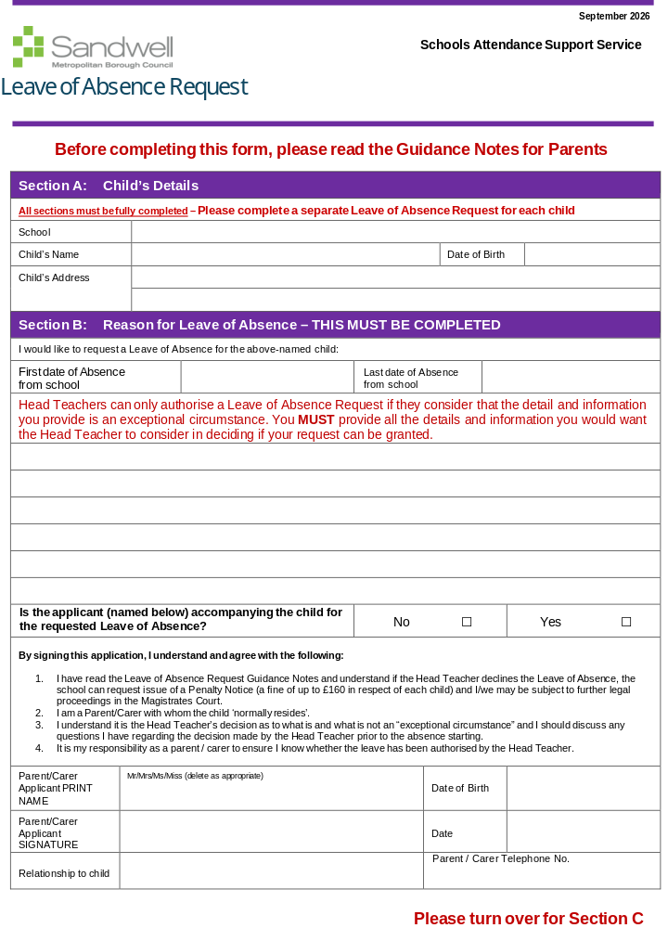

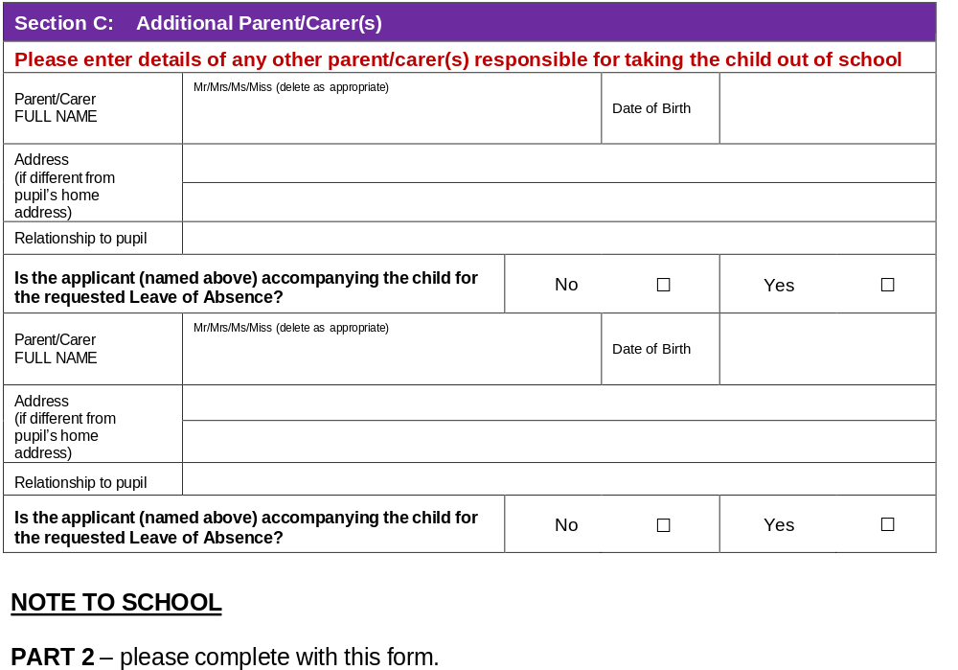

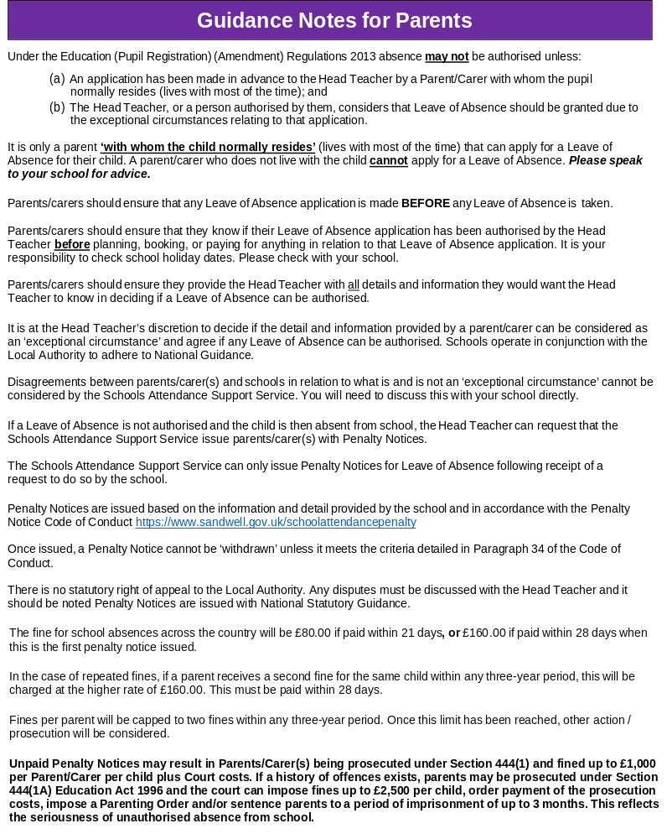

Appendix 3: Sandwell Local Authority – Legal Action Information.
Legal Action
Information for Parents
How does your child compare?
Section 23(1) Anti-Social Behaviour Act 2007:
Penalty Notices may be issued to the parent of pupils who have unauthorised absence from school. The amount of the penalty is £80.
- If this is not paid within 21 days, the amount rises to £160.
- If not paid within 28 days, the Local Authority may prosecute under Section 444(1) unless it comes to our attention that the penalty notice had been issued in error.

Section 444(1) Education Act 1996:
“If you are the parent of a child of compulsory school age who fails to attend school regularly, you are guilty of an offence.”
- The court can fine each parent up to £1,000 per child, order payment of the prosecution costs and/or impose a Parenting Order.

Section 444(1A) Education Act 1996:
“If in the above circumstances you, the parent, know that your child is failing to attend regularly at the school and fail without reasonable justification to cause him/her to attend, you are guilty of an offence.”
- The court can fine you up to £2,500 per child, order payment of the prosecution costs, impose a Parenting Order and/or sentence you to a period of imprisonment of up to 3 months.
Please note that:
- Penalties and prosecutions are in respect of each parent for each child.
- “Parent” includes any person who is not a parent but who has parental responsibility for the child or who has care of him/her.

These prosecutions are criminal proceedings and could result in you having a criminal record.
Attendance during one school year | Equals this number of days absent | Which is approximately this many weeks absent | Which means this number of lessons missed
90% | 19 days | 4 weeks | 100 lessons
80% | 38 days | 8 weeks | 200 lessons
70% | 57 days | 11.5 weeks | 290 lessons

Frequent absence can add up to a considerable amount of lost learning and can seriously disadvantage your child in adult life.

