

Approved by Governing Body on: | 13/10/2026
Signed by Chair of Governors: | 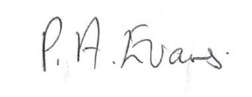
Executive Head Teacher: | O M Flowers
Lead Personnel: | O M Flowers
Date of Review: | 13/101/2027

Allergy Policy
2026/2027
www.thewestminsterschool.co.uk
Contents
1. Aims 2
2. Legislation and guidance 2
3. Roles and responsibilities 2
4. Assessing risk 4
5. Managing risk 4
6. Procedures for handling an allergic reaction 6
7. Adrenaline auto-injectors (AAIs) 7
8. Training 8
9. Links to other policies 8
Appendix 1 9
Appendix 2 10
Appendix 3 11

1. Aims
This policy aims to:
- Set out our school’s approach to allergy management, including reducing the risk of exposure and the procedures in place in case of allergic reaction
- Make clear how our school supports pupils with allergies to ensure their safety, wellbeing and inclusion
- Promote and maintain allergy awareness among the school community
- Identify the communication requirements between parents, school, staff and catering providers.

2. Legislation and guidance
This policy is based on the Department for Education (DfE)’s guidance on allergies in schools and supporting pupils with medical conditions at school, the Department of Health and Social Care’s guidance on using emergency adrenaline auto-injectors in schools, and the following legislation:
- The Food Information Regulations 2014
- The Food Information (Amendment) (England) Regulations 2019

3. Roles and responsibilities
We take a whole-school approach to allergy awareness.
3.1 Allergy lead
The nominated allergy lead is Oliver Flowers, Executive Headteacher.
They’re responsible for:
- Promoting and maintaining allergy awareness across our school community
- Ensuring Allergy policies are kept up to date in line with changing need of pupil cohort and legislative amendments.
- Ensuring there are processes, procedures and nominated staff to ensure the effective record keeping, risk management and communication of student allergies.
3.2 Link Governor
The Link Governor for Health & Safety will provide strategic oversight of the school's allergy management arrangements and receive reports on allergy incidents and policy reviews
3.3 Student Needs Medical HLTA
- The Student Needs Medical HLTA is Marie Harewood
- Recording and collating allergy and special dietary information for all relevant pupils in conjunction with the administrative team responsible for student records.
- Ensuring:
- All allergy information is up to date and readily available to relevant members of staff
- All pupils with allergies have an allergy action plan/Individual Health Care Plan completed by a medical professional
- All staff receive an appropriate level of allergy training
- All staff are aware of the school’s policy and procedures regarding allergies
- Relevant staff are aware of what activities need an allergy risk assessment
- Keeping stock of the school’s adrenaline auto-injectors (AAIs) for individuals and for general use in the event of an emergency.
- Liaising with the school catering provider’s nutritionist and parents to ensure that appropriate pupil meal plans are implemented where necessary
- Operationalising the Allergy Policy.
- Co-ordinating the paperwork and information from families
- Co-ordinating medication with families
- Checking spare AAIs are in date
- Any other appropriate tasks delegated by the allergy lead
3.4 Teaching and support staff
All teaching and support staff are responsible for:
- Promoting and maintaining allergy awareness among pupils
- Maintaining awareness of our allergy policy and procedures
- Being able to recognise the signs of severe allergic reactions and anaphylaxis
- Attending appropriate allergy training as required
- Being aware of specific pupils with allergies in their care
- Carefully considering the use of food or other potential allergens in lesson and activity planning
- Ensuring the wellbeing and inclusion of pupils with allergies
- Making the Student Medical Needs HLTA aware of any severe allergies they have.
3.4 Parents/carers
Parents/carers are responsible for:
- Being aware of our school’s allergy policy
- Providing the school with up-to-date details of their child’s medical needs, dietary requirements, and any history of allergies, reactions and anaphylaxis
- If required, providing their child with 2 in-date adrenaline auto-injectors and any other medication, including inhalers, antihistamine etc., and making sure these are replaced in a timely manner
- Carefully considering the food they provide to their child as packed lunches and snacks, and trying to limit the number of allergens included
- Following the school’s guidance on food brought in to be shared
- Updating the school on any changes to their child’s condition
3.6 Pupils with allergies
These pupils are responsible for:
- Where possible, being aware of their allergens and the risks they pose
- Where possible, understanding how and when to use their adrenaline auto-injector
- If age-appropriate and cognitively appropriate, carrying their adrenaline auto-injector on their person and only using it for its intended purpose
3.7 Pupils without allergies
These pupils are responsible for:
- Where possible, being aware of allergens and the risk they pose to their peers
3.8 Administration Team
The administration team of the school are responsible for:
- Collecting information from parents regarding pupil allergies, intolerances and other dietary requirements via the Allergy/Intolerance and Dietary Requirements form (Appendix 3)
- Providing reports for school’s catering regarding pupil allergies, intolerances and other dietary requirements for the School’s catering provider

4. Assessing risk
The school will conduct a risk assessment for any pupil at risk of anaphylaxis taking part in:
- Lessons such as food technology
- Science experiments involving foods
- Crafts using food packaging
- Off-site events and school trips
- Any other activities involving animals or food, such as animal handling experiences or baking
A risk assessment for any pupil at risk of an allergic reaction will also be carried out where a visitor requires an assistance animal.

5. Managing risk
5.1 Hygiene procedures
- Pupils are reminded to wash their hands before and after eating
- Sharing of food is not allowed
- Pupils have their own water bottles
5.2 Catering
The catering is provided through the BSF contract and Mitie PLC. At present the catering provider is Chartwells and Compass. Inherent within the contract is the requirement for the catering provider to provide safe food options to meet the dietary needs of pupils with allergies.
- Catering staff receive appropriate training and are able to identify pupils with allergies
- School menus are available for parents/carers to view with ingredients clearly labelled
- Where changes are made to school menus, the catering provider will make sure these continue to meet any special dietary needs of pupils
- Food allergen information relating to the ‘top 14’ allergens is displayed on the packaging of all food products, allowing pupils and staff to make safer choices. Allergen information labelling will follow all legal requirements that apply to naming the food and listing ingredients, as outlined by the Food Standards Agency (FSA)
- Catering staff follow hygiene and allergy procedures when preparing food to avoid cross-contamination
- The catering provider will ensure students with high risk allergies are not served food stuffs that pose risk to identified individuals.
- The catering provider will have the list of high risk allergy students with pictures to ensure they are able to keep them safe in line with the allergy risks, irrespective of staffing rotations and absences.
5.3 Food restrictions
We acknowledge that it is impractical to enforce an allergen-free school. However, we would like to encourage pupils and staff to avoid certain high-risk foods to reduce the chances of someone experiencing a reaction. These foods include:
- Packaged nuts
- Cereal, granola or chocolate bars containing nuts
- Peanut butter or chocolate spreads containing nuts
- Peanut-based sauces, such as satay
- Sesame seeds and foods containing sesame seeds
If a pupil brings these foods into school, they may be asked to eat them away from others to minimise the risk, or the food may be confiscated.
5.4 Insect bites/stings
When outdoors:
- Shoes should always be worn
- Food and drink should be covered
- Those who have known allergies to bites and stings should have a risk assessment understood and implemented by supervising members of staff.
- Access to emergency medication should be ready available to trained members of supervising staff.
5.5 Animals
- All pupils will always wash hands after interacting with animals to avoid putting pupils with allergies at risk through later contact
- Pupils with animal allergies will not interact with animals
- Those who have known allergies to animals should have a risk assessment understood and implemented by supervising members of staff.
- Access to emergency medication should be readily available to trained members of supervising staff.
5.6 Support for mental health
Pupils with allergies will have additional support through:
- Pastoral care through supervising members of staff.
- Regular check-ins with the school's medical teams.
5.7 Inclusion
The school is committed to ensuring that pupils with allergies are able to participate fully and safely in all aspects of school life and will make reasonable adjustments to reduce barriers to participation where appropriate.
5.8 Events and school trips
- For events, including ones that take place outside of the school, and school trips, no pupils with allergies will be excluded from taking part
- The school will plan accordingly for all events and school trips, and arrange for the staff members involved to be aware of pupils’ allergies and to have received adequate training
- Those who have known allergies should have a risk assessment understood and implemented by supervising members of staff.
- Appropriate measures will be taken in line with the school's AAI protocols for off-site events and school trips (see section 7.5).
5.9 Allergy-Related Bullying and Discrimination
The school recognises that pupils with allergies may be vulnerable to bullying, discrimination, exclusion or behaviour that places them at risk. Any allergy-related bullying will be treated seriously and managed in accordance with the school's Behaviour (Wellbeing and Engagement) and Anti-Bullying Policies.

6. Procedures for handling an allergic reaction
6.1 Register of pupils with AAIs
- The school maintains a register of pupils who have been prescribed AAIs or where a doctor has provided a written plan recommending AAIs to be used in the event of anaphylaxis. The register includes:
- Known allergens and risk factors for anaphylaxis
- Whether a pupil has been prescribed AAI(s) (and if so, what type and dose)
- Where a pupil has been prescribed an AAI, whether parental consent has been given for use of the spare AAI, which may be different to the personal AAI prescribed for the pupil
- A photograph of each pupil to allow a visual check to be made
- The register is kept in the school’s medical room, catering and food areas and on SharePoint. For those students with high risk factors associated with allergies the individual emergency medicine administration plan will be kept with the emergency medication in a red bum-bag. This will ensure it can be checked quickly by any member of staff as part of initiating an emergency response
6.2 Allergic reaction procedures
- As part of the whole-school awareness approach to allergies, all appropriate staff are trained in the school’s allergic reaction procedure, and to recognise the signs of anaphylaxis and respond appropriately
- Staff are trained in the administration of AAIs to minimise delays in pupils receiving adrenaline in an emergency
- If a pupil has an allergic reaction, the staff member will initiate the school’s emergency response plan, following the pupil’s allergy action plan/Individual Health Care Plan
- If an AAI needs to be administered, a member of staff will use the pupil's own AAI, or if it is not available, a school one
- If the pupil has no allergy action plan/Individual Health Care Plan, staff will follow the school's procedures on responding to allergy and, if needed, the school's normal emergency procedures.
- A school AAI device will be used instead of the pupil’s own AAI device if:
  - Medical authorisation and written parental consent have been provided, or
  - The pupil’s own prescribed AAI(s) are not immediately available (for example, because they are broken, out-of-date, have misfired or been wrongly administered)
- If a pupil needs to be taken to hospital, staff will stay with the pupil until the parent/carer arrives, or accompany the pupil to hospital by ambulance
- If the allergic reaction is mild (e.g. skin rash, itching or sneezing), the pupil will be monitored and the parents/carers informed.
6.3 Incident and Near-Miss Reporting
- All allergy-related incidents and near-misses must be reported via the Near Miss Form in Appendix 6 , recorded, investigated, and reviewed. Reports should be completed as soon as practicable and no later than the end of the working day. The Executive Headteacher or designated member of staff will investigate each event, identify lessons learned, and implement appropriate corrective actions to reduce the likelihood of recurrence. Records will be maintained centrally and reviewed regularly to support continuous improvement in allergy management.

7. Adrenaline auto-injectors (AAIs)
7.1 Purchasing of spare AAIs
The allergy lead is responsible for ensuring funding is available to facilitate the Student Needs Medical HLTA to buy AAIs and ensuring they are stored according to the guidance.
- Where the AAIs will be sourced (i.e. a local pharmacy)
- The quantity of AAIs required
- Which brand(s) of AAI are purchased (schools are recommended to buy a single brand to avoid confusion)
- The dosage required (based on Resuscitation Council UK’s age-based criteria, see page 11 of the guidance)
(See pages 11 and 12 of the guidance.)
7.2 Storage (of both spare and prescribed AAIs)
The allergy lead will make sure all AAIs are:
- Stored at room temperature (in line with manufacturer’s guidelines), protected from direct sunlight and extremes of temperature
- Kept in a safe and suitably central location to which all staff have access at all times, but is out of the reach and sight of children
- Prescribed AAIs are kept in red bum-bags and carried by the supervising member of staff in close proximity to the student.
- Not locked away, but accessible and available for use at all times
- Not located more than 5 minutes away from where they may be needed.
Spare AAIs will be kept separate from any pupil’s own prescribed AAI, and clearly labelled to avoid confusion.
7.3 Maintenance (of spare AAIs)
Marie Harewood and Sam Coffield are responsible for checking monthly that:
- The AAIs are present and in date
- Replacement AAIs are obtained when the expiry date is near
7.4 Disposal
AAIs can only be used once. Once an AAI has been used, it will be disposed of in line with the manufacturer's instructions in the yellow medical disposal bins.
7.5 Use of AAIs off school premises
- Pupils at risk of anaphylaxis who are able to administer their own AAIs should carry their own AAI with them on school trips and off-site events
- Pupils who are not able to administer their own AAI will have a nominated member of staff to carry the AAI and administer them when required.
7.6 Emergency anaphylaxis kit
The school holds an emergency anaphylaxis kit. This includes:
- Spare AAIs
- Instructions for the use of AAIs
- Instructions on storage
- Manufacturer’s information
- A checklist of injectors, identified by batch number and expiry date with monthly checks recorded
- A note of arrangements for replacing injectors
- A list of pupils to whom the AAI can be administered
- A record of when AAIs have been administered

8. Training
The school is committed to training all staff in allergy response. This includes:
- How to reduce and prevent the risk of allergic reactions
- How to spot the signs of allergic reactions (including anaphylaxis)
- The importance of acting quickly in the case of anaphylaxis
- Where AAIs are kept on the school site, and how to access them
- How to administer AAIs
- The wellbeing and inclusion implications of allergies
Training will be co-ordinated annually by the Pupil Needs Medical HLTA in conjunction with the allergy lead.
Training records will be maintained and monitored.

9. Links to other policies
This policy links to the following policies and procedures:
- Health and safety policy
- Supporting pupils with medical conditions policy
- First aid policy

10. Policy publication
The school's Allergy Policy will be published on the school website and made available to parents and carers on request

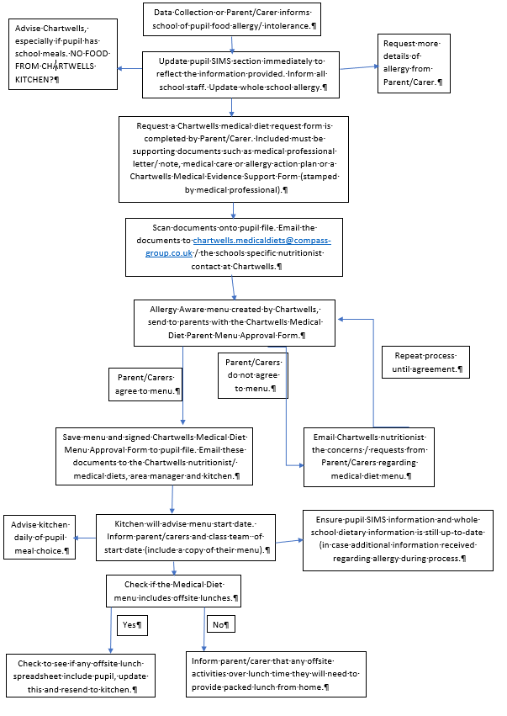
Appendix 1
Allergy/Intolerance/Dietary Requirements Management Flowchart

Appendix 2
Tier Management System

Category | Dietary Needs
1 | Pupils with severe allergies requiring emergency treatment and/or emergency rescue medication.
2 | Pupils who have mild to moderate allergies.
3 | Pupils who have food intolerances.
4 | Pupils with dietary preferences based on religious/ethical beliefs.
5 | Pupils who have dietary preferences.

Appendix 3
ALLERGY AND INTOLERANCE NOTIFICATION FORM
Pupil Name: Class:
What is an allergy?
Allergies occur when the body’s immune system reacts to a substance as though it is harmful. It causes a release of histamine and other substances into the body. A reaction usually occurs within a few minutes of eating the offending food. In severe cases, allergic reactions can be life threatening.
What is an intolerance?
A food intolerance is a difficulty digesting certain foods and have an unpleasant physical reaction eg bloating and tummy pain. The symptoms usually occur a few hours after eating the food. A child might only need to have eaten a small amount to have a reaction.
Please tick the relevant boxes below:
Substance | Allergy | Intolerance
Celery
Cereals containing gluten
Crustaceans (eg shrimp, lobster etc)
Eggs
Fish
Lupin
Milk/Dairy Products
Molluscs
Mustard
Nuts
Sesame
Soya
Sulphites
Tree Nuts
Any other food/drink - please state:

Dietary Preferences - please tick the relevant boxes below:
Vegan
Vegetarian
Pescatarian
Halal
Kosher
No Halal
No Beef
No Pork
No Gelatine
Other

Parent/Carer Name:…………………………………………………………….

Signature:……………………………………………………………………….

Date……………………………………………………………………………..:

If your child has no known food allergies/intolerances.

If your child has no known food allergies/intolerances, please sign the below declaration:

I (insert name) ______________________ declare that my child
(insert name) _________________________ has no known food allergies or intolerances. I will also update the school immediately if my child develops a food allergy/ intolerance.
Signed _______________________________
Date ________________________

Appendix 4
Allergy Management Risk Assessment for Individual Students
This form should be completed by the setting in liaison with the parents/guardian and the student if appropriate. It should be shared with everyone who has contact with the student. It should be read alongside the student’s Health Care Plan that has been produced the Allergy clinic. A whole school approach is recommended in the management of allergy which would involve all staff to have awareness training in addition to key staff having adrenaline autoinjector (AAI) training.
Child/Young person: Click or tap here to enter text. |  | Date of Birth: Click or tap here to enter text.
Setting/School: Click or tap here to enter text. |  | Key Worker/Teacher/Tutor: Click or tap here to enter text.
Allergies: Click or tap here to enter text.
Are reactions: Ingestion Click or tap here to enter text. Direct contact: Click or tap here to enter text. Indirect contact: Click or tap here to enter text.
G.P:  Name: Click or tap here to enter text.  Phone number: Click or tap here to enter text. |  | Clinic/Hospital:  Name: Click or tap here to enter text.  Phone number: Click or tap here to enter text.
Date: Click or tap here to enter text. | Review date: Click or tap here to enter text.
Who is responsible for providing support in school: Click or tap here to enter text.
People involved in writing this plan: Click or tap here to enter text.
Signatures:
Setting Manager/Head teacher:
Date: Click or tap here to enter text.
Young person: Date: Click or tap here to enter text.
I give permission for this risk assessment to be shared with anyone who needs this information to keep my child/young person safe,
I give permission for my child’s photograph to be displayed sensitively to keep my child safe,
I give permission for the school’s ‘spare’ AAI to be used on my child in an emergency where anaphylaxis is suspected.
Parents: Date: Click or tap here to enter text.

Complete this risk assessment in discussion with the parent/guardian, student if appropriate and medical professional if available. Consider all situations that the student may be in and agree control measures. Use the risk analysis tool at the end of the document to assess probability and impact producing further control measures if necessary. This is intended to be dynamic document and should be updated annually or after an incident or near miss.
Can the student recognise a reaction for themselves?

What have been the symptoms of previous reactions?

What are the hazards for each activity? |  |  |  |  |  | What are you already doing to control the risks? |  |  |  |  |  |  |  |  | Probability |  |  | Impact
Medication:
Storage:
Location of child’s medication
Location of generic ‘spare’ AAI

Food and drink:
Break time snacks including drinks

Lunch time:
Hot meals
Sandwiches
Drinks

Events involving food:
Cake sales
Parties
Other PTA events
Drinks

Celebrations: e.g. Birthdays, Easter

Curriculum activities:
Cooking
Creative activities: e.g. junk modelling, pasta
Music: instrument sharing (cross contamination issue)

Science activities:
PE:
Indoor
Outdoor
Forest Schools
Playtime:
Playground
Field

Offsite activities:
Curriculum visitors
Day trips

Residential visits
Other:
This must be completed for any activity that is medium with the aim of bringing the risk to LOW.

Activities that are High or Extreme must not happen unless action can be implemented to bring the risk to LOW.
Hazard |  | What further action do you need to take to control the risks? |  |  |  |  |  |  |  |  | Who needs to carry out the action? |  |  | What is the action needed by? |  |  | Completed
Consequence |  |  |  |  | Minor |  |  | Moderate |  | Major |  | Critical |  |  |  | Catastrophic
Likelihood | Rare |  |  |  | Low |  |  | Low |  | Low |  | Low |  |  |  | Low
Likelihood | Unlikely |  |  |  | Low |  |  | Low |  | Medium |  | Medium |  |  |  | Medium
Likelihood | Possible |  |  |  | Low |  |  | Medium |  | Medium |  | High |  |  |  | High
Likelihood | Likely |  |  |  | Medium |  |  | Medium |  | High |  | High |  |  |  | Extreme
Likelihood | Certain |  |  |  | Medium |  |  | Medium |  | High |  | Extreme |  |  |  | Extreme
Consequence |  |  |  | Minor |  |  | Moderate |  | Major |  |  |  | Critical |  |  |  |  |  | Catastrophic
This is the impact of the action being allowed to happen |  |  |  | No reaction |  |  | Non anaphylactic reaction |  | Emergency response required, ambulance and hospital |  |  |  | Emergency response required, ambulance and hospital |  |  |  |  |  | Fatal, Death
Likelihood |  |  | Definition
Rare |  |  | May only occur in exceptional circumstances
Unlikely |  |  | Could occur in some circumstances, surprised if happened
Possible |  |  | Possible or likely to occur in most circumstances
Likely |  |  | Will occur in most circumstances
certain |  |  | It is expected to occur, inevitable

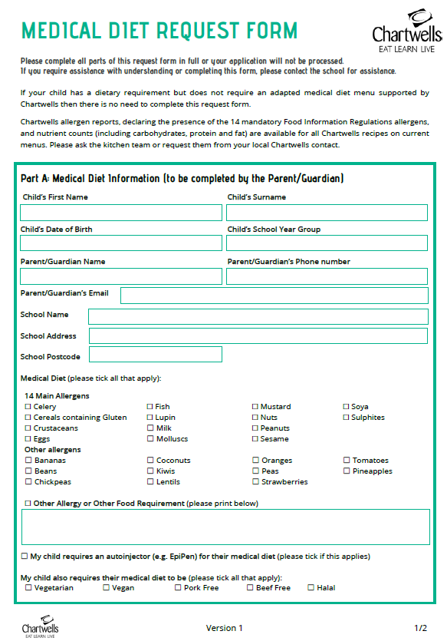
Appendix 5
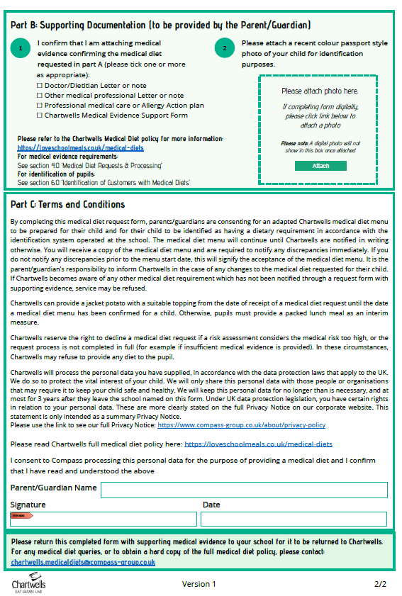

ALLERGY NEAR MISS REPORT FORM
Appendix 6
This form should be completed whenever a Near Miss occurs.

NEAR MISS REPORT FORM
i | Date of Near Miss: | Time of Near Miss:
ii | Location of Near Miss:
iii | Who was involved in the Near Miss:  ◻ Pupil ◻ Employee
iv | Name of person(s) involved in Near Miss:
v | Name & Contact details of any witnesses to Near Miss:
 | Details of Incident
vii
 | Signature of person completing report: |  | Date:
 | Print Name & Job Title:

Copies of the completed Near Miss Report Form are to be sent to the Executive Head Teacher

