

Approved by Governing Body on: | 12 February 2026
Signed by Chair of Governors: | 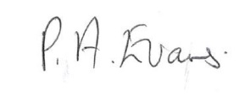
Executive Head Teacher: | O M Flowers
Lead Personnel: | A Gibson
Date of Review: | 12 February 2028


Introduction

School Safer Recruitment Policy
2025-2026
Building foundations and providing opportunities to create confident,
aspirational, and independent members of our community.
www.thewestminsterschool.co.uk
The Westminster School (TWS) is committed to safeguarding and promoting the welfare of children and young people and expects all staff, volunteers, site staff, personnel from alternative providers and 3rd party contractors to share this commitment.
TWS is committed to recruiting and selecting high-quality staff with the necessary skills, experience, and aptitude to care for, nurture, and enable pupils to learn and thrive in a happy, caring, and safe environment. This continues the School’s vision of Safe, Happy and Learning.
When recruiting any staff, there is always at least one member of staff of the interviewing panel who has completed the Safer Recruitment Training. This training is provided by a recognised training provider with the relevant skill sets and expertise to deliver topics pertinent to the qualification obtained on completion.
All staff employed at TWS, including volunteers, casual staff, and university and college students will be required to undertake an enhanced DBS and Barring Check. This is renewed in line with Sandwell Local Authority Guidelines on a three-year cycle.

Safer Recruitment Procedure
New Staff
When a post becomes vacant or is created then the following procedure takes place:
- Job and Person Specification

For every vacancy a job and person specification will be written and approved by the Executive Head Teacher. Each role is tailored to take into account the following:
- General Professional Duties and Responsibilities
- Knowledge and Understanding
- Planning, Teaching and Classroom Management
- Sickness Absence and Disability
- Qualifications
- Experience
- Disposition
- Practical and Intellectual Skills
- Other Professional Requirements
- Legal and Legislative Requirements (e.g. Enhanced DBS and Barring Check, Criminal Convictions, Childcare Disqualification Declaration and other pre-employment checks relevant to Sandwell Council’s Schools Model Recruitment and Selection Policy).

- Job Advertisement

All posts will be advertised internally and externally in order to attract a wide field of candidates as possible. The exception to this is where internal applicants are required due to budgetary challenges.
All advertisements for posts will include:

- Our school’s commitment to safeguarding and promoting the welfare of children
- That safeguarding checks will be undertaken
- The safeguarding requirements and responsibilities of the role, such as the extent to which the role will involve contact with children
- Whether or not the role is exempt from the Rehabilitation of Offenders Act 1974 and the amendments to the Exceptions Order 1975, 2013 and 2020. If the role is exempt, certain spent convictions and cautions are ‘protected’, so they do not need to be disclosed, and if they are disclosed, we cannot take them into account.
- Application Form

- Include a statement saying that it is an offence to apply for the role if an applicant is barred from engaging in regulated activity relevant to children (where the role involves this type of regulated activity)
- Include a copy of, or link to, our child protection and safeguarding policy and our policy on the employment of ex-offenders

- Shortlisting and References

- All applications will be looked at in detail and scrutinised by at least two members of SLT or the Governing Board and the HR Manager.
- They will consider any inconsistencies and look for gaps in employment and reasons given for them and explore all potential concerns
- All applicants for any post within the school will be required to complete an application form - a curriculum vitae will not be accepted.
- Incomplete applications will not be accepted, and may be returned for completion.
- Applicants will be shortlisted for the post if they meet the particulars of the job description and person specification.
- Immediately after shortlisting, references will be sent for those candidates identified.
- All applicants will be asked to provide two referees, one of whom should be the applicant’s current or most recent employer. NB where an applicant who is not currently working with children, has done so in the past, it is important that a reference is also obtained from the employer by whom the person was most recently employed in work with children.
- When seeking references we will:
  - Not accept open references
  - Liaise directly with referees and verify any information contained within references with the referees
  - Ensure any references are from the candidate’s current employer and completed by a senior person. Where the referee is school based, we will ask for the reference to be confirmed by the headteacher as accurate in respect to disciplinary investigations
  - Obtain verification of the candidate’s most recent relevant period of employment if they are not currently employed
  - Secure a reference from the relevant employer from the last time the candidate worked with children if they are not currently working with children
  - Compare the information on the application form with that in the reference and take up any inconsistencies with the candidate
  - Resolve any concerns before any appointment is confirmed.

- All referees will be asked if the candidate is suitable to work with children, has any disciplinary procedures relating to the safety and welfare of children, or any details of allegations/concerns/bad behaviour relating to the safety and welfare of children (see appendix 1).
- The HR provider or other nominated person will inform those shortlisted immediately after the shortlisting process has taken place. Unsuccessful applicants will not always be informed due to the potential volume of applications the school may experience.

In line with Keeping Children Safe in Education (September 2025) all shortlisted applicants will be subject to an online search as part of our due diligence. This may help identify any incidents or issues that have happened and are publicly available online, which the school may wish to explore with the applicant at interview. This search does not form part of the shortlisting process and you will have the chance to discuss any issues of concern that come up during the search at interview.
Shortlisted candidates will be made aware that an online search of publicly available information will be undertaken and will have an opportunity to address any issues of concern that arise during the search at interview.
The check will be made by a member of staff who is not part of the recruitment process (to prevent any unconscious bias) unless this is not possible due to confidentiality reasons and will then be carried out by the HR Manager and the form for the check to be made is included as Appendix 5.
Shortlisted candidates will be sent:
- A self-declaration form to detail their criminal record or any information that would make them unsuitable to work with children, so that they have the opportunity to share relevant information and discuss it at interview stage. The information we will ask for includes:
  - If they have a criminal history
  - Whether they are included on the barred list
  - Whether they have any unspent conditional cautions or convictions under the Rehabilitation of Offenders Act 1974
  - Whether they have any adult cautions (simple or conditional) or spent convictions that are not protected as defined by the Rehabilitation of Offenders Act 1974 (Exceptions) Order 1975 (Amendment) (England and Wales) Order 2020
  - Whether they are prohibited from teaching
  - Information about any criminal offences committed in any country in line with the law as applicable in England and Wales
  - Any relevant overseas information
  - They will be asked to sign a declaration confirming the information they have provided is true
- detailed documentation of the interview process
Shortlisted candidates will be asked if they have a disability within the meaning of the Equality Act 2010 and if they require any particular adjustments to accommodate their particular needs.
Also, they will be informed if they will have to undertake skill tests as part of the interview.
- The Interview
- On the day of the interview all candidates will need to provide proof of identity, proof of their qualifications and proof of eligibility to live and work in the UK.
- The interview may consist of an activity, informal meetings with the Governing Board and representatives from the Local Authority, a meeting with the School Council and a Professional Interview.
- Teaching posts will require a short micro-teach and Classroom Support Staff posts will be required to support a class for a period of time.
- All candidates will be assessed for their suitability to the post and their capability to safeguard and protect the welfare of children and young people. This is to be assessed through specific Child Protection and Safeguarding questions coupled with e-Safety questions.
- During the interview, any discrepancies noted from the shortlisting, including any gaps in employment, will be explored. If the interviewing panel are not satisfied with any explanation given, the applicant will not be successful.
When interviewing candidates, we will:
- Probe any gaps in employment, or where the candidate has changed employment or location frequently, and ask candidates to explain this
- Explore any potential areas of concern to determine the candidate’s suitability to work with children
- Record all information considered and decisions made
Pre-appointment vetting checks
We will record all information on the checks carried out in the school’s single central record (SCR). Copies of these checks, where appropriate, will be held in individuals’ personnel files. We follow requirements and best practice in retaining copies of these checks, as set out below.
New staff
All offers of appointment will be conditional until satisfactory completion of the necessary pre-employment checks. When appointing new staff, we will:
- Verify their identity – Keeping Children Safe in Education September 2025 states that best practice to do this is to check the name on the candidate’s birth certificate where available
- Obtain (via the applicant) an enhanced DBS certificate, including barred list information for those who will be engaging in regulated activity (see definition below). We will obtain the certificate before, or as soon as practicable after, appointment, including when using the DBS update service. We will not keep a copy of the certificate for longer than 6 months, but when the copy is destroyed we may still keep a record of the fact that vetting took place, the result of the check and recruitment decision taken
- Obtain a separate barred list check if they will start work in regulated activity before the DBS certificate is available
- Verify their mental and physical fitness to carry out their work responsibilities
- Verify their right to work in the UK. We will keep a copy of this verification for the duration of the member of staff’s employment and for 2 years afterwards
- Verify their professional qualifications, as appropriate
- Ensure they are not subject to a prohibition order if they are employed to be a teacher
- Carry out further additional checks, as appropriate, on candidates who have lived or worked outside of the UK. Where available, these will include:
  - For all staff, including teaching positions: criminal records checks for overseas applicants
  - For teaching positions: obtaining a letter of professional standing from the professional regulating authority in the country where the applicant has worked
Regulated activity means a person who will be:
- Responsible, on a regular basis in a school or college, for teaching, training, instructing, caring for or supervising children; or
- Carrying out paid, or unsupervised unpaid, work regularly in a school or college where that work provides an opportunity for contact with children; or
- Engaging in intimate or personal care or overnight activity, even if this happens only once and regardless of whether they are supervised or not.
Existing staff
In certain circumstances we will carry out all the relevant checks on existing staff as if the individual was a new member of staff. These circumstances are when:
- There are concerns about an existing member of staff’s suitability to work with children; or
- An individual moves from a post that is not regulated activity to one that is; or
- There has been a break in service of 12 weeks or more
We will refer to the DBS anyone who has harmed, or poses a risk of harm, to a child or vulnerable adult where:
- We believe the individual has engaged in relevant conduct; or
- We believe the individual has received a caution or conviction for a relevant (automatic barring either with or without the right to make representations) offence, under the Safeguarding Vulnerable Groups Act 2006 (Prescribed Criteria and Miscellaneous Provisions) Regulations 2009; or
- We believe the ‘harm test’ is satisfied in respect of the individual (i.e. they may harm a child or vulnerable adult or put them at risk of harm); and
- The individual has been removed from working in regulated activity (paid or unpaid) or would have been removed if they had not left
Agency and third-party staff
We will obtain written notification from any agency or third-party organisation that it has carried out the necessary safer recruitment checks that we would otherwise perform. We will also check that the person presenting themselves for work is the same person on whom the checks have been made.
Contractors
We will ensure that any contractor, or any employee of the contractor, who is to work at the school has had the appropriate level of DBS check (this includes contractors who are provided through a PFI or similar contract). This will be:
- An enhanced DBS check with barred list information for contractors engaging in regulated activity
- An enhanced DBS check, not including barred list information, for all other contractors who are not in regulated activity but whose work provides them with an opportunity for regular contact with children
We will obtain the DBS check for self-employed contractors.
We will not keep copies of such checks for longer than 6 months.
Contractors who have not had any checks will not be allowed to work unsupervised or engage in regulated activity under any circumstances.
We will check the identity of all contractors and their staff on arrival at the school.
Trainee/student teachers
Where applicants for initial teacher training are salaried by us, we will ensure that all necessary checks are carried out.
Where trainee teachers are fee-funded, we will obtain written confirmation from the training provider that necessary checks have been carried out and that the trainee has been judged by the provider to be suitable to work with children.
Volunteers
We will:
- Never leave an unchecked volunteer unsupervised or allow them to work in regulated activity
- Obtain an enhanced DBS check with barred list information for all volunteers who are new to working in regulated activity
- Carry out a risk assessment when deciding whether to seek an enhanced DBS check without barred list information for any volunteers not engaging in regulated activity. We will retain a record of this risk assessment.
- Ensure that appropriate checks are carried out to ensure that individuals are not disqualified under the 2018 Childcare Disqualification Regulations and Childcare Act 2006. Where we decide that an individual falls outside of the scope of these regulations and we do not carry out such checks, we will retain a record of our assessment. This will include our evaluation of any risks and control measures put in place, and any advice sought
Governors
All governors will have an enhanced DBS check without barred list information.
They will have an enhanced DBS check with barred list information if working in regulated activity.
All governors will also have a section 128 check (as a section 128 direction disqualifies an individual from being a maintained school governor).
Staff working in alternative provision settings
Where we place a pupil with an alternative provision provider, we obtain written confirmation from the provider that they have carried out the appropriate safeguarding checks on individuals working there that we would otherwise perform.
Adults who supervise pupils on work experience
When organising work experience, we will ensure that policies and procedures are in place to protect children from harm.
We will also consider whether it is necessary for barred list checks to be carried out on the individuals who supervise a pupil under 16 on work experience. This will depend on the specific circumstances of the work experience, including the nature of the supervision, the frequency of the activity being supervised, and whether the work is regulated activity.
Further reading and other Policy information
It is important that this policy is read in conjunction with the school’s Child Protection Policy and Guidance.
Where supply staff are used, compliance checks will be made ensuring that agencies provide written evidence of in date enhanced DBS.

Appendix 1 The Westminster School Reference Request Template

Appendix 2 The Westminster School SCR Headings.

Appendix 3 SIPS HR Pre-employment Checklist

Appendix 4 SIPS HR Fully Cleared Memo

Appendix 5 – Shortlisted Candidate Online Search Form and Risk Assessment Form

The Westminster School Child Protection and Safeguarding Policy. – Please refer to policy

Appendix 1
The Westminster School Reference Request Template

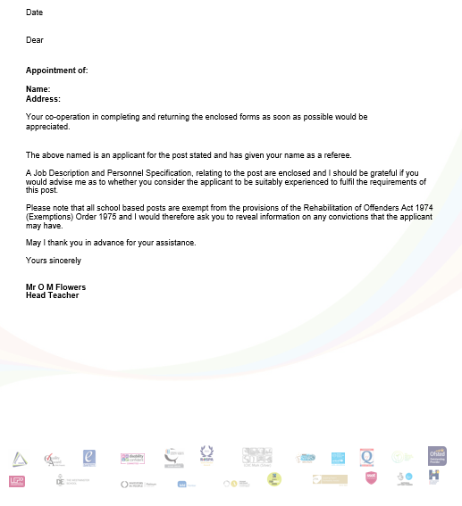

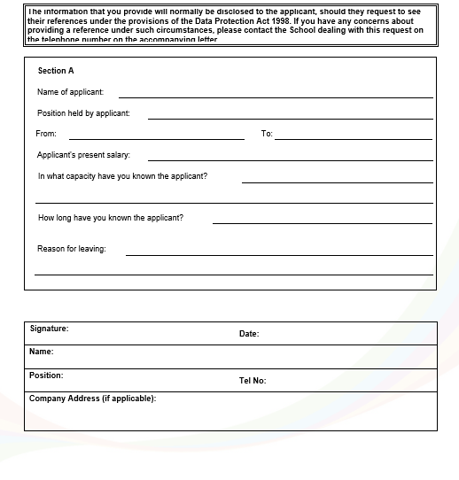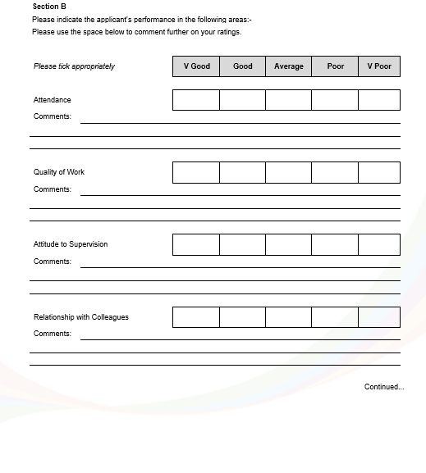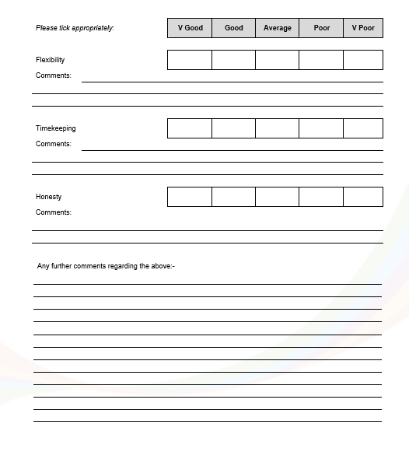

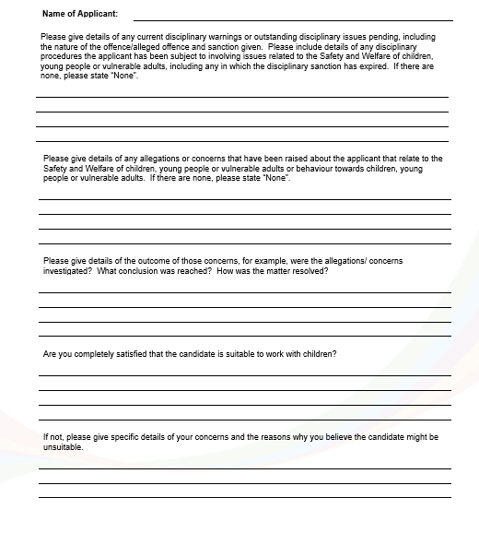

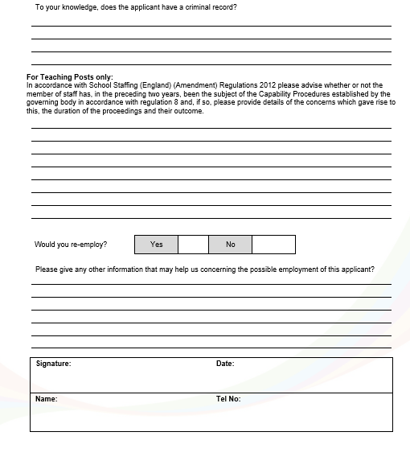

Appendix 2 The Westminster School SCR Headings.
ID Checks
- Name
- Address
- Date of Birth
- Address ID seen by and date
- Photo ID seen by and date
- Date started with School
- Position held

Prohibition from Teaching Check
- Check required (Yes/ No)
- Date of check
- Check undertaken by

Qualifications and Registration
- Teaching qualifications required (Yes/No)
- If required, teaching qualifications evidenced
- Teacher Reference Number
- If required, date teaching qualifications seen
- If required, date teaching agency reference seen

Vetting Checks
- Disclosure Number
- DBS date of issue
- DBS date of expiry
- DBS checked by and date
- DBS Countersignatory
- Barred list checked by and date
- Letter of professional standing from the professional regulating authority in the country where the applicant has worked
- For Staff Appointed Pre 01/01/2021
  - Overseas Police check required (Yes/No)
  - Overseas Check made by and date
  - EEA Check (Yes/No)
  - EEA Check made by and date
- For Staff Appointed post 01/01/2021
  - Has individual worked or lived outside of the UK
  - Appropriate checks completed (include details of checks)
  - Date checked and by
- Risk assessment (Yes/No)
- Risk assessment date
- References Received
- Online Checks Conducted
Right to work in the UK Check
- Evidence seen
- Evidence seen by and date
Appendix 3
SIPS PRE-EMPLOYMENT CHECKLIST

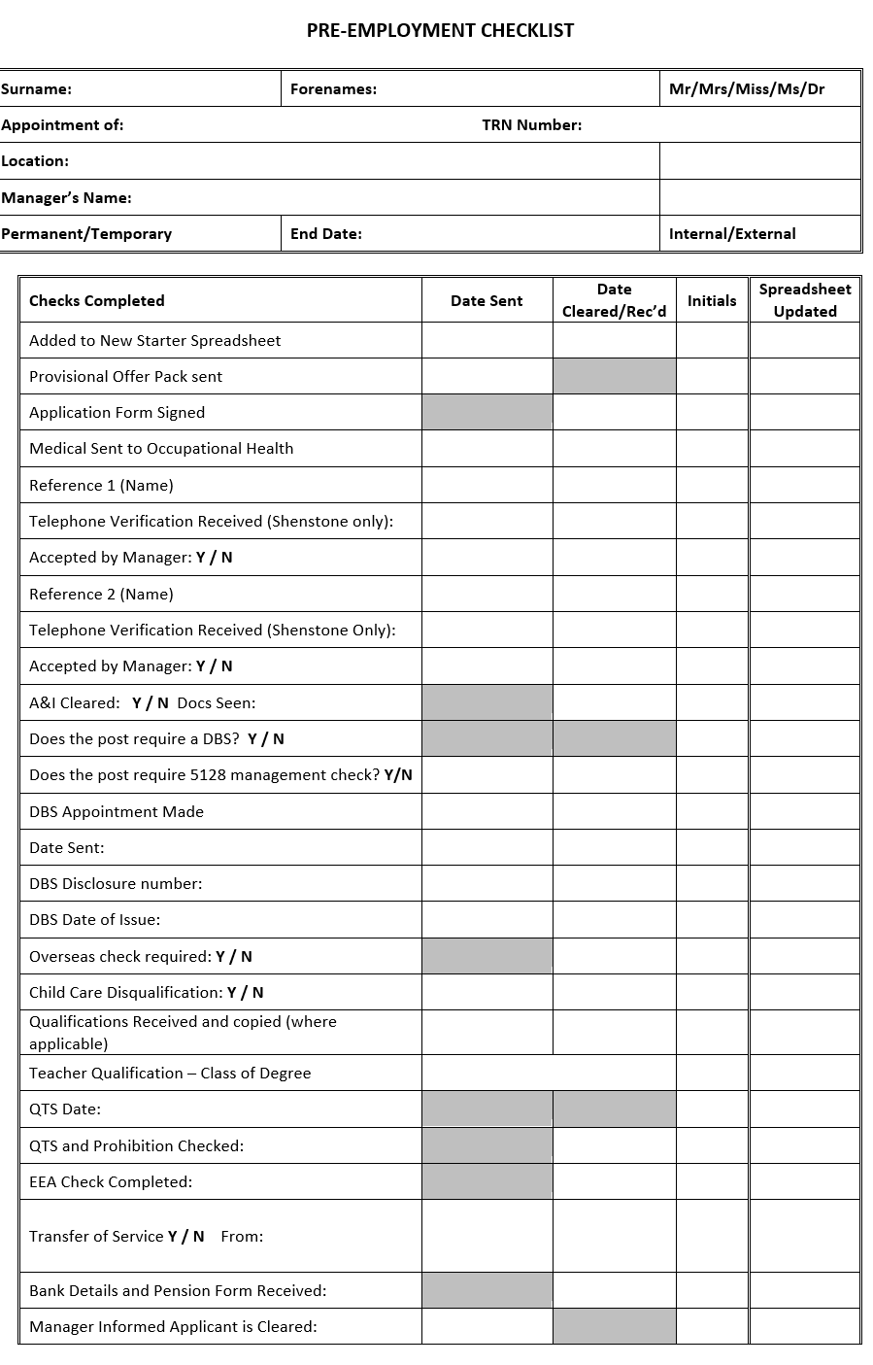

Appendix 4 – Full Cleared Memo

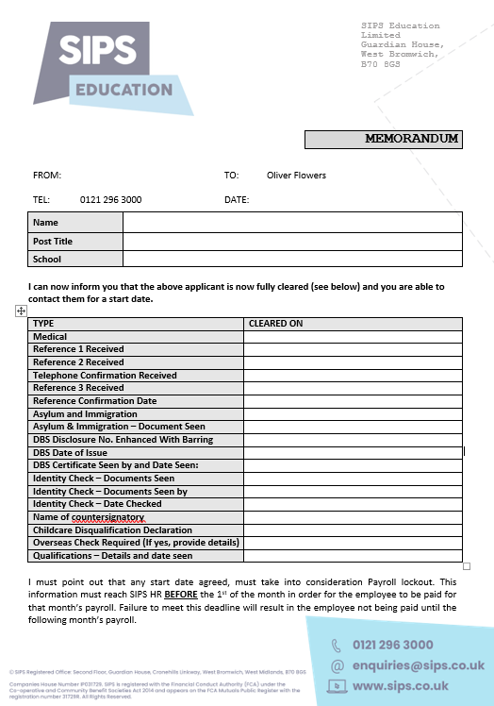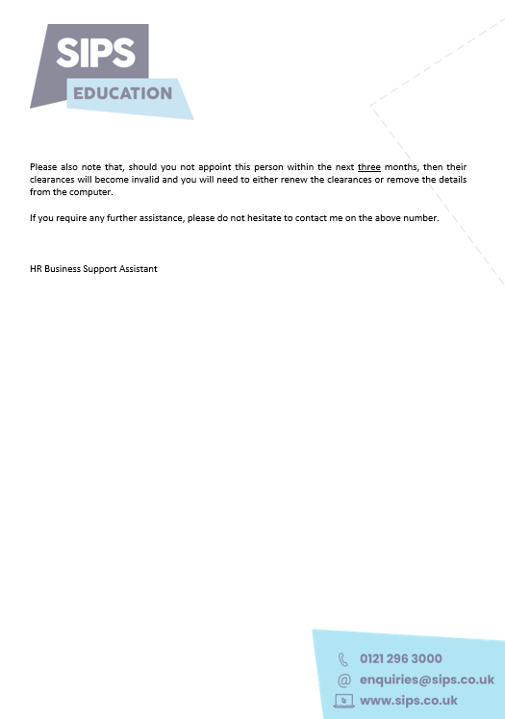

Appendix 5 – Shortlisted Candidate Online Search Form and Risk Assessment Form


Online Search – Shortlisted Candidates

Candidate Name:
Role Shortlisted for:
Searcher Name:
Date online search conducted:

Search Parameter | Outcome of Search
Google:
Candidate Name
Candidate name and Job Title

Linkedin: | Results of name found (attach a screen shot)  No Results found
For staff undertaking Teaching work only (including Teachers/Unqualified Teachers):  TRA hearing search | Search applicants name with TRA hearing (example: Jane Doe TRA hearing)

Risk Assessment needed: Yes/No

Online Search Risk Assessment
Name of individual |  | Discussed with individual |  | Date
Post Applied for |  | School
Head Teacher |  | Signed |  | Date

Risk Assessment
Outline the explanation and/or circumstances provided by the applicant

Are the search findings relevant to the position?
Are you satisfied with the candidate’s explanation of the circumstances surrounding the online search findings?
Do the online search findings impact on the candidate’s suitability to work with children and young people?
Do the candidate’s referees identify any concerns?

Decision (tick as applicable) | Employ | Do not employ | Comments (including any adjustments required)

