
Approved by Governing Body on: | 07/10/2025
Signed by Chair of Governors: | 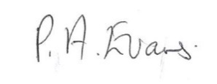
Executive Head Teacher: | O Flowers
Lead Personnel: | N Brenton
Date of Review: | 06/10/2026


Appeals Policy
2025/2026

Building foundations and providing opportunities to create confident,
aspirational, and independent members of our community.
www.thewestminsterschool.co.uk

Appeals Policy
The Westminster School is committed to ensuring that whenever it’s staff mark candidates’ controlled assessments or coursework this is done fairly, consistently and in accordance with the awarding body’s specification and subject-specific associated documents.
Candidates’ work will be marked by staff who have appropriate knowledge, understanding and skill, and who have been trained in this activity. The Westminster School is committed to ensuring that work produced by candidates is authenticated in line with the requirements of the awarding body. Where several subject teachers are involved in marking candidates’ work, internal moderation and standardisation will ensure consistency of marking.

If a candidate believes that this may not have happened in relation to his/her work, he/she may make use of this appeals procedure.
On being informed of their centre assessed marks, if a candidate believes that the above procedures were not followed in relation to the marking of his/her work, or that the assessor has not properly applied the mark scheme to his/her marking, then he/she may make use of this appeals procedure to consider whether to request a review of the centre’s marking.
An appeal may only be made against the assessment process and not against the mark submitted to the awarding body.

- Appeals should be made as early as possible, and no later than two weeks before the last timetabled examination in the series (e.g. the last GCSE written paper in the June series).
- Appeals must be made in writing by the candidates’ parent/carer to the examinations officer.
- The Head of Centre will appoint a senior member of staff, i.e. Assistant Head Teacher or Deputy Head Teacher, to conduct the investigation. The senior member of staff will not have had any involvement in the internal assessment process for that subject.
- The purpose of the appeal will be to decide whether the process used for internal assessment conformed to the awarding body’s specification and subject-specific associated documents.
- The appellant will be informed in writing of the outcome of the appeal, including any relevant correspondence with the awarding body, and any changes made to internal assessment procedures.
- The outcome of the appeal will be made known to the Head Teacher and will be logged as a complaint. A written record will be kept and made available to the awarding body upon request. Should the appeal bring any irregularity in procedures to light, the awarding body will be informed.

After the candidates’ work has been internally assessed, it is moderated by the awarding body to ensure consistency in marking between centres. The moderation process may lead to mark changes. This process is outside the control of The Westminster School and is not covered by this procedure.
The Westminster School’s Appeals Policy aims to enable the learner to enquire, question or appeal against an assessment decision. It has been developed so that the school can attempt to reach an agreement between the learner and the assessor at the earliest opportunity. It also aims to standardise and record appeals with openness and fairness; facilitate a learner’s ultimate right of appeal to the awarding body, where appropriate; and finally, to protect the interests of all learners and the integrity of the qualification.
To do this the school will:

- Inform the learner at induction, of the Appeals Policy and procedure.
- Ensure that induction for students is appropriate and that any handbooks given to students regarding appeals are accessible.
- Record, track and validate any appeal.
- Forward the appeal to the awarding body when a learner considers that a decision continues to disadvantage him/her after the internal appeals process has been exhausted.
- Keep appeals records until all post-results services and appeals/malpractice investigations are completed, and longer where requires by the awarding body.
- Have a staged appeals procedure.
- Will take appropriate action to protect the interests of other learners and the integrity of the qualification, when the outcome of an appeal questions the validity of other results.
- Monitor appeals to inform quality improvement.

Appeals should be made in writing stating the details of complaint and the reasons for the appeal within 3 working days of receiving the feedback and grade of work in question. Appendix one outlines a template that may be used to support the reporting of a written complaint about an appeal. The teacher who made the assessment decision will be given a copy of the appeal and will respond in writing to this to the lead internal assessor within 5 working days. The internal assessor will decide on the grading and give written feedback to both the learner and the teacher involved within a further 5 working day period, this is in line with JCQ requirements and provides a reasonable period of time, the school will publish internal deadlines.
The learner raising the appeal will have the opportunity to a personal hearing if they are not happy with the written response received. The learner will be given reasonable notice of the hearing date and should have sight of all the relevant documents to the case in advance of the hearing. Where the learner is presenting their own case, they are allowed to bring along a parent/guardian. The teacher(s) and learner will have the opportunity to hear each other’s submission to the panel Senior Management Team. A written record of the appeal and hearing will be taken including the outcome of an appeal and reason for that outcome. This will be kept on file for 18 months and the learner will also receive a hard copy. The school will inform the awarding body if there is any change to an internally assessed grade because of an appeal.

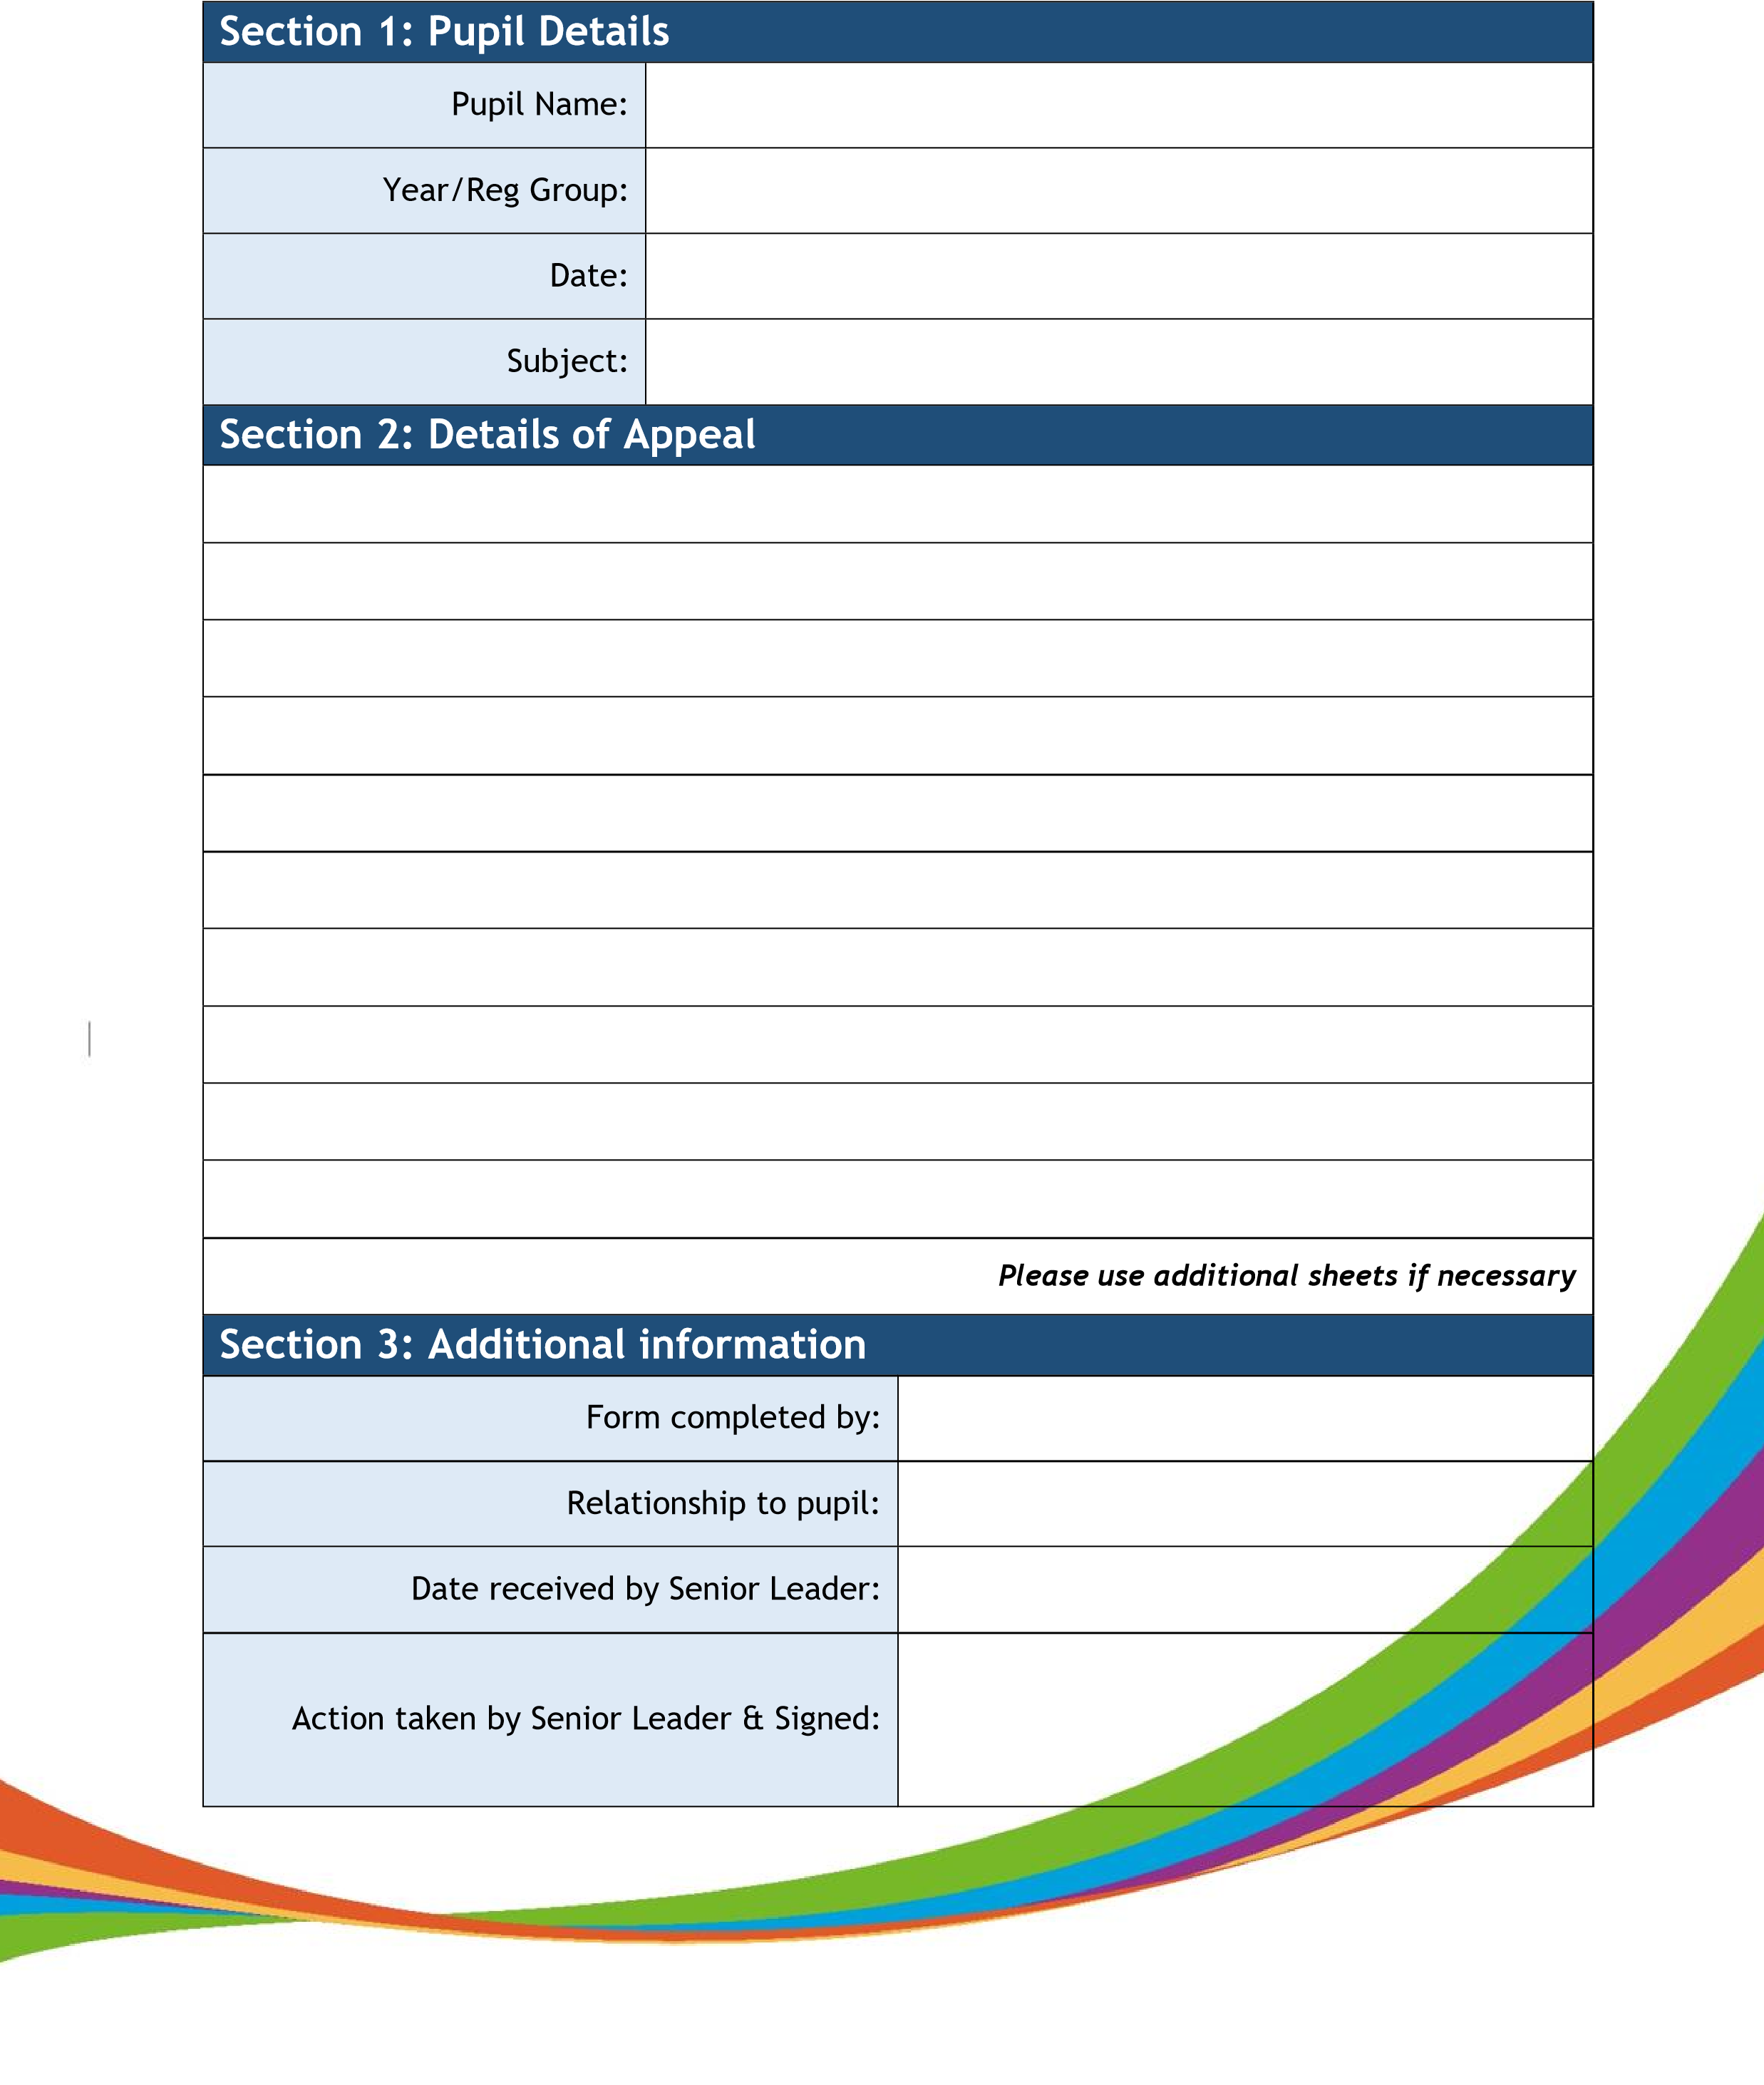
Appendix 1: Appeals Form

