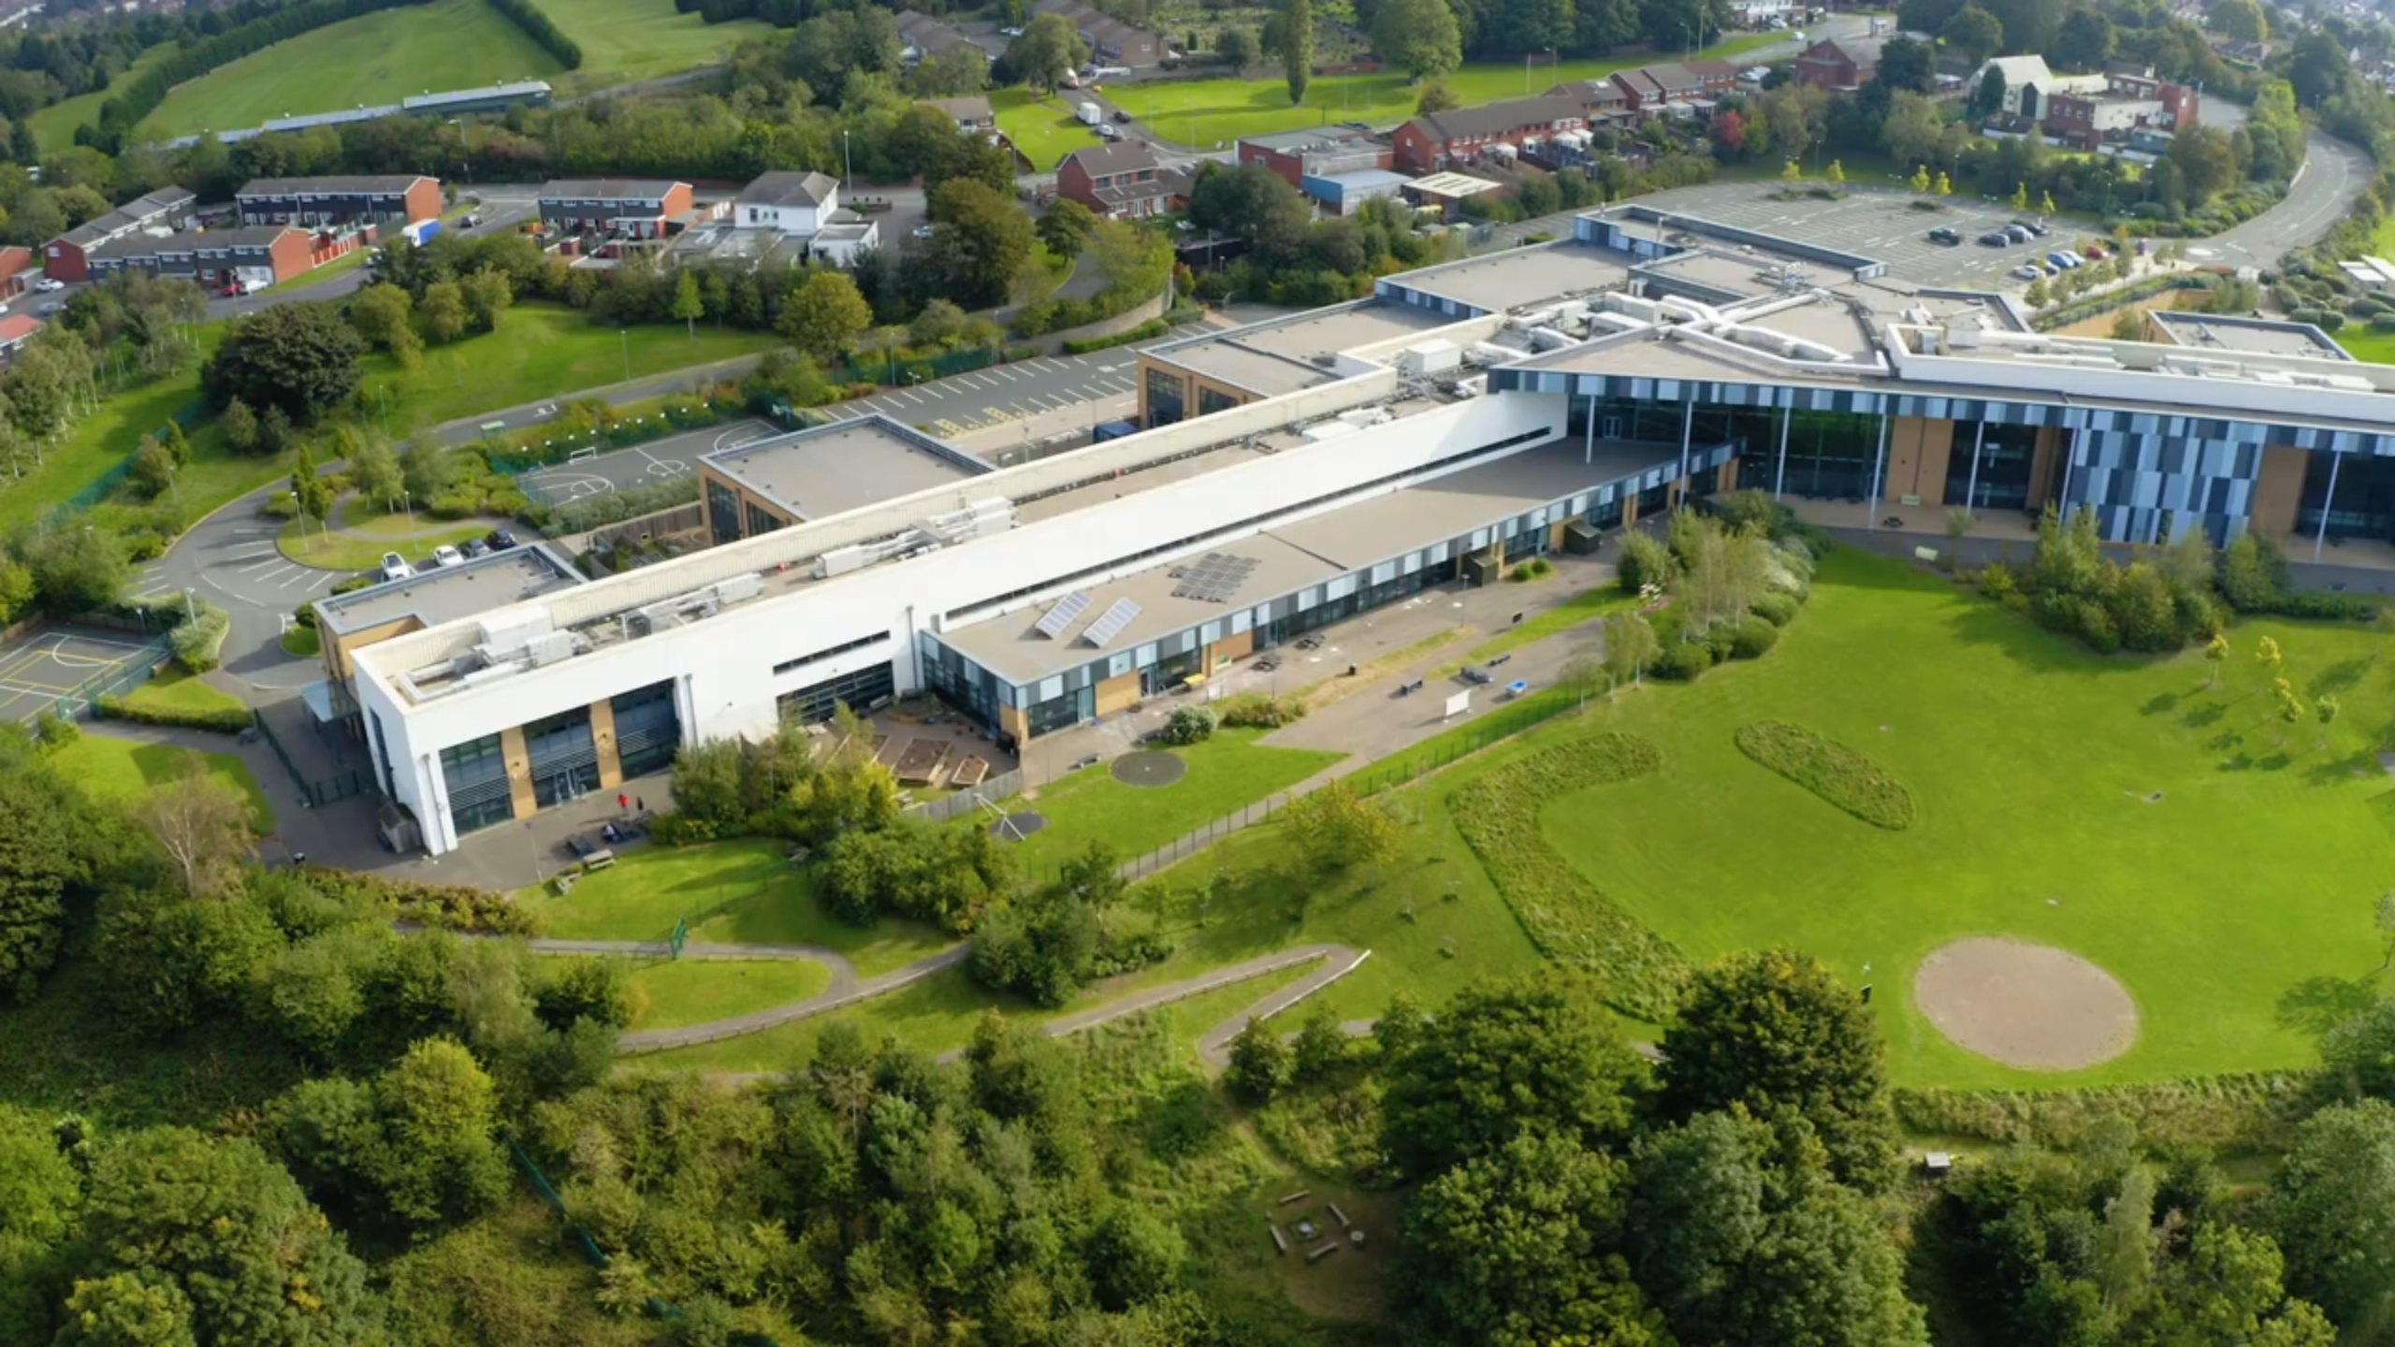

Approved by Governing Body on: | 06/02/2023
Signed by Chair of Governors: | 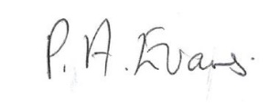
Head Teacher: | O M Flowers
Lead Personnel: | B Taylor
Date of Review: | 06/02/2024

School Provider Access Policy
2022/2023
Building foundations and providing opportunities to create confident,
aspirational, and independent members of our community.
www.thewestminsterschool.co.uk
The Westminster School Provider Access Policy
Introduction
This policy statement sets out the school’s arrangements for managing the access of providers to pupils at the school for the purpose of giving them information about the provider’s education or training offer. This complies with the school’s legal obligations under Section 42B of the Education Act 1997.
Schools and academies must give education and training providers the opportunity to talk to pupils in Years 8 to 13 about approved technical qualifications and apprenticeships. In January 2023 the updated Provider Access Legislation (PAL) came into force. The updated legislation specifies schools must provide at least six encounters with approved providers of apprenticeships and technical education for all their students:
- Two encounters for pupils during the ‘first key phase’ (year 8 or 9) that are mandatory for all pupils to attend.
- Two encounters for pupils during the ‘second key phase’ (year 10 or 11) that are mandatory for all pupils to attend.
- Two encounters for pupils during the ‘third key phase’ (year 12 or 13) that are mandatory for the school to put on but optional for pupils to attend
The new legislation will become a key mechanism to further help learners understand and take-up, not just apprenticeships, but wider technical education options such as T-Levels and Higher Technical Qualifications.
Pupil entitlement
At The Westminster School all pupils in years 8-13 are entitled:
- to find out about technical education qualifications and apprenticeships opportunities, as part of a careers programme which provides information on the full range of education and training options available at each transition point;
- to hear from a range of local providers about the opportunities they offer, including technical education and apprenticeships – through options events, assemblies and group discussions and taster events;
- to understand how to make applications for the full range of academic and technical courses
How?
The school will meet this new legislation by providing students with the possible following activities:
Careers Fairs (in school or in the community)
Visits to the workplace (preferably for organisations that offer inclusive apprenticeships)
Employer visits to school which include information on apprenticeships
Careers Assemblies
Virtual presentations
Breakfast events
Speed networking conferences
Focussed careers advice and mentoring

Management of provider access requests
A provider wishing to request access should contact:
Ben Taylor
Deputy Head Teacher
The Westminster School
The Rowley Learning Campus
Hawes Lane
Rowley Regis
B65 9AL
Tel: 0121 5616884 Mob: 07583011890
Benjamin.taylor@westminster.sandwell.sch.uk

Opportunities for access
A number of events, integrated into the school careers programme, will offer providers an opportunity to come into school to speak to pupils and/or their parents/carers. Our school careers programme is available on the School website.
Please speak to Mr Taylor to identify the most suitable opportunity for you.
Upcoming events are also publicised on the school website and Facebook page. Providers are welcome to leave a copy of their prospectus or other relevant course literature at the Careers Resource Centre which is managed by the school librarian
Careers related activities happen throughout the school week but the timetabled can be adjusted to accommodate businesses and apprenticeship providers. These activities can happen during the school day which starts at 8.50am and finishes at 3.05pm.
Safeguarding
Our safeguarding/child protection policy outlines the school’s procedure for checking the identity and suitability of visitors. A copy of this policy can also be found on our website.

Premises and facilities
The school will make the main hall, classrooms or private meeting rooms available for discussions between the provider and students, as appropriate to the activity. As above if this is not possible due to restrictions then the school can facilitate virtual events.
The school will also make available AV and other specialist equipment to support provider presentations. This will all be discussed and agreed in advance of the visit with the Careers Leader or a member of their team.
Providers are welcome to leave a copy of their prospectus or other relevant course literature at the Careers Resource Centre, which is managed by the school librarian.
This information will be made available to our students when and how we feel it is appropriate.
Monitoring Arrangements
The school’s arrangements for managing the access of education and training providers to students is monitored by Ben Taylor, Deputy Head Teacher
CEIAG Policy
A copy of our Careers Education Advice and Guidance and Work-Related Learning policy (CEIAG) can be accessed via the school website. If you would like a printed copy, please contact the school office.
Previous organisations
The school have been very proud to partner with the following organisations who have given advice and guidance around careers (including apprenticeships)
Department for Work and Pensions
Ground Control
A F Blakemore
DPD
Marston’s Brewery
Chartwells
Mitie
Graham Construction

Student Destinations
Below is an overview of destinations of students from the schools Post 16 cohort for the academic year 2021/22
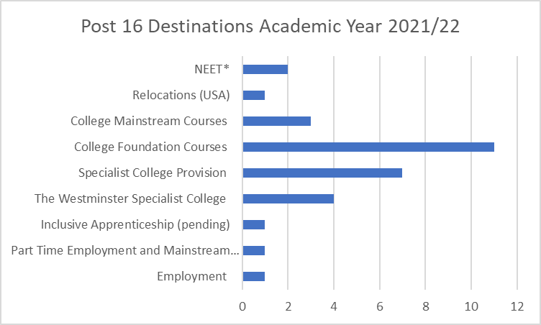

Complaints
Any organisations who wish to make a complaint about their experience with the school can follow the procedures outlined in the school complaints policy which can be found on the school website.

