Approved by Governing Body on: | 6/2/2023
Signed by Chair of Governors: | 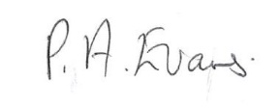
Head Teacher: | O M Flowers
Lead Personnel: | J Flowers/B Taylor
Date of Review: | 6/2/2025

Behaviour (Wellbeing and Engagement) Policy
2022/2023
Building foundations and providing opportunities to create confident,
aspirational, and independent members of our community.
www.thewestminsterschool.co.uk

Rationale
The Westminster School promotes a caring and supportive environment. We aim to promote positive behaviour, mental health and wellbeing for everyone by using both universal, whole school approaches and specialised, targeted support. We endeavour to enable all members of the School community to feel safe and happy in order to promote positive behaviour and wellbeing in all areas of School life.
Our school promotes a reflective, open and compassionate culture whereby everyone in the school community feels valued and able to approach each other for support and guidance.
There is a lot of debate in positive psychology about what wellbeing actually is. Martin Seligman’s (2011) PERMA theory is a way of thinking about five elements which he believes make up wellbeing. These are: Positive emotions, Engagement, Positive Relationships, Meaning and Accomplishment.
Seligman’s PERMA Model
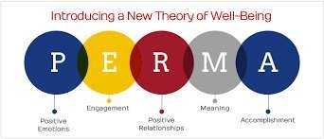

It has also been described as:
... “the balance point between an individual’s resource pool and the challenges faced…” Dodge, Daley, Huyton and Sanders (2012)

Aims

The Policy Aims to:
- Promote positive behaviour, mental health and wellbeing through our vision of Safe, Happy and Learning Together.
- Increase the understanding and awareness of behaviours presented by pupils linked to specific needs and how to respond to these appropriately.
- Alert staff to early warning signs of mental ill health.
- Provide support to staff working with young people with specific needs or mental health issues.

Positive behaviour and wellbeing

Promoting positive behaviour and wellbeing

Everyone at The Westminster School has agreed to recognise and highlight good behaviour as it occurs, thereby constantly reinforcing appropriate behaviours. We also encourage pupils to be responsible for their own behaviour by giving them opportunities to discuss their behaviour with adults and their peers and by promoting positive role models.

Reward Systems
- Peer praise assembly
- Praise postcards, letters and phone calls home, stickers and reward visits
- Certificates in assemblies and Pride of Westminster Awards
- Pupil Oscars
- Teachers should ensure that they complete certificates to celebrate good work, being helpful or considerate or general effort which can be given to pupils during the appropriate assembly.
- Positive comments in home/school log books and Personal Planners
- Personalised gifts/prizes
- TTF – Terrific Text Friday
- Reward visits

At The Westminster School good behaviour will always be recognised. Everyone thrives on praise and encouragement.

Curriculum, Teaching and Learning

Personalised programmes of support
Pupils at The Westminster School often have co-existing diagnoses. At any point, pupils can experience a period of crisis and require a more intensive support package to enable them to engage in their curriculum. Pathway leaders work with staff, pupils, parents and other professionals to ensure that the pupil is able to access an adapted and personalised curriculum where appropriate to meet their needs. This is often designed to be a short term arrangement which provides the pupils with more intensive support for a period of time. Personalised timetables are reviewed at regular intervals and amended or updated as required.

Risk Assessments
All pupils who pose a risk to themselves or others may require a risk assessment. A risk assessment template is available in Appendix 11.

In all instances where a Risk Assessment is in place we will work closely with parents and other agencies, e.g. Educational Psychologists to ensure the pupil is supported in developing self-regulation strategies. Each case will be discussed at the weekly Triage meetings and a Risk assessment completed and made available to all staff. Parents should also be provided with a copy of the Risk Assessment for their child. A Risk assessment should be reviewed at least once a term. There may be the need to create a different one for onsite and offsite activities.

Educational Visits
Loss of entitlement to curriculum education visits should not be used as a consequence. However, prior to any educational visit a risk assessment should be undertaken. Individual risk assessments should be considered for all offsite activities. All individual risk assessments are to be confirmed by a member of SLT.

Teaching about Mental Health
The skills, knowledge and understanding needed by our students to keep themselves and others physically and mentally healthy and safe are included as part of our SHaLT curriculum.
The specific content of lessons will be determined by the specific needs of the cohort we’re teaching but there will always be an emphasis on enabling students to develop the skills, knowledge, understanding, language and confidence to seek help, as needed, for themselves or others.
We will follow the PSHE Association Guidance to ensure that we teach mental health and emotional wellbeing issues in a safe and sensitive manner which helps rather than harms.

Responding to Behaviour and wellbeing

Ethos and Environment

In addition to promoting positive mental health and wellbeing, we aim to recognise and respond to mental ill health. In an average classroom, three children will be suffering from a diagnosable mental health issue. By developing and implementing practical, relevant and effective responses and procedures we can promote a safe and stable environment for students affected both directly, and indirectly, by mental ill health. It is important to note, however, that there may be some incidences where the pupil requires more specific and intensive support than the school is able to offer. In this instance, an Annual Review will be held to discuss a suitable alternative to allow the pupil to access the support they need.

Targeted support

Weekly Triage meetings are held by members of the Senior Leadership Team, SENCO and Educational Psychologist. Staff can refer pupils to the Triage meeting if they feel they require additional support to manage their emotions, wellbeing or behaviours by completing the Support Referral Form. Following discussions at the Triage meeting, suitable support will be identified and communicated to staff. This support will be reviewed on at least a half termly basis. The aim of the Triage group is to ensure that the right level of support is identified based on the need of the pupil at the time.
School staff may become aware of warning signs which indicate a student is experiencing mental health or emotional wellbeing issues. These warning signs should always be taken seriously and staff observing any of these warning signs should communicate their concerns with the Pathway Leader or SENCo.
Possible warning signs include:
- Physical signs of harm that are repeated or appear non-accidental
- Changes in eating / sleeping habits
- Increased isolation from friends or family, becoming socially withdrawn
- Changes in activity and mood
- Lowering of academic achievement
- Talking or joking about self-harm or suicide
- Abusing drugs or alcohol
- Expressing feelings of failure, uselessness or loss of hope
- Changes in clothing – e.g. long sleeves in warm weather
- Secretive behaviour
- Skipping PE or getting changed secretively
- Lateness to or absence from school
- Repeated physical pain or nausea with no evident cause
- An increase in lateness or absenteeism

If there is a fear that the student is in danger of immediate harm then the normal child protection procedures should be followed with an immediate referral to the Designated Safeguarding Lead. If the student presents a medical emergency then the normal procedures for medical emergencies should be followed, including alerting the first aid staff and contacting the emergency services if necessary. Where a referral to CAMHS is appropriate, this will be led and managed by Gemma Webb, SENCo.
If the concern is related to a member of staff, then the Headteacher should be informed.
If the concern relates to a member of the pupils family, a member of the Safeguarding team should be informed.

Signposting
We will ensure that staff, students and parents are aware of sources of support within school and in the local community through the Local Offer.
Parents are often very welcoming of support and information from the school about supporting their children’s emotional and mental health. In order to support parents we will:
- Highlight sources of information and support about common behavioural or mental health issues on our school website
- Ensure that all parents are aware of who to talk to, and how to get about this, if they have concerns about their own child or a friend of their child
- Share ideas about how parents can support positive wellbeing in their children
- Keep parents informed about the wellbeing topics their children are learning about in SHaLT and share ideas for extending and exploring this learning at home
We will display relevant sources of support in areas around the school and will highlight sources of support to students and parents within relevant parts of the curriculum. We will aim to support students and their families to know:
- What help is available
- Who it is aimed at
- How to access it
- Why to access it
- What is likely to happen next
Mental Health First Aid
Where a pupils experiences a crisis, support can be provided by a Mental Health First Aider. Staff who are currently trained in Mental Health First Aid are:
- Jade Allen (HLTA)
- Marie Harewood (HLTA)
- Marie Benion (LSP)
- Joanne Turner (Deputy Head)

Recording and Reporting

Recording and reporting incidents of behaviour is integral to the reflective culture of the school. Effective recording enables data to be analysed and appropriate strategies to be implemented in order to improve behaviour and engagement of students. The reporting system that the school uses is Sleuth.

All incidents should be recorded within 24 hours of them happening. Staff should use their professional judgement as to whether an incident is to be recorded on sleuth and should consider the possible reasons (antecedents) for the incident taking place.

On Sleuth incidents have been categorised as:

- High Level Incidents
- Medium Level Incidents
- Low Level Incidents

The behaviours that are included in each of these levels is identified in Appendix one

Low Level Incidents should be recorded on sleuth and will not require a follow up from a Pathway lead or member of the senior leadership team

Medium level incidents should be recorded on sleuth and the follow up box should be ticked in order for the incident to be brought to the attention of a Senior Leader or a Pathway Lead.

High Level incidents should inform a Senior Leader or a Pathway lead prior to completing a Sleuth as an investigation into the incident may need to take place. Once this has happened then Sleuth must be completed with the follow up box being selected

Any staff having challenges with accessing sleuth should e-mail Lance Goodby for log in details.

The use of Positive Touch
Many of the pupils who require emotional support from school may have been subject to trauma or distress or may not have had a positive start in life. It is with this in mind that staff seek to respond to children’s developmental needs by using appropriate safe touch. We have adopted an informed, evidence based decision to allow safe touch as a developmentally appropriate intervention that will aid healthy growth and learning.

This approach rests on the belief that every member of staff needs to know the difference between appropriate and inappropriate touch. Hence, staff need to demonstrate a clear understanding of the difference.

Different types of touch
There are four different types of touch and physical contact that may be used, these are:

1. Casual / informal / incidental touch
Staff use touch with pupils as part of a normal relationship, for example comforting a child, giving reassurance and congratulating. This might include taking a child by the hand, patting on the back or putting an arm around the shoulders. The benefit of this action is often proactive and can prevent a situation from escalating.

2. General reparative touch
This is used by staff working with children who are having difficulties with their emotions. Healthy emotional development requires safe touch as a means of calming, soothing and containing distress for a frightened, angry or sad child. Touch used to regulate a child’s emotions triggers the release of the calming chemical oxytocin in the body. Reparative touch may include stroking a back or an arm, rocking gently, cuddling, tickling or hand or foot massage.

3. Contact/interactive Play
Contact play is used by staff adopting a role similar to a parent in a healthy child-parent relationship. This will only take place when the child has developed a trusting relationship with the adult and when they feel completely comfortable and at ease with this type of contact. Contact play may include an adult chasing and catching the child or an adult and child playing a game of building towers with their hands.
This sort of play releases the following chemicals in the brain:
- Opiodes - to calm and soothe and give pleasure;
- Dopamine - to focus, be alert and concentrate;
- BDNF (Brain Derived Neurotropic Factor) - a brain ‘fertiliser’ that encourages growth. Interactive play may include: throwing cushions to each other or using soft foam bats to ‘fence’ each other.
4. Positive handling (calming a dysregulating child) - the Sandwell Framework for use of Physical Intervention will apply

- The restraining techniques used should be familiar to the staff involved, and they should be appropriately trained and be able to use them safely. A child who is in a state of dysregulation and has no mechanism for self-calming or regulating their strong emotional reactions may be physically contained by staff.
- Tactical Pre Escalation: Staff should work tirelessly to ensure they form positive relationships with all pupils. This will support staff to ensure any negative behaviour is eradicated and prevented. Staff have appropriate training (MAPA) where emphasis is on de-escalating behaviour before it results in ‘physical Intervention’ or ‘exclusion assault’.
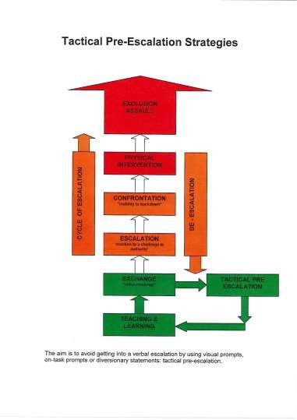

Reporting Positive Handling Interventions

When an incident has occurred that has required a physical intervention staff must inform a member of the Senior Leadership Team who will then make contact with parents and carers to inform them that a physical intervention has taken place. This incident must then be documented in the Bound Book and also on Sleuth. The Bound Book can be found in the headteachers office and is kept secure at all times. Following an incident of Physical intervention data is reviewed termly by the leadership team.

Debriefs
We recognise that incidents where Physical Intervention has been required can be distressing and impact on the wellbeing of all involved. Debrief opportunities will be available for staff in order to:

- Reflect on the incidents that have taken place
- Discuss what went well and possible opportunities for improvement
- Future strategies to try and prevent the incident from happening again

Debriefing documentation should be completed and uploaded to the school system to be referred to when required.

Tactical Pre Escalation
Staff should work tirelessly to ensure they form positive relationships with all pupils.
This will support staff to ensure any negative behaviour is eradicated and prevented. Staff have appropriate training (MAPA) where emphasis is on de-escalating behaviour before it results in ‘physical Intervention’ or ‘exclusion assault’.

Prohibited Measures and Guidance
Staff should be aware of the following PROHIBITED PUNISHMENTS and understand that disciplinary action will be taken against any staff member using any such practise.

Corporal Punishment (Regulation 8 (2) (6))

The use of corporal punishment is not permitted and is illegal. This includes any intentional application of force as punishment including slapping, throwing missiles, rough handling, punching or pushing even in the heat of the moment. It does not prevent a person taking necessary physical action where any other action would be likely to fail to avert immediate danger or personal injury to the young person or another person.

Deprivation of Food and Drink (Regulation 8 (2) (6))
On no account should staff ever use the deprivation of food as a disciplinary technique. Deprivation of food and drink should be taken to include the denial of access to the amounts and range of food and drink normally available within the community. It does not include instances where specified food or drinks have to be withheld on medical advice. Equally, it would be unacceptable to force a youngster to eat or drink foods which are disliked. It would be appropriate to encourage a young person to try a wide range of foods. Within these bounds, the individual staff must be given responsibility to manage immediate response.

Requiring a Pupil to Wear Distinctive or Inappropriate Clothing (Regulation 8 (2) (d)) Requiring pupils to wear distinctive or inappropriate clothing (including badges) as a disciplinary measure is prohibited. This includes clothes which are inappropriate for the time of day and/or the activity being undertaken – this applies to footwear and hair styles, e.g. extreme hair styles, colour styles.

The wearing of School Uniform or appropriate sports kit is, of course, not excluded and it is recognised that this can help to promote a positive self-image, identity and allegiance to the School.

The Use of the Withholding of Medication or Medical or Dental Treatment (Regulation 8 (2) (e))

This is totally forbidden in all circumstances, whether as a disciplinary measure or otherwise to control the pupil.

Managing Actual and Potential Aggression (MAPA)
At the Westminster School we cater for a range of pupil needs, some of these needs may result in incidents of aggression. We recognize that this behaviour is a method of communicating. Whilst we endeavour to reduce all incidents through reflection, consideration and planning, we recognize that there may be occurrences that necessitate the use of physical intervention to prevent injury to self or others. Section 550A of the Education Act 1996 clarifies the position of school staff in these circumstances. We endeavour to ensure that all staff are trained in Managing Actual and Potential Aggression (MAPA) techniques and follow their guidance on de-escalation strategies as well as interventions and debriefs. We ensure that all incidents of aggression are followed by a ‘debrief’ exercise with a Senior Member of staff in a timely yet appropriate manner. This debrief is managed on a case by case basis and may include the pupil, pupils and staff present. The aim of the debrief is to ensure the wellbeing of all involved and enable relationships to be rebuilt in order to move on with the future support of the pupil.

Members of staff have the power to use reasonable force to prevent pupils committing an offence, injuring themselves or others. This should be used as a last resort. All staff are trained in MAPA and have had appropriate training to ensure that this is done in a safe manner

The Westminster School currently uses the Sandwell Framework for use of Physical Intervention as a guide.

“physical restraint should be avoided as far as possible and should only be used if there are good reasons for believing that immediate action is necessary to prevent a child or young person causing significant injury to themselves or to others” (para 1.)

The Use of Accommodation to Physically Restrict the Liberty of Any Pupil

This is prohibited as a form of discipline or management.

Advice – where a pupil indicates their intention to leave the premises any member of staff may try the use of verbal negotiation try to retain the pupil. Where this procedure fails to be effective and the pupil leaves the premises a senior member of staff must be informed immediately. They will follow the School procedure for pupils that abscond. Where there is a risk of injury to pupil staff will observe and follow from a non-threatening distance (this may vary depending on the child).

However, young people and those with additional learning and complex needs require planned restrictions where they would otherwise be at significant risk. This will be clearly outlined on a Pupil Risk Assessment/Engagement Support Plan and agreed with parents, social workers and the School’s management team and where necessary the Educational Psychologist on admission and subjected to annual review or more regularly when required.

Confiscation of Inappropriate Items
If a member of staff deems, and has sufficient evidence to support that a pupil has an item that can cause considerable harm or is a prohibited item they have the right to confiscate the item. Once this item is confiscated it must be handed to a member of senior management and collected by parents in a formal setting. Staff in school have the power to search a pupil if there is evidence to suggest they have the following items:

- Knives
- Alcohol
- Illegal drugs
- Stolen items
- Tobacco/Cigarettes
- Fireworks
- Pornographic images (e-safety cause of concern to be completed in line with e-safety policy
- Mobile phones
- Or other items that may cause

At The Westminster School we pride ourselves on our understanding of our pupils and this good understanding should be used to support any judgements made regarding the intent of a pupil using items for inappropriate use or in order to cause harm to others.

A risk assessment is written for any child that may display behaviour that could result in the use of items inappropriately or for the use to harm in order to minimise risk to themselves and others.

Weapons and Knives and extreme or child pornography will be handed over to the police.
Intimate Physical Searches (Regulation 8 (2) (h))
Intimate physical searches of pupils are totally unacceptable.

Occasionally, and, not as punishment, a search of pupils’ clothing or possessions may be necessary – e.g. weapons, any item that might endanger the young person or others – including flammable items, materials. If it is suspected that a young person has secreted drugs on his/her person, then the police should be notified.

Exclusions
If a situation arises where a pupil is not making progress towards improving their behaviour and engagement as a result of an extensive behaviour plan and support then a permanent exclusion may be deemed appropriate. It is likely that an emergency statement or EHC plan review will have already taken place before a permanent exclusion is considered and this will have been discussed with school, parents, professionals and the local authority.

There may also be extenuating circumstances where an exclusion may be considered. This could be in response to a very serious incident such as an assault on a member of staff, an unprovoked attack on another pupil, the use of drugs, bringing an offensive weapon into school or blatant disregard for the School’s authority. The Head Teacher makes the decision whether or not to exclude and the type of exclusion. The Governors’ Student Disciplinary Committee meets to consider all permanent exclusions and certain fixed term ones.

The exclusions policy can be found on our website.

Staff Development

As a minimum, all staff will receive regular training about recognising and responding to behaviour, wellbeing and mental health issues as part of their regular training during the academic year.
Training opportunities for staff who require more in depth knowledge will be considered as part of our performance management process and additional CPD will be supported throughout the year where it becomes appropriate due to changing needs of the pupils.
Where the need to do so becomes evident, we will host twilight training sessions for all staff to promote learning or understanding about specific issues related to mental health.
Suggestions for individual, group or whole school CPD should be discussed with Joanne Turner, Deputy Head, who can also highlight sources of relevant training and support for individuals as needed.

Other sources of support

Attached to this policy are a number of different strategies and approaches that can be used within the school environment and beyond to support the needs of pupils. It is important to remember that there is not a ‘one size fits all’ approach to managing behaviour and wellbeing. Each pupil will present with different needs and responses and the approach to each pupil should be person centred and positive in approach. School works with a number of different agencies to ensure that pupils and staff can access the support they need in a timely manner. These include, but are not limited to:
- Specialist Higher Level Teaching Assistants
- Creative Therapy
- Music Therapy
- Educational Psychologists • Mentoring services (KRUNCH etc) • Employee assistant helpline.
- Occupational Therapy
- Dog Therapy

Appendix One- Levels of behavioural responses

Low | Medium | High
Lack of Effort  Disengagement or refusal to complete task  Unable to follow instructions  Uncontrollable outburst  ICT Misuse  Pupil not arrived at lesson  Ongoing low level disruption and disruption to others  Non compliance  Damage to property (low level) | Bullying others in the classroom and around school  Damage to Property (medium level)  Repeated inappropriate language to staff or students  Inappropriate touching of staff/pupils  Verbal threatening behaviour |  | Allegations against staff
Incident of racial or homophobic abuse
COVID Concern Coughing or Spitting
Hurting Adults
Hurting Pupils
Physically Threatening behaviour (adults or staff)
Absconding from school without permission Absconding from others while on an offsite activity
Action: Incidents should be recorded on sleuth and will not require a follow up from a Pathway lead or member of the senior leadership team | Action: Incidents should be recorded on sleuth and the follow up box should be ticked in order for the incident to be brought to the attention of a Senior Leader or a Pathway Lead. | Action: Incident incidents should inform a Senior Leader or a Pathway lead prior to completing a Sleuth as an investigation into the incident may need to take place. Once this has happened then Sleuth must be completed with the follow up box being selected
1

Appendix Two: Solution Circles
This is a short and powerful tool that takes no more than a half hour. It’s effective in getting “unstuck” from a problem or issue. Solution Circles are tools to build “community capacity”.
• Time required: No more than thirty minutes • People per Solution circle: Best with 5-9 • Roles to be played:
- Problem Presenter (focus person)
- Process Facilitator (team manager, time keeper) o Note Taker or Graphic Recorder o Amazingly creative Brainstorm Team
Steps to follow:

Step One: (6 minutes)
The problem presenter will have 6 uninterrupted minutes to outline the problem. The job of the process facilitator is to keep time and make sure no one interrupts. The recorder takes notes. Everyone else (the brainstormers) listen. If the problem presenter stops talking before the six minutes elapse, everyone else stays silent until the 6 minutes pass. This is key! The problem presenter gets 6 uninterrupted minutes.

Step two: (6 minutes)
This is a brainstorm. Everyone chimes in with ideas about creative solutions to what they just heard. It is not a time to clarify the problem or to ask questions. It is not a time to give speeches, lectures or advice. The process facilitator must make sure this is a brainstorm/thought shower. Everyone gets a chance to give his or her brilliant ideas. No one must be allowed to dominate. The problem presenter listens – without interrupting. He/she must not talk or respond.!

Step 3. (6 minutes)
Now the group can have a dialogue led by the problem presenter. This is time to explore and clarify the problem. Focus on the positive points only and not what can’t be done.

Step 4: (6 minutes)
The First Step. The focus person and the group decide on first steps that are doable within the next few days. A coach from the group volunteers to see the person within 3 days and check if they took their first step.

1

Appendix Three: Trauma Informed practice
What is it?
- The aim of this is for schools, communities and organisations to be mentally healthy places for everyone.
- Training so that everyone understands what makes good mental health, so that children and young people are helped before problems develop. The approach is preventative.
Why?
- Children are more vulnerable to the stress of trauma. Their responses to trauma are complex and are different from those of adults. Children’s traumatising experiences can compromise all area of childhood development, including: identity, cognitive processing, ability to manage behaviour, tolerance, moral development, ability to trust others.
- Children who have experienced trauma will develop “survivor behaviours” and these behaviours help the chid to survive extreme psychological stress in a hostile environment. Examples of this can be fighting, running away, substance abuse, shutting down, self herm, eating disorders etc.
- In a non-threatening environment the children will exhibit these behaviours to deal with their ‘uncomfortableness’ and anxiety – to these children even a nurturing environment is threatening.
Adults working with children and young people
- It is important that the adults who work with young people also look after themselves and each other, as part of the organisational culture; dealing with trauma can affect adults too.
Where can I find more information?
- https://www.traumainformedschools.co.uk/

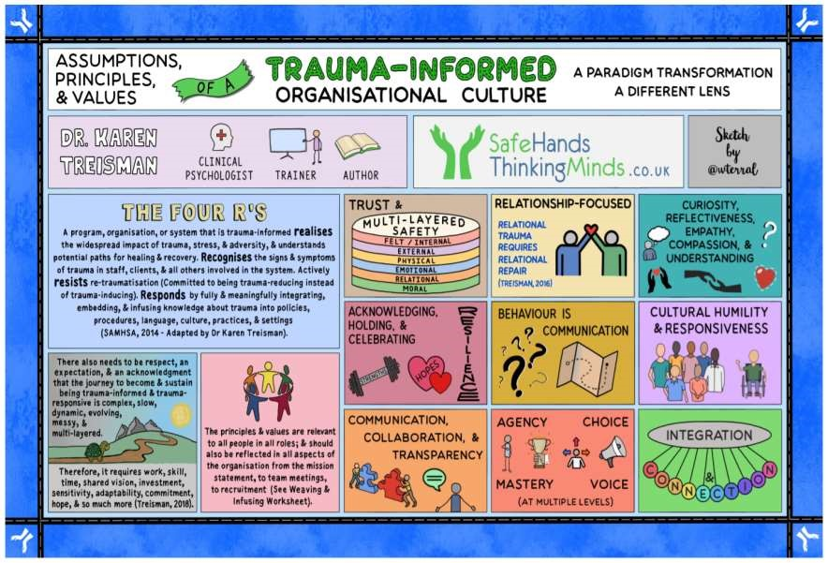
1

Appendix Four: De-escalation
What is De-escalation?
To calm a high anxiety moment or a situation down.

What may a high anxiety moment look like?
An intense response to overwhelming situations. It happens when someone becomes completely overwhelmed by their current situation and temporarily loses behavioural control. This loss of control can be expressed verbally (e.g. shouting, screaming, crying), physically (e.g. kicking, lashing out, biting) or in both ways.

De-escalation Strategies
- Act calm even if you are not
- Give a choice of activity
- Ask them to draw a picture
- Say ‘I see where you are coming from’
- Talk about something they like
- Try to understand their perspective
- Let the pupil talk without interrupting
- Avoid needing to get the last word
- Remind them they are not in trouble
- Tell them you are there for them
- Try to ignore the behaviour if you can
- Offer to change something they are doing
- Let them take a walk or have a drink
- Have a de-escalation box set up somewhere in the classroom to utilise if required
- Set up a designated de-escalation area within your classroom
- Build strong positive relationships with your pupils
- Remember your wording and the language you use – keep it positive
- Take the time to re-build the relationship after a high anxiety moment. You will both need time to recover and rebuild.

Appendix Five: Comic Strip Conversations
What is a Comic Strip Conversation?
A comic strip conversation uses simple drawings to visually outline a conversation between two or more people who may be reporting the past, describing the present or planning for the future. These drawings serve to illustrate ongoing communication and to provide additional support to individuals who struggle to understand the quick exchange of information that occurs in social situations.

Why use Comic Strip Conversation
- To visually work through a challenging situation and identify possible solutions/strategies
- To identify what people say and do as well as emphasize what people may be thinking
- To better understand the perspective of a situation
- As a tool to help develop social skills

How to make your own comic strip conversation
- You can use just paper, pencils, crayons and felt tip pens or use the computer.
- Ask the person you are supporting to choose what materials they would like to use.
- Some people may like to have their comic strip conversations in a notebook, or saved on their devises so that they can refer to them as needed.
SAMPLE:
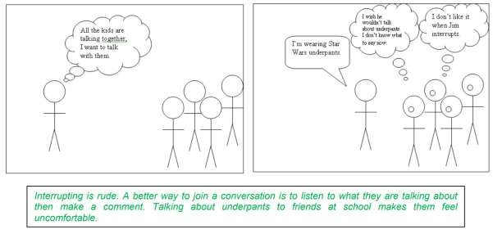
Things to consider
- Ideal for pupils that can read or use a pencil to draw their ideas
- You may want to “pre-teach” using this technique so the pupil becomes familiar with it. For example, the first time you introduce comic strip conversations; have the pupil describe an activity that he/she enjoys (such as playing Xbox, visiting the zoo etc) and introduce a few symbols at a time, starting with people (stick figures) and talking (speech bubbles)
- Once a pupil is familiar with the basic symbols and how the comic strip works you can assist them in understanding and expressing ideas in a social situation that may be difficult for him/her
- The initial stages may take on an “interview” format but the hope is to work towards a conversation-like format
- Here are some questions to help guide your pupil’s drawing; o Where are you? Who else is here? o What are you doing? o What happened? o What did others do?
  - What did you say?
  - What did you think when you said that? What did others think when you said/did that?
• Before implementing any strategy, remember to:
- Assess: What is the pupil is currently able to do?
- Goal: what is a specific goal for the pupil to work towards?
- Strategies: How will you teach to reach the goal?
- Monitor: How will you know if the teaching strategies are working?

Appendix Five: Talking Toolkit

What are Talking Toolkits?
Talking Toolkits are used as a distraction technique to re-engage disengaged pupils. It help alleviate stress and anxiety, by encouraging discussions about emotions and feelings. The toolkits are used by redirecting the pupils from an overwhelming situation and encouraging them to participate in a different activity, either with support or on their own. They are used as an aid to help open discussions about any challenges the pupil is currently facing, whilst also giving them some important 1:1 time with an adult to talk.
How can Talking Toolkits be used for?
If a child is displaying emotional or challenging behaviours, they can be redirected to a talking toolkit to engage in an activity as a distraction technique. It enables conversation to help deal with emotions and challenging behaviours. This is pupil led, how the pupil wants to use the time and toolkit, whether to calm and be quiet or discuss and resolve problems.
Talking Toolkits include items such as:
- Arts and crafts equipment
- Lego
- Sensory Slime
- Stress Balls
- SMILE emotion wheels/faces
- Playdough
- Laminated speech bubbles
- Hand puppets
- Jigsaws
Where can I find out more information?
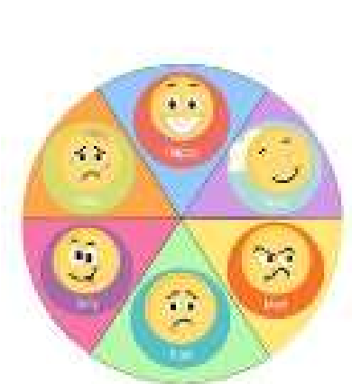
For further help on Talking Toolkits please speak to any of the following:
SENCO Team
Pathway Team leaders
HLTAs
Mental Health First Aiders

Appendix Six: Social Stories What are Social Stories?
Social stories are short stories that are personalised for an individual to break down something they are finding challenging into smaller steps that are more manageable. Social stories are highly descriptive to encourage the person to reflect and be able to deal with this challenge in an appropriate way, acknowledging emotions they may feel and strategies to cope with this. Other strategies have usually been used prior to a Social Story being created, however the individual’s challenge is still reoccurring and causing anxiety so a more personalised strategy is needed.
How can Social Stories be used?
Social stories can be used as an additional aid to strategies already in place to support the individual to recall previous discussions, and to remind them an appropriate way to deal with their challenge. Social stories help a pupil to understand the situation more clearly, and can help to re-focus their thinking.
A social story should be read with an individual at least twice before expecting them to understand and relate to. The story should be accessible to the individual at all times, and should be re-read leading up to, and immediately before the event/situation the person is finding challenging occurs to support the individual to remember the strategies and coping methods discussed.
Social stories often support in answering open questions an individual may repeatedly ask if they are anxious about something. Staff should re-direct the pupil to their social story to support the pupil in answering their own question and to give a consistent response. Social stories are most successful when information personal to the individual is used to enable them to relate and understand that the situation in the story is about them e.g. family names, specific places etc.
Where can I find out more information?
If you would like more information or support to create a social story, please speak to a member of the Speech and Language team. If you require more information about an individual that is finding a situation challenging, speak to the staff that know this pupil best. Form tutors, support staff who have worked with this pupil, previous teachers, Pathway Leaders and Mental Health First Aiders may be able to give you further information and support.
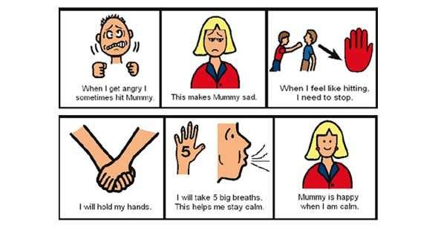
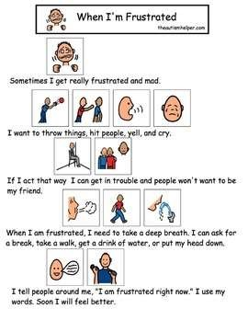

Appendix Seven: Learning Environment checklist
Physical Environment |  | Yes |  | Partially |  | No |  | Notes
Is the room temperature appropriate and comfortable for staff and students?
Is the lighting appropriate? (consider is there anything blocking natural light into the room?)
Is the furniture and resources available in the room appropriate for the students and are they purposeful?
Are there any noises that are constant that may persistently disrupt learning?
Is the room free of visual clutter and not overpowering for students?
 | Classroom Environment |  | Yes |  | Partially |  | No |  | Notes
 | Is the room free from clutter and is generally tidy?
 | Does the room celebrate learning and pupil achievement? (through displays, working walls etc?)
 | Does the layout of the room promote communication and social interaction?
 | Is there a space for students to self regulate in the classroom?
 | Are displays up to date and relevant to the learners?
 | For class based classes – do you feel that learners feel part of the class and valued? Is this evident in the room?
 | Is communication, literacy and numeracy promoted in the classroom?

Appendix Eight: Communication in the environment

Makaton
Makaton uses speech with signs (gestures) and symbols (pictures) to help people communicate. We also use facial expression, eye contact and body language to give as much information as possible.
https://www.makaton.org/

PECS
The Picture Communication System (PECS) allows people with little or no communication abilities to communicate using pictures. People using PECS are taught to approach another person and give them a picture of a desired item in exchange for that item https://youtu.be/aouSfDAW-Q8

Blank Level Questioning
There are four different levels of questioning: Naming, Describing, Retelling/Narrative and Justifying. They encourage the development of Verbal reasoning.
https://youtu.be/VcpoVK66qUU

Aided Language Displays
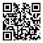
An ‘aided language display’ (ALD) is a symbol display where all the relevant symbolised vocabulary for a specific activity is displayed. They are used to supplement AC systems already in place (e.g PECS, Communication books) as they are quick and easy to implement. Vocabulary is organised to help combine words and build simple sentences.
https://youtu.be/kiqYapgu69g

COSST
COSST supports students with communication and/or literacy difficulties to develop a range of basic language skills. It involves the use of ‘symbols’ with supporting ‘text’ and a simple colour coding system to assist students in constructing phrases and sentences to describe, comment and talk about single pictures and/or a sequence of pictures/books.

Word equivalents
Not all pupils will learn to read using words. Some pupils will learn to read using real life objects, photographs, symbols and words. Objects, pictures and symbols can be used individually, as key word sentences or in full sentences, just like words. When creating a visual timetable, it is important to remember to use the visuals which pupils can access on their most challenging days.

Intensive Interaction
Intensive interaction teachers pupils the fundamentals of communication. For example, sharing attention, understanding facial expressions, playing and turn taking. The process is done with just you and the pupil. https://www.youtube.com/watch?v=rjKxu6QKjAo

Key word language
It is useful to limit the information carrying words in a sentence. Using key word language reduses the amount of information that a pupils has to process, making it more likely that they will process the information successfully. When a pupil has mastered instructions containing one key eord, increase it to two.

Appendix Nine: Sensory Circuits
Type of activity | Examples
Alerting activities | - Jumping jacks  - Hopping/ jogging from one spot to another  - Animal walks e.g. frog hops, penguin waddle, crab walk etc…  - Stacking books or other heavy objects  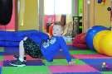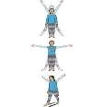
Organizing activities | - Wall push ups  - Commando crawling  - Infinity walk – walk around 2 chairs in the figure of 8 then repeat with eyes closed  - Egg and spoon walk (can be a little ball, doesn’t have to be an egg)  - Moving objects from 1 container to another e.g.  bottles of water  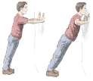
Calming activities | - Hugging themselves  - Deep pressure on shoulders, hands or feet  - Being squished with sofa cushions  - Blowing bubbles/ straws if you have some • Deep breathing  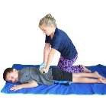

Appendix Ten: Emotion Coaching
Emotion Coaching is a non-judgemental, empathetic, person-centred approach to wellbeing and behaviour. It focuses on and validates feelings and encourages pupils to develop appropriate strategies linked to emotions. The approach makes it clear that some behaviours are not appropriate without placing judgement on the child. There are three steps to emotion coaching:
- Label the emotion and creating an empathetic bond. Reassure the pupil that the emotions that they are experiencing are okay. Teach the pupils about their emotions in the moment.
- Reinforce boundaries, setting limits on behaviours.
- Explore strategies and guide the pupils to develop safe and respectful responses to their emotions.
By using emotion coaching regularly, the pupils are learn that:
- their feelings are valid
- staff members can be relied upon for support and guidance
- there are rules and boundaries that we all adhere to
- they can take control over their own responses to emotions.
Emotion coaching will look different in practice depending on the pupil that you are working with.
With some pupils you will be able to ask them to reflect and plan future strategies.
- I can see that you’re feeling angry. It’s okay to feel angry, I feel angry sometimes, too.
- It’s not safe to do this.
- Next time you feel this way, what can we do instead?
For others, it you might need to use less words and be more specific.
- Feeling sad (exaggerated sad face)
- Hitting has finished.
- Using kind hands.
For some pupils, we just need to empathise and attune. In these cases, it might not be appropriate to talk about the behaviour itself but just focus on the emotion. Sometimes we just need to show that we understand how they feel by using exaggerated facial expressions and body language and label the emotion using signs, symbols, pictures or words.

Appendix Eleven: Stages of Anxiety
How to help (insert name) when she/he is feeling anxious
You won’t see these stages in the order that they are written. You may only see stage 5. Please follow the blue column and inform class staff of any other successful strategies.
Stage of anxiety | What you might see me doing | What you can do to help me
1 | - Communicating verbally.  - Smiling.  - Laughing.  - Asking questions.  - Seeking reassurance.  - Concentrating on  activities. (Grinding teeth and making a grunting noise)  - Hugging and greeting people. | - Allow me to have some control over my activities and who I am working with.  - Pay lots of attention to me.  - Respond to all attempts of communication including eye contact. (Even to say – “I can’t talk right now; I’ll speak to you after…)  - Respond and then follow through with any promises to work or play.  - Remind me what is now and next.  - Encourage me to stay on task.  - Give me time to process what you have asked me.
2 | - Throwing random  small odd objects. • Banging the table.  - Trying to sit on the teacher’s lap or chair.  - Standing by the teacher’s desk playing with items on the desk. | - Encourage me to tell an adult what I need.  - Stay calm and don’t give me a reaction to my behaviour.  - Ask me if I would like to change activity or change who I am working with.  - Give me control over my choice of activity.  - Give me time to process what you have asked me.  - Use humour and motivators (my favourite games) to distract me.  - Remind me what is now and next.  - Don’t direct me to use the words please or thank you.
 |  | • | Remove anything that could cause me or others harm.
3 | - Shouting and indirect swearing.  - Hiding head in hands.  - Biting t-shirt.  - Unresponsive to attempts at verbal communication.  - Gritting/grinding teeth.  - Pushing  tables/knocking chairs over.  - Kicking the bin over.  - I might ask you to rub my back. | •  •  •  •  •  •  •  •  • | Give me time alone.  Don’t talk to me.  Stay calm and don’t give me a reaction to my behaviour. Ensure my visuals are accessible to me. (But don’t speak to me – use these to communicate with me)  Offer me my chewy. (Boris)  Rub my back if I ask you to.  Don’t label my behaviour. Don’t talk to me about tidying up.  Remove me from the room if I am not showing signs of calming.
4 | Some elements of Stage 3 with the addition of:  - Throwing things towards other pupils in the class and teachers.  - Grabbing/hitting staff in reach.  - Swearing at people directly.  - Targeting other people’s belongings to provoke a reaction.  - Emptying cupboards, drawers, boxes etc. | •  •  •  •  • | Leave me alone.  Don’t talk to me.  Stay calm and don’t give me a reaction to my behaviour.  Do not get close to me. Ensure my visuals are accessible to me. (But don’t speak to me – use these to communicate with me)
5 | Some elements of Stage 3 & 4 with the addition of:  - Wetting myself.  - Spitting.  - Biting.  - Pinching.  - Slapping. | •  •  •  •  • | Leave me alone.  Don’t talk to me.  Stay calm and don’t give me a reaction to my behaviour.  Do not get close to me. Ensure my visuals are accessible to me. (But don’t speak to me – use these to communicate with me)

MAPA will be used as a last resort to remove the risk of harm to self or others. This will be up to the staff in the room to decide when that risk is present and act accordingly.
When completing MAPA please remember to log all incidents in the bound book in the Headteachers office and record the incident on Sleuth.

Appendix Twelve: Risk Assessment template

Pupil Risk Assessment
Location / Site |  | The Westminster School
Assessment date
People at Risk

The following plan has been written by Joanne Turner. It is intended to identify, assess and minimise
(wherever possible) any risks involved with Sayeed attending school. It also takes into account
Government guidance, health and safety recommendations and updates from Sandwell Local Authority.

Identify hazard
Existing level of risk | HIGH |  | MEDIUM | L | OW | NEGLIGIBLE
Control measures | The following actions are required to help reduce |  |  | risk
Remaining level of risk following the control measures
HIGH |  | MEDIUM | LOW |  | NEGLIGIBLE

Written by
Date

Risk assessment reviews
Date | Signature | Comments

Appendix Thirteen: Restorative Justice

Restorative solutions
- Different approach to dealing with conflict and behaviour which is hard to understand
- At the heart of restorative solutions, is the idea of 'making it right'
- Restitution and reparation rather than retribution

4 R’s
- Responsibility (CYP are learning about their own responsivity)
- Reintegration (bringing CYP together- rather than exclusion through punishment)
- Reparation (involvement and consultation of all participants)
- Rights (the right to ‘be and feel safe’… and the right to ‘have a say’)

Retributive vs Restorative
- Retributive
Usually involves the adult asking 3 questions:
- What happened?
- Who is to blame?
- Which punishment is appropriate?
The function is to clarify responsibility, establish blame and carry out punishment, as swiftly as possible
- Restorative
A restorative intervention involves the adult genuinely asking the following questions:
- What happened?
- What were you thinking?
- What were you feeling?
- Who has been affected by what happened?
- How can we put things right?

Restorative Conferences
An opportunity for the CYP involved in an incident to discuss what happened and their thoughts, feelings and the effects on the incident on them
Aims for conference
- reparation
- an agreement between everyone present
- repairing relationships

