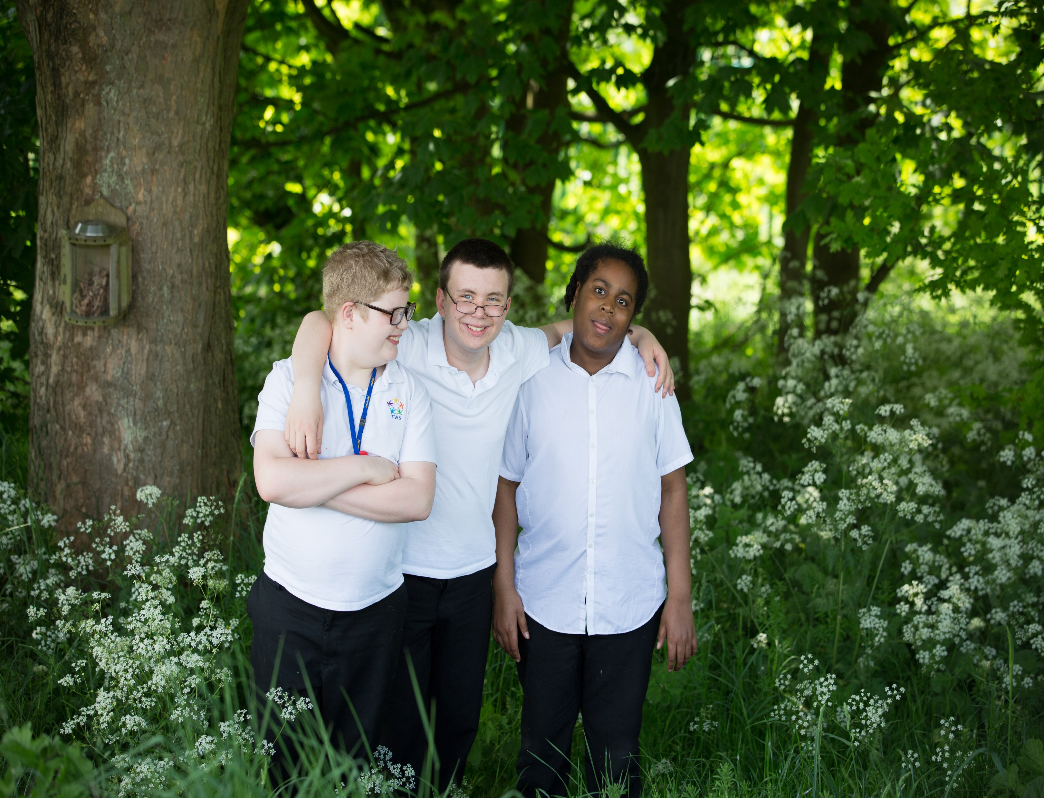

The Westminster School





Trainee Teacher Application Pack







Welcome to Westminster

Thank you for your interest in the role of Trainee Teacher at The Westminster School.

We are an Outstanding School in Rowley Regis which caters for pupils aged 7 to 19 years with a wide range of special educational needs including Autism Spectrum Disorder, Global Development Delay and Moderate to Severe Learning Difficulties.

We are looking to appoint a dedicated and enthusiastic practitioner to share our vision for education.

As one of our class teachers, under the direction of the Senior Leadership Team, you will play a key part in delivering our innovative curriculum, which is personalised to our pupils to prepare them for life after education.

You will have the support of a dedicated and committed governing board that considers continuing professional development for all staff an essential factor in achieving the best outcomes for all pupils.

**Mr O M Flowers**Head Teacher



About Our School

The Westminster School currently has 221 pupils on roll between the ages of 7 and 19. Pupils have a wide range of special educational needs plus additional needs.

We moved to our new site in February 2011. The School was purpose built. Most ground floor classrooms have access to outside spaces, incorporating Learning Outside the Classroom into our enriched curriculum.

Our values are encompassed in our statement of Safe, Happy and Learning Together. Through this we seek to develop our values statement: Building foundations and providing opportunities to create confident, aspirational and independent members of our community.

Our most recent Ofsted Inspection in November 2017 recognised we were an Outstanding School. The report stated that our “leaders are fundamentally committed to improving the life chances of pupils with SEN and disabilities, both at The Westminster School and across the country.”

All pupils are supported to reach their full potential with a level of independence, confidence and resilience according to their special needs in order that they have the ability to face the challenges of adult life.

Our work on supported internships and supported apprenticeships for students with learning disabilities are at the forefront of national developments.

All of our committed, enthusiastic staff are well qualified and highly skilled. This translates into an amazing working environment for both staff and pupils.

Ours is a happy School. As identified in our recent Ofsted Inspection Report, “There is a lot of laughter and enjoyment in lessons and around the School.”

We have an exceptionally strong culture of safeguarding, and pupil welfare is one of our highest priorities.

TEACHING RESPONSIBILITIES

* Have a detailed knowledge of the appropriate National Curriculum and current assessment across all Key Stages.
* Understand progression through Key Stage Programmes of Study.
* Know and can teach the development of key skills in the appropriate subject(s).
* Understand how pupils’ learning is affected by their physical, intellectual, emotional and social development.
* Select, and make good use of, ICT skills for subject and management support.
* Be familiar with the School’s current systems and structures as outlined in policy documents including the Health and Safety and Safeguarding/Child Protection Policies.
* Know and understand how national, local and school comparative data can be used to set clear targets for pupils’ achievement and to raise standards.

DUTIES AND RESPONSIBILITIES

* To carry out under the reasonable direction of the Head Teacher the professional duties of a teacher which are set out in the current ‘School Teachers’ Pay and Conditions Document’ (DfE).
* To continue to meet the required standards for Qualified Teacher Status.
* To know and carry out all School policies and procedures.
* It is the responsibility of each employee to carry out their duties in line with Council policies on equality (please refer to the Policy Statement), harassment, racial equality and the CRE action plan, and be sensitive and caring to the needs of the disadvantaged, promoting a positive approach to a harmonious working environment. Each employee should act as an exemplar on these issues and must, where appropriate, identify and monitor training for themselves and any employees they are responsible for in line with these policies and the CRE standards.
* Use and development of ICT as required.
* Such other duties as may be appropriate to achieve the objectives of the post to assist The Westminster School in the fulfilment of its objectives commensurate with the post holder’s salary grade, abilities and aptitudes.
* The post holder must at all times carry out his/her responsibilities with due regard to the Council’s policy, organisation and arrangements for Health and Safety at Work.
* All staff within The Westminster School will be expected to accept reasonable flexibility in working arrangements and the allocation of duties to reflect the changing roles and responsibilities of Children and Young People's Services. Any changes arising will take account of salary and status. They will also be subject to discussion with individuals or sections affected and with appropriate trades unions.
* “The Westminster School is committed to safeguarding and promoting the welfare of pupils and young people and expects all staff and volunteers to share this commitment.”

SEN Teacher – Job Description



PLANNING, TEACHING AND CLASSROOM MANAGEMENT

* Identify clear teaching objectives and content to deliver the National Curriculum, and appropriate courses with regard to the School’s aims, policies and schemes of work.
* Set tasks for the class, group and individuals, including homework, which are both appropriate and challenging in order to ensure high levels of pupil interest.
* Set appropriate and demanding expectations for pupils’ learning, motivation and presentation of work.
* Identify pupils who have additional special educational needs, are gifted and talented or who are not yet fluent in English, and know where to get help in order to give positive and targeted support.
* Provide clear structures for lessons, and for sequences of lessons, in the short, medium and long term, which maintain pace, motivation and challenge for pupils.
* Make effective use of assessment information on pupils’ attainment and progress and in planning future lessons.
* Monitor and intervene when teaching to ensure sound learning and discipline, maintaining a safe environment in which pupils feel confident.
* Use a variety of teaching and learning styles to keep all pupils engaged and on-task.
* Be familiar with the Code of Practice for SEN., implement and keep records on Individual Education Plans, Individual Learning Plans and, where appropriate, Behaviour Plans.
* To work effectively with Learning Support Practitioners/Assistants.
* Critically evaluate own teaching and use this to improve professional effectiveness.

MONITORING, ASSESSMENT, RECORDING AND ACCOUNTABLITY

* Assess and record each pupil’s progress systematically with reference to the School’s policy and practice, and use the results to inform planning.
* Mark and monitor classwork and homework, providing constructive feedback and setting targets for future progress.
* Understand and know how to use different kinds of assessment appropriately for different purposes, including those for Statutory Testing and examination courses.
* Provide reports on individual progress to the Head Teacher and parents/ guardians/carers as required.

SEN Teacher – Job Description



SEN Teacher – Job Description

OTHER PROFESSIONAL REQUIREMENTS

* Understand professional responsibilities, having a working knowledge and understanding of current legislation.
* Undertake rota duties and lead assemblies as required.
* Set appropriate cover work in the event of a known absence.
* Establish positive working relationships with colleagues, Governors, parents/carers, LA, outside agencies and the community where appropriate.
* Set a good example through own presentation, personal and professional conduct.
* Undertake, if required, the duties of a Form Tutor as follows:
  + To carry out the general pastoral welfare of the Form according to School policy, including:
    - Oversight of discipline, behaviour and conduct;
    - Maintaining the Behaviour Recovery Policy and Procedures;
    - Maintaining high standards regarding uniform.
  + To carry out registration procedures and be vigilant regarding pupil absence.
  + To ensure that pupil reports are completed at the appropriate time, according to School policy.
  + To ensure that the classroom environment is stimulating and aesthetically appealing.
  + To take part in activity days where appropriate.
* Contribute to the corporate life of the School through meetings, assemblies, shared projects and School functions.
* Be aware of the need to take responsibility for own professional development, and to keep up-to-date with relevant research and developments in pedagogy, especially SEN.
* To undertake any duties and responsibilities commensurate with the post, as designated by the Head Teacher.



LEADERSHIP

* Proven ability to lead and manage a class team

PRACTICAL AND INTELLECTUAL SKILLS

* Is an outstanding classroom practitioner.
* Has understanding of reward strategies and reporting systems for behaviour and  
  engagement.

LEGAL REQUIREMENTS

* The successful applicant will be required to undertake an enhanced DBS check and other necessary checks by the Local Authority.

**For the role of SEN Teacher, we will be looking for the following which will be identified through your application form, selection process and references:**

SEN Teacher – Job Description

– Person Specification



QUALIFICATIONS

* Willingness to work towards achieving Qualified Teaching Status (we are able to accept QTLS).
* Experience of teaching pupils with a range of SEN including Autistic Spectrum Disorder, TEACCH, PECS, SCERTS, Intensive Interaction, Sensory Regulation.

TEACHING AND LEARNING

* Has outstanding knowledge of teaching and learning strategies.
* Has a very good understanding of a range of SEN and can adapt approaches to cater for this range of need.
* Team player.
* Committed to own training and professional development.
* Committed to Positive Behaviour Management.
* Willing to undertake further training and development.
* Working knowledge and understanding of a sensory curriculum.
* Proven ability to establish and maintain high quality planning and recording in line with School policy.
* Working knowledge of formative and summative assessment for pupils with ASD and complex needs

PERSONAL CIRCUMSTANCES

* The ability to commit to the working the contracted hours and yearly calendar of the School.
* Effective English skills both oral and written
* Excellent international skills.
* High aspirations and expectations for all
* Competent ICT users
* Ability to give and receive constructive feedback
* Flexible and adaptable
* Ability to prioritise and manage own workload.



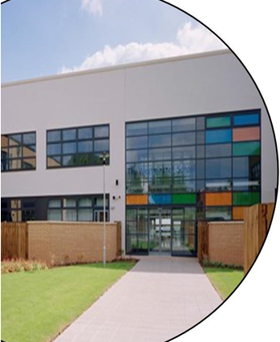

**The Westminster School  
Hawes Lane  
Rowley Regis  
West Midlands  
B65 9AL**

**0121 561 6884**